SUBCOURSE EDITION
IT0667 A

US ARMY INTELLIGENCE CENTER

IMAGERY ANALYSIS REPORTS/

REQUEST PREPARATION IN USMTF FORMATS
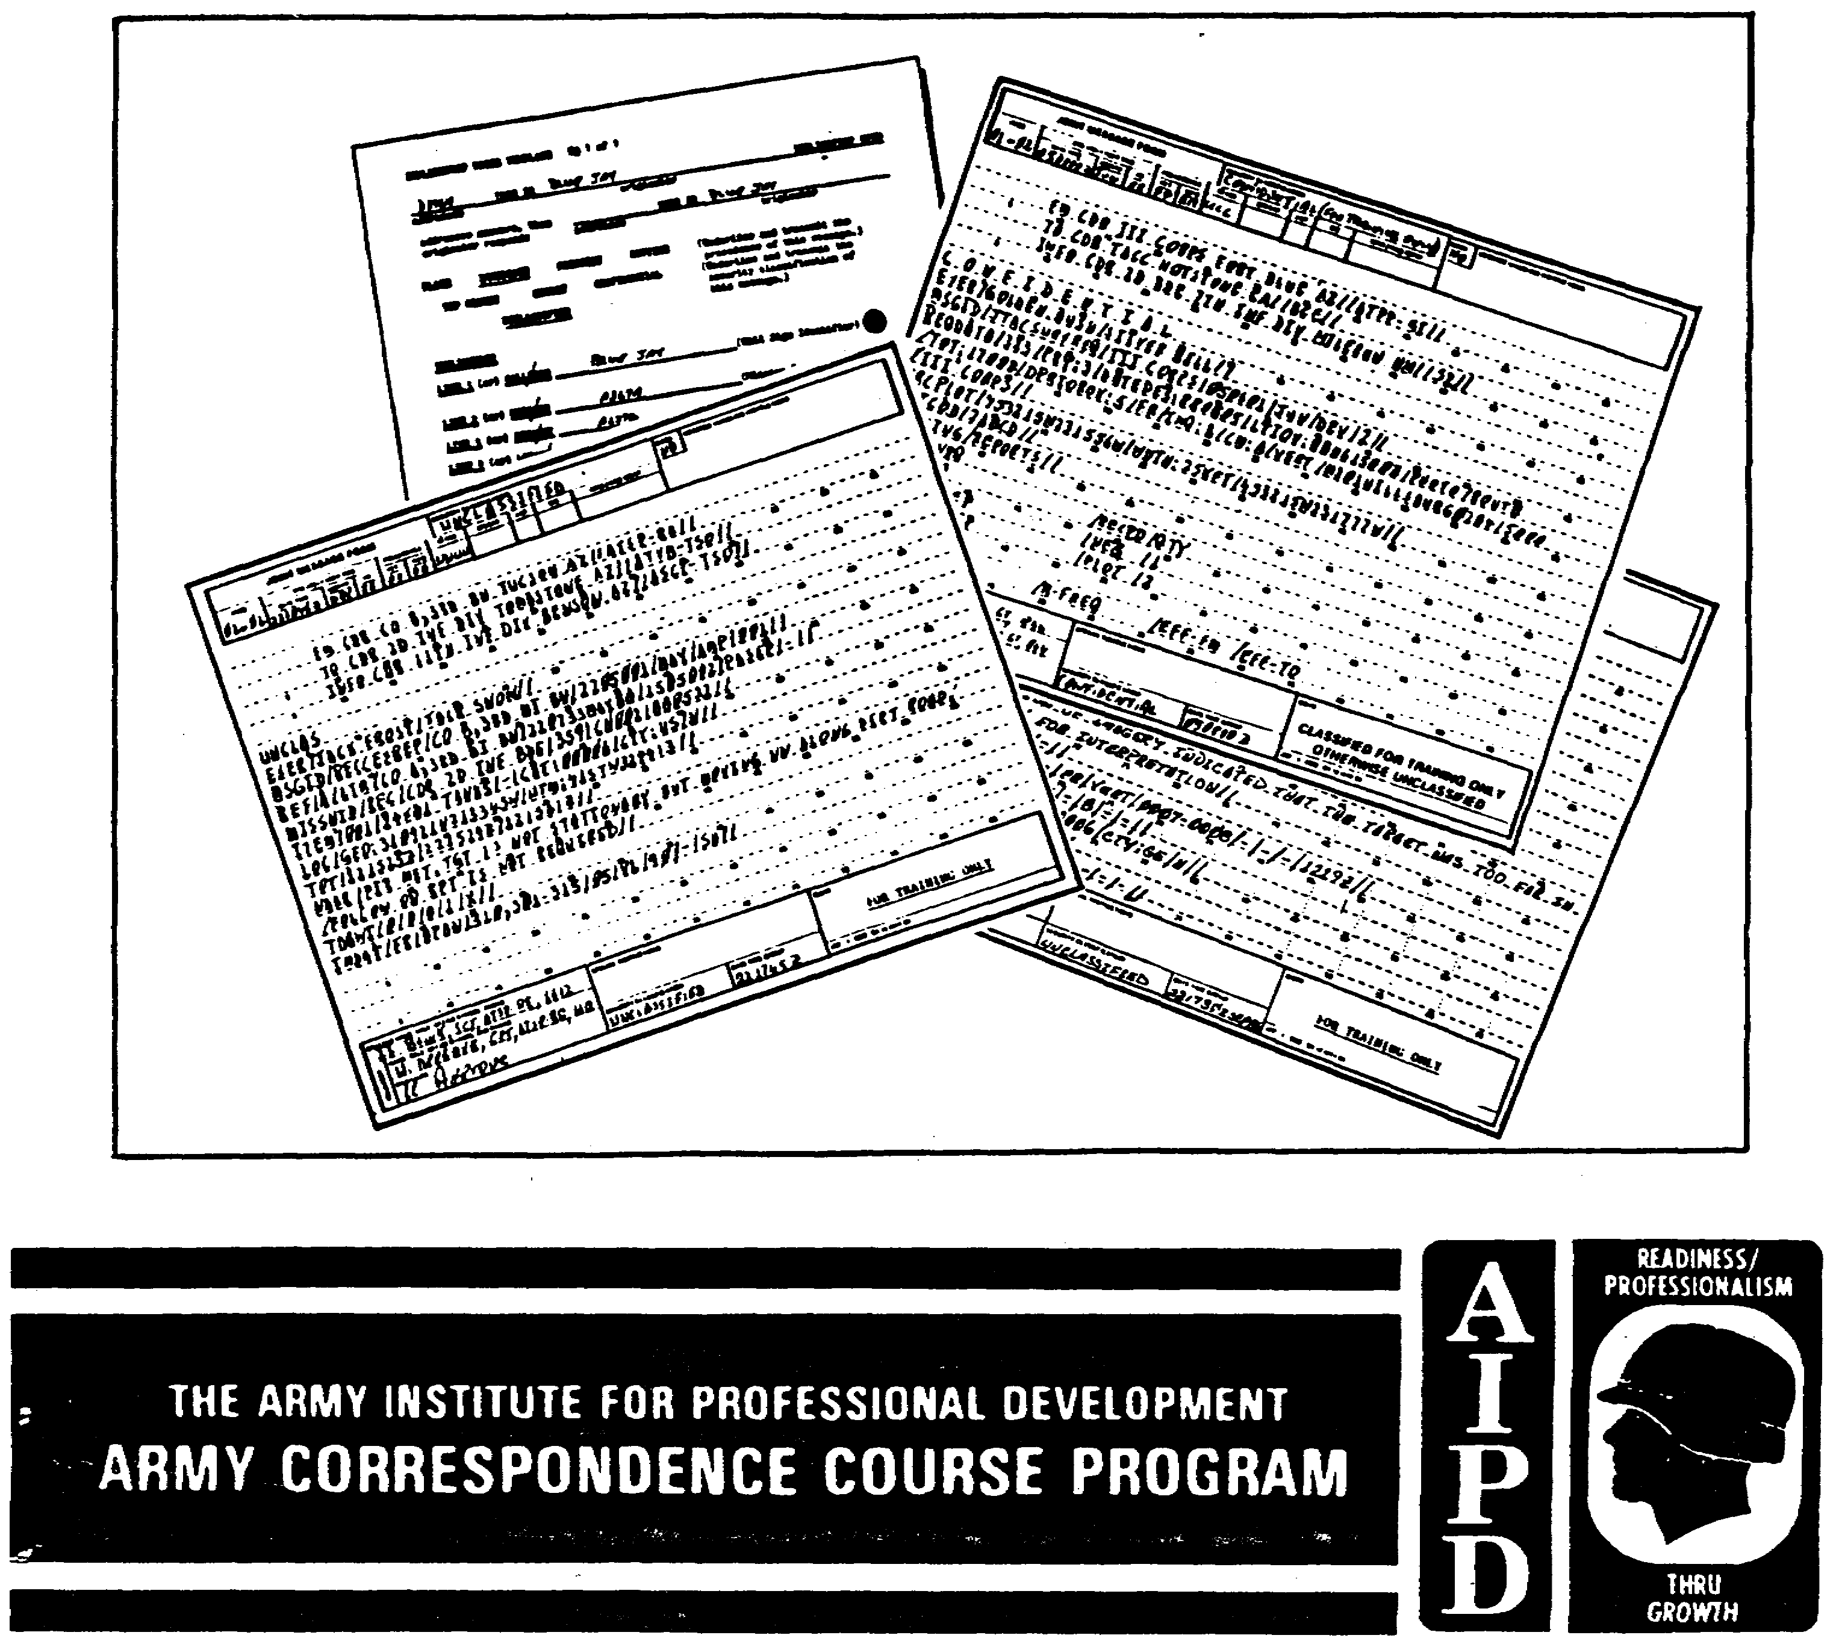

The proponency for this subcourse has changed from FT Devens to FT Huachuca. Whenever reference is made to Ft Devens within this subcourse, the student should write FT Huachuca. See address on Student Inquiry page and Phone Number on Inside front cover.

IMAGERY ANALYSIS REPORTS/REQUESTS PREPARATION IN USMTF FORMATS

Subcourse Number IT0667

Edition A

US Army Intelligence Center

15 Credit Hours

Edition Date: March 1992

SUBCOURSE OVERVIEW

This subcourse is designed to teach you the basic procedures involved in preparing imagery analysis reports and request using the US Message Text Formats (USMTF), which are based on the Joint Interoperability of Tactical Command and Control Systems (JINTACCS).

There are no prerequisites for this subcourse.

This subcourse reflects the doctrine which was current at the time the subcourse was prepared.

TASK: You will prepare imagery analysis reports and request using the US Message Text Formats (USMTF).

CONDITIONS: You will have access to extracts from DA Pam 25-7, NATO STANAG 3377, NATO STANAG 3596, STP 34-96D1-SM, and STP 34-96D24-TG.

STANDARD: You will prepare imagery analysis reports and request in accordance with (IAW) DA Pam 25-7, NATO STANAG 3377, NATO STANAG 3596, STP 34-96D1-SM, and STP 34-96D24-TG.

NOTE: You will not need DA Pam 25-7 for this subcourse since the required extracts are contained in Appendices A-C.

i IT0667

TABLE OF CONTENTS
Section Page

Subcourse Overview i

LESSON 1: GENERAL US MESSAGE TEXT FORMAT INFORMATION AND RULES 1
Part A: General US Message Text Format Information 2
Part B: General US Message Text Format and Initial Sets Rules 5
Practice Exercise 13
Answer Key and Feedback 14

LESSON 2: INFLIGHTREP PREPARATION 15
Part A: INFLIGHTREP Description 16
Part B: INFLIGHTREP Preparation in USMTF Message Format 16
Practice Exercise 19
Answer Key and Feedback 20

LESSON 3: RECCEXREP PREPARATION 21
Part A: RECCEXREP Description 22
Part B: RECCEXREP Preparation in USMTF Message Format 22
Part C: RECCEXREP Voice Template Preparation 31
Practice Exercise 32
Answer Key and Feedback 36

LESSON 4: IIR PREPARATION 37
Part A: IIR Description 38
Part B: IIR Preparation in USMTF Format 38
Practice Exercise 56
Answer Key and Feedback 66

LESSON 5: JTACSURVREQ PREPARATION 68
Part A: JTACSURVREQ Description 69
Part B: JTACSURVREQ Preparation in USMTF Format 69
Part C: AIRREQRECON Voice Template Preparation 80
Practice Exercise 84
Answer Key and Feedback 90

APPENDIX A. GENERAL MESSAGE PREPARATION/INTERPRETATION RULES 106
APPENDIX B. IMAGERY ANALYSIS MESSAGES 134
APPENDIX C. ENTRY LISTS 198
APPENDIX D. WORLD TIME ZONES 321

IT0667 ii

LESSON 1

GENERAL US MESSAGE TEXT FORMAT INFORMATION AND RULES

MOS Manual Task: 301-338-1606
301-338-1607

OVERVIEW

TASK DESCRIPTION:
In this lesson you will learn information and rules on preparing reports and request using US Message Text Format (USMTF).

LEARNING OBJECTIVE:

ACTIONS: Describe general information and rules on preparing request and reports in USMTF.

CONDITIONS: You will be given access to extracts form DA Pam 25-7, STP 34-96D1-SM, and STP 34-96D24-TG.

STANDARDS: Understand general information and rules on preparing requests and reports in USMTF.

REFERENCES: The material contained in this lesson was derived from the following publications:

DA Pam 25-7.
STP 34-96D1-TG.
STP 34-96D24-TG.

INTRODUCTION

DA Pam 25-7 is used for preparing or interpreting USMTF messages. These messages are prepared for and used by all the armed services of the United States. It is essential that even the most minute detail can be considered crucial, since improper preparation could be time consuming causing delays in transmission of messages. As an imagery analyst (IA) you often encounter USMTF messages, therefore it is necessary that you know how to properly prepare and interpret these messages.

1 IT0667

PART A: GENERAL US MESSAGE TEXT FORMAT INFORMATION

1. The Joint User Handbook (DA Pam 25-7) gives you directions on how to write and interpret USMTF messages. This handbook contains four chapters:

a. Chapter 1 of the handbook gives general information about messages and defines terms associated with the messages pertaining to imagery analysis reports.

b. Chapter 2 of the handbook explains the general preparation/interpretation rules for USMTF messages. In this chapter are some special symbols that are authorized for use and information on how to place actual message content (Appendix A, page 106).

c. Chapter 3 of the handbook provides specific details on how to write and read each message (including the initial sets) which pertain to imagery analysis reports (Appendix B, page 134).

d. Chapter 4 of the handbook contains all the authorized annexes for all messages. Within these annexes are the authorized entry codes for specific sets or fields used in imagery analysis reports (Appendix C, page 198).

2. All USMTF messages are prepared on JRF-1-0002 Joint Message Form (Figure 1-1) or DD Form 173 (Figure 1-2).

a. Main features of the JRF-1-0002 Joint Message form (Figure 1-1) include:

(1) Normally hand printed.

(2) There are 20 lines on the form.

(3) Space to write 69 characters on each line.

(4) Every fifth space is numbered to assist in finding the correct space you need on the form.

IT0667 2

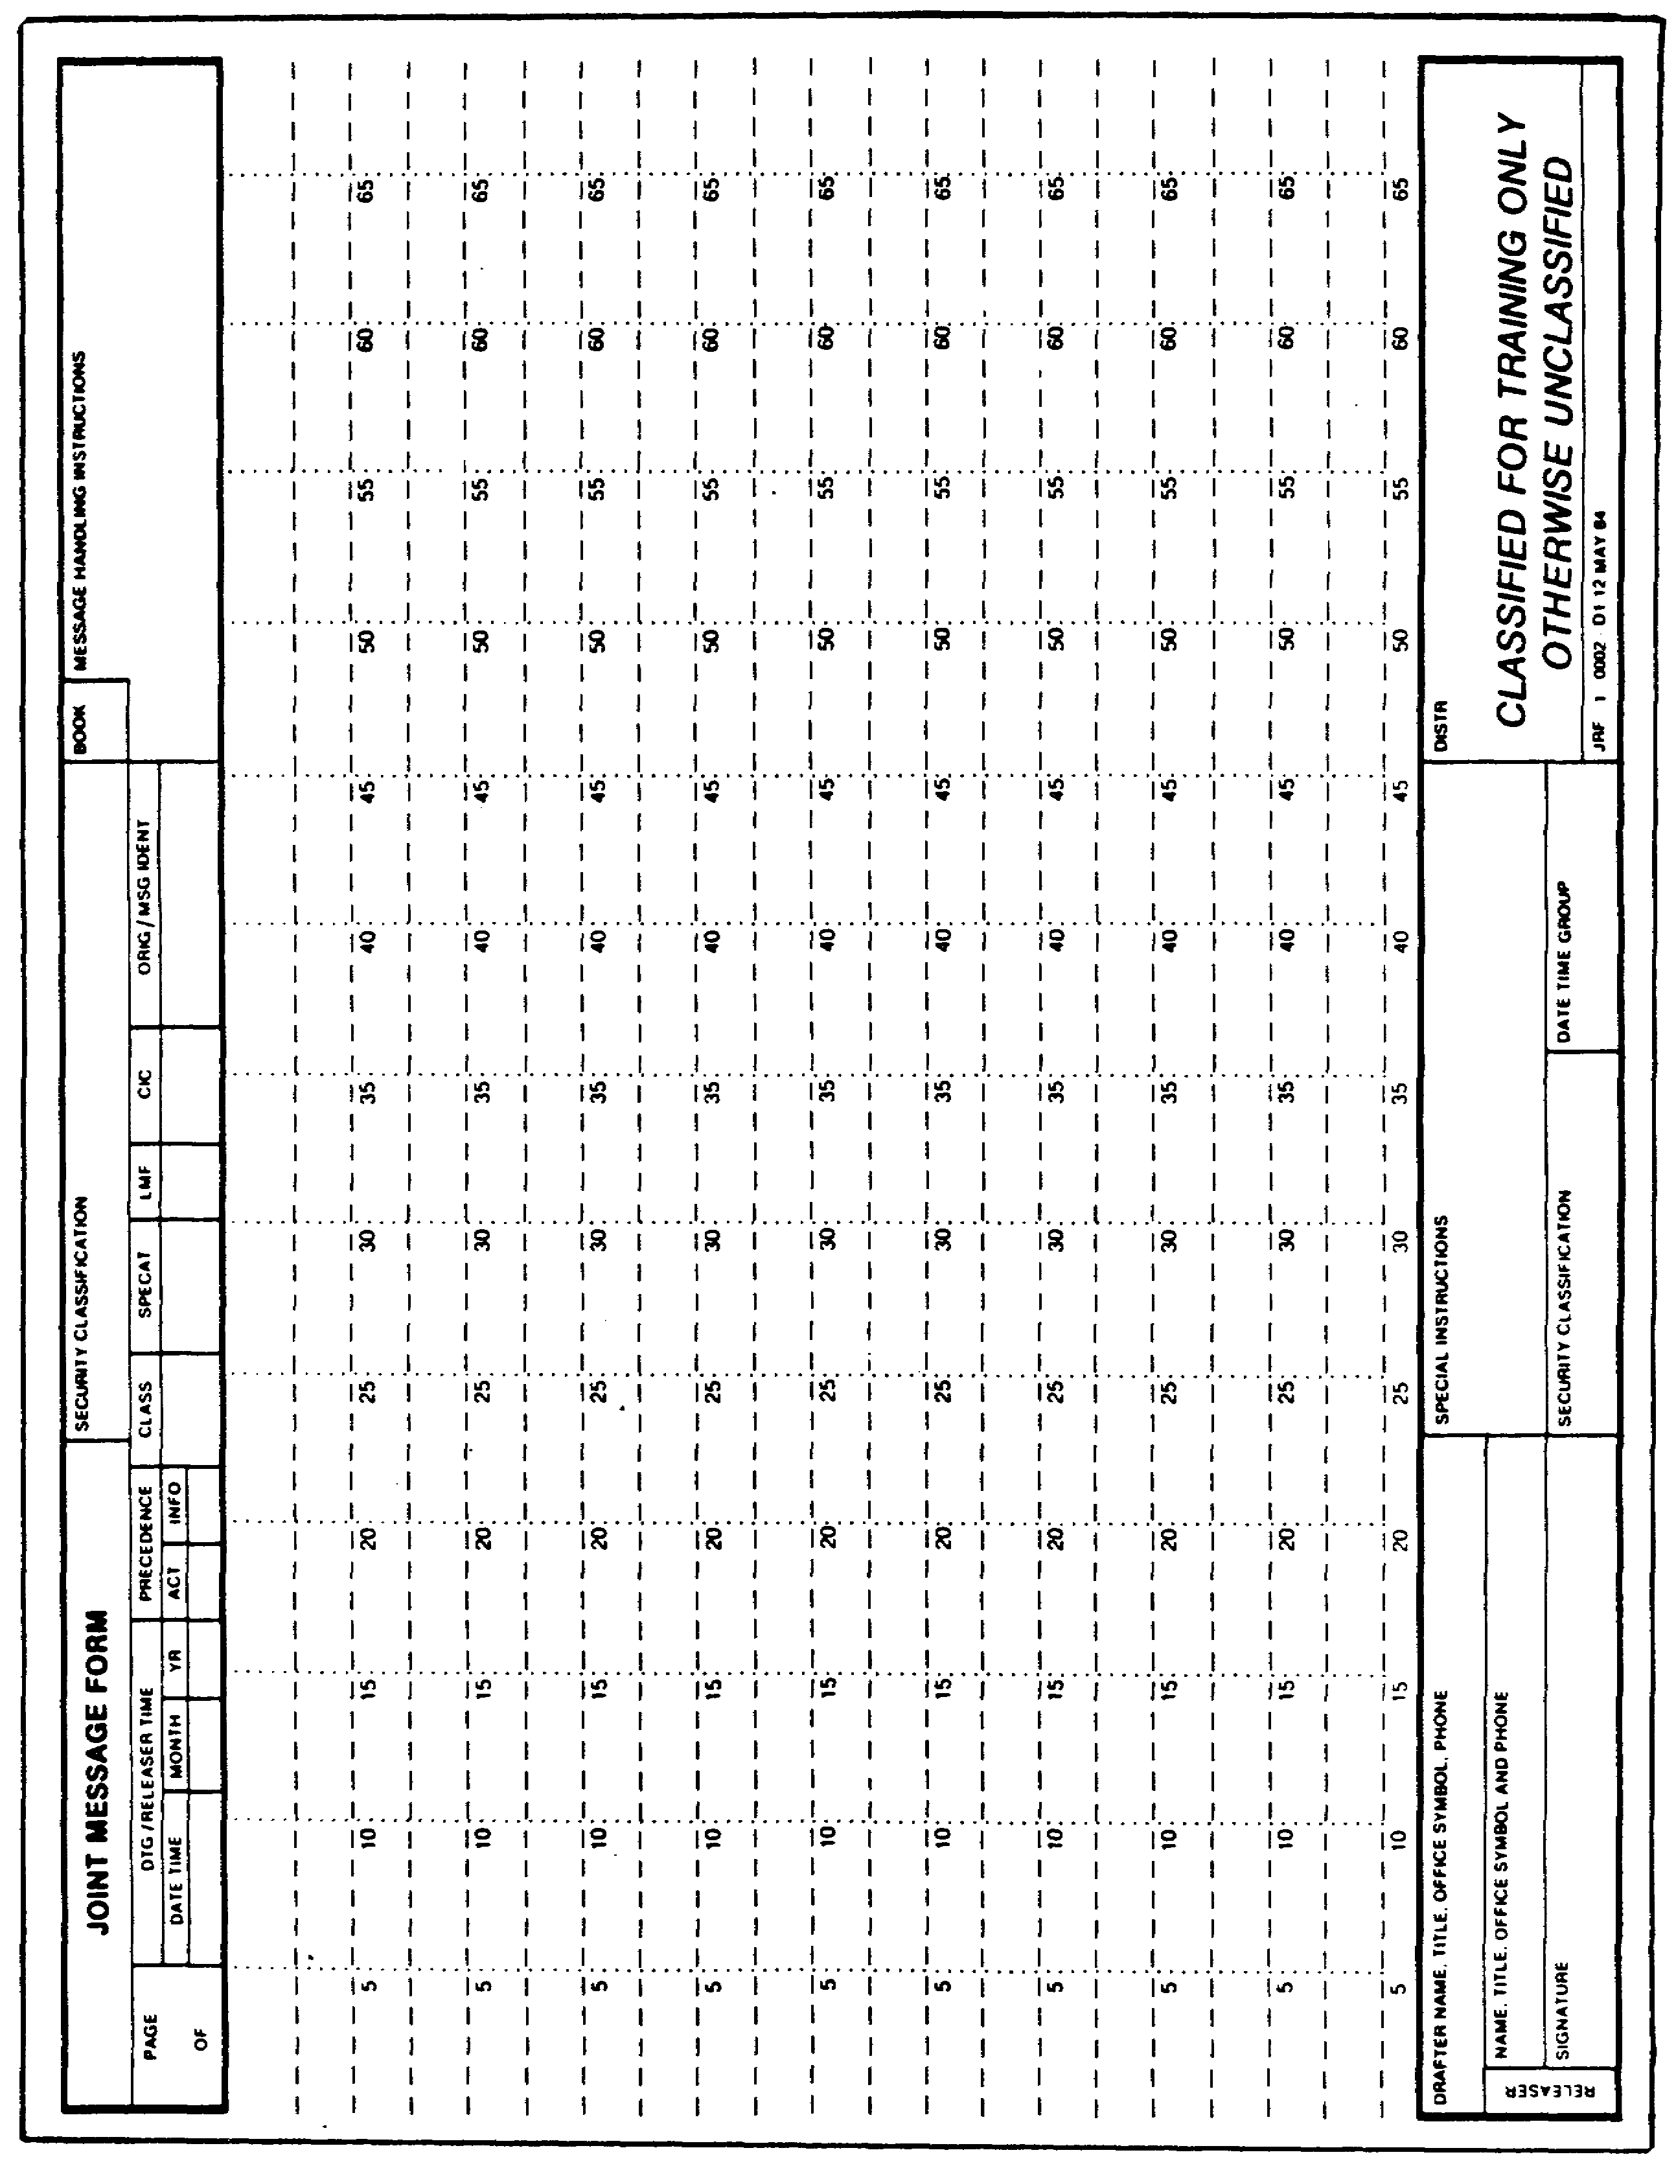

Figure 1-1. JRF-0002 Joint Message Form.

3 IT0667

b. Main features of the DD Form 173 (Figure 1-2) include:

(1) Modified standard DD Form 173 with 69 numbered column.

(2) Must be typed while in garrison.

(3) Comes in optical red or blue ink depending on type of optical character reader (OCR) your comm center has.

(4) You can use all characters in a line.

NOTE: DD Form 173 can be hand printed while in the field.

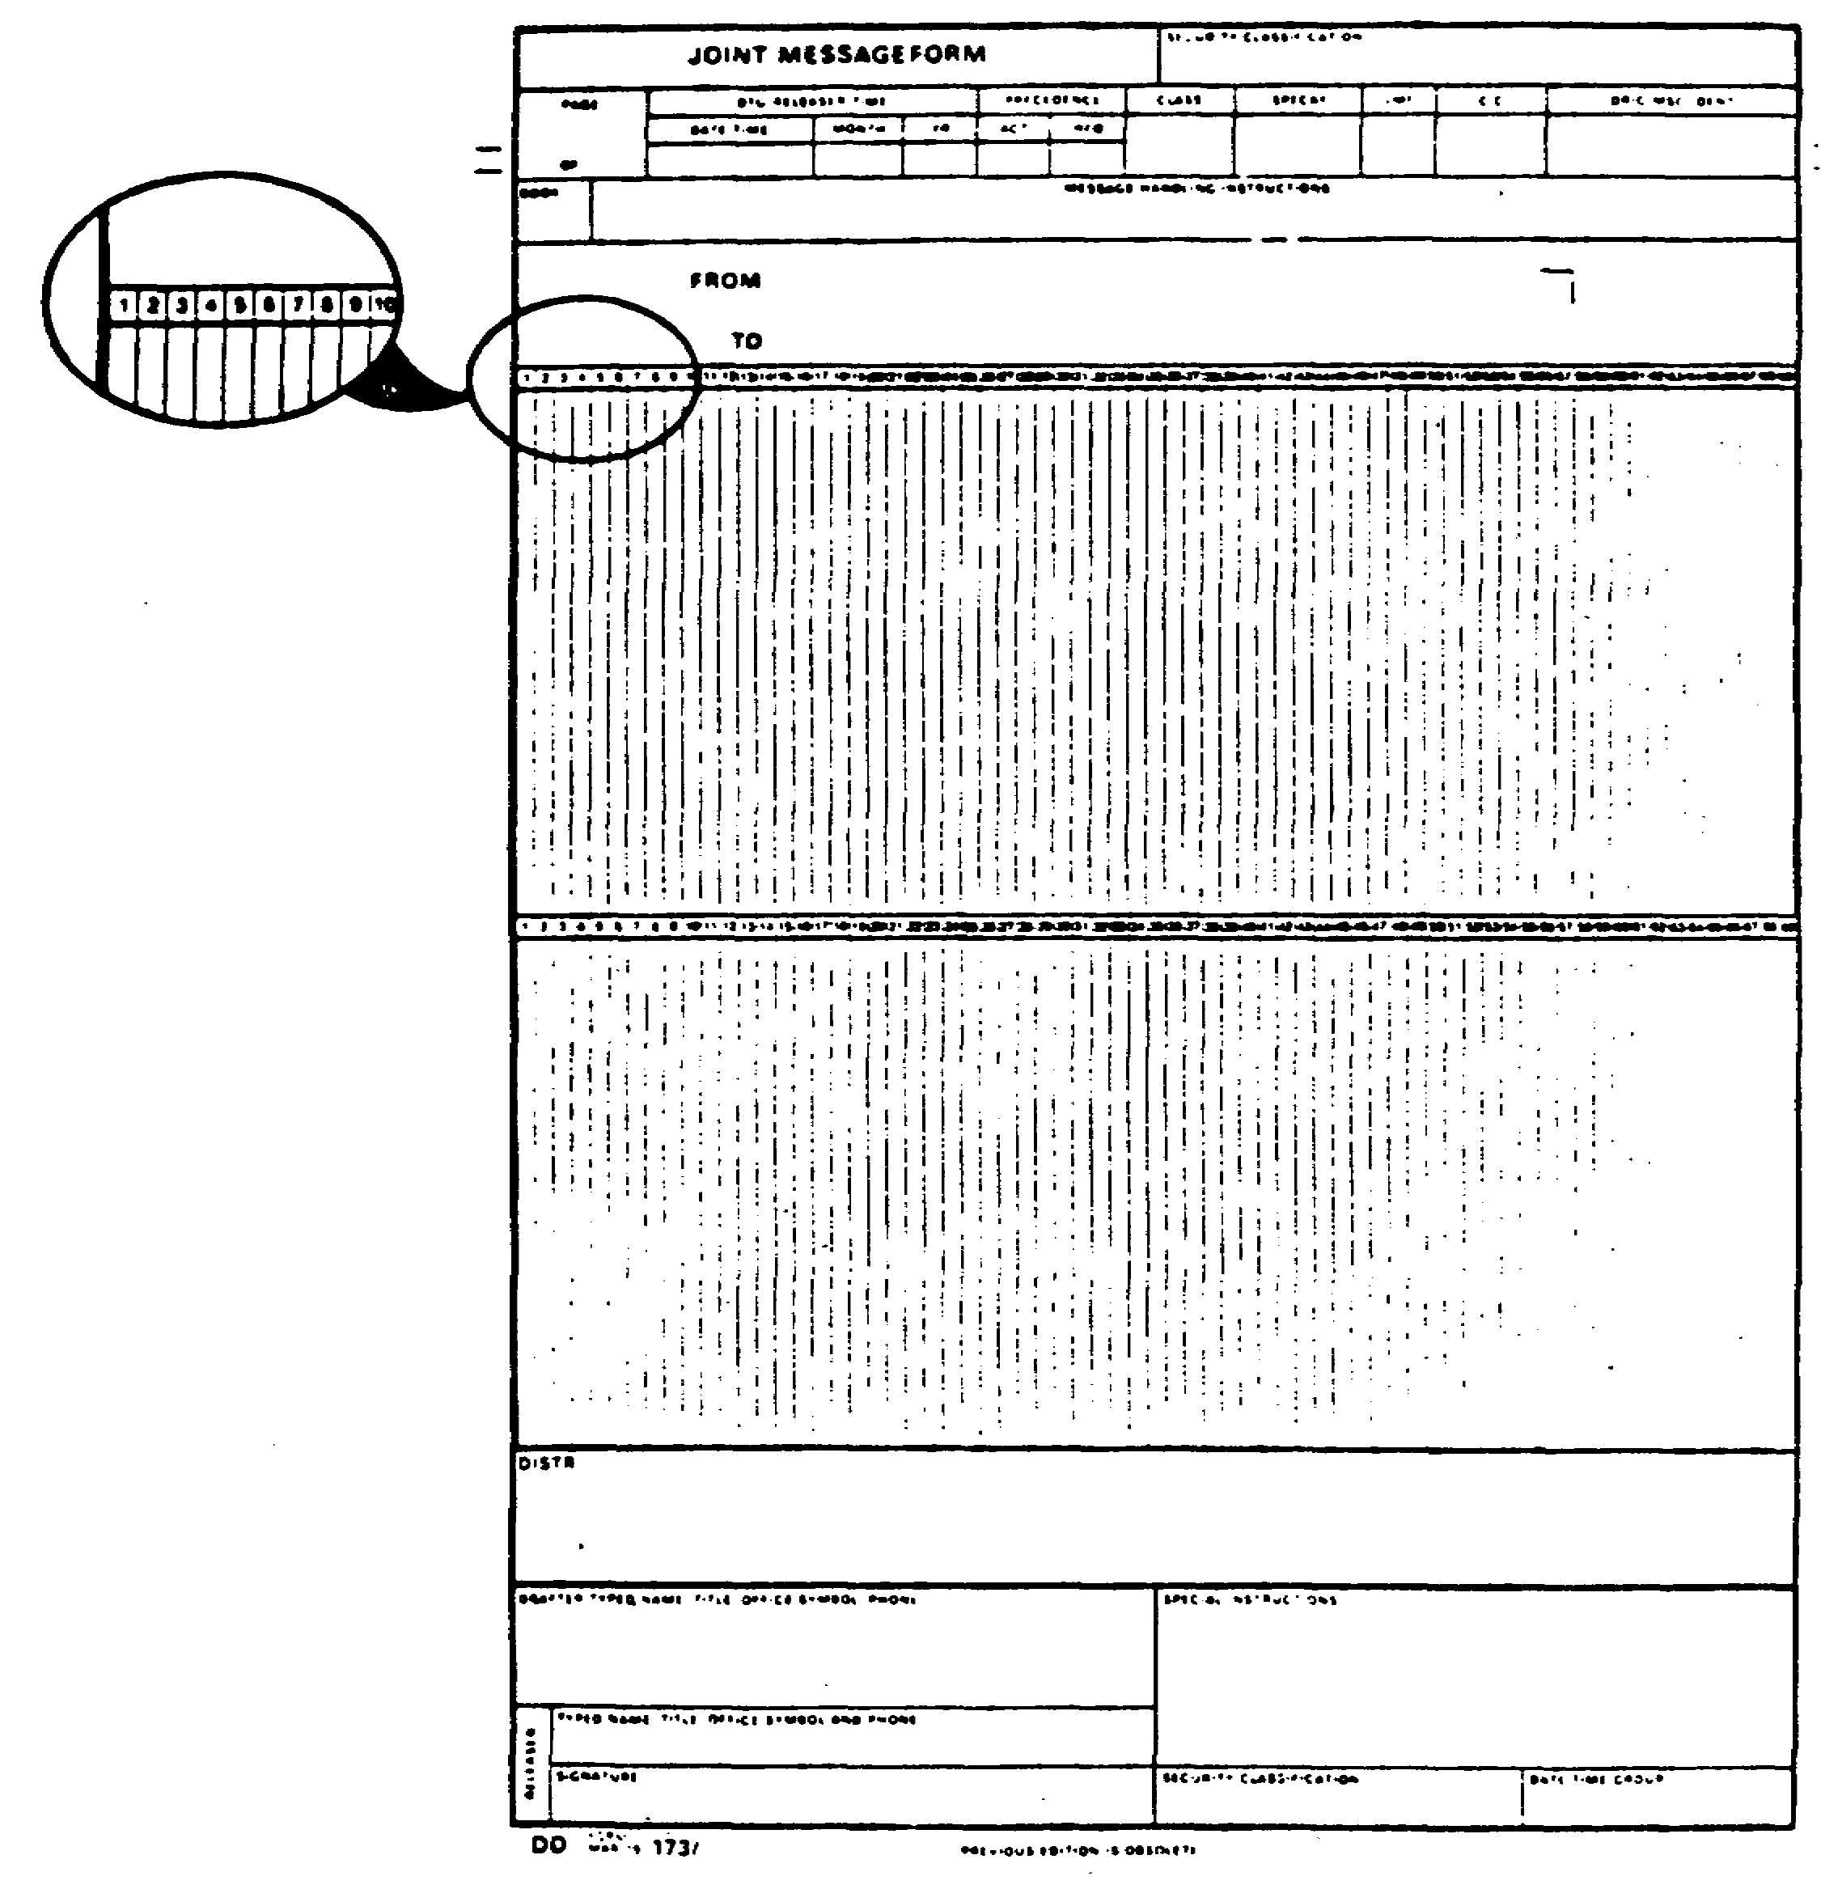

Figure 1-2. Modified DD Form 173.

IT0667 4

PART B: GENERAL US MESSAGE TEXT FORMAT AND INITIAL SETS RULES

1. There are several general message text format and initial sets rules you need to know when writing USMTF messages. The three main parts of the message are the heading, text, and ending.

a. Heading includes the security classification, Date Time Group (DTG) in "Z" (Zulu) time, releaser time, precedence, to, from, info, drafter/releaser information followed by the releaser's signature. Using the JRF-1-0002 in Figure 1-3, follow the instructions for completing the message heading as outlined.

(1) Step 1: Enter the security classification at the top and bottom of the JRF-1-0002 and each continuation JRF-1-0002.

(2) Step 2: Enter the page number. For example: 01 of 01.

(3) Step 3: Enter the (DTG) /Releaser Time.

(a) This column is broken down into three areas: Date and time which must be expressed as the date of the month first, followed by the time and the "Z" time zone indicator. For example: 230500Z.

(b) The month will be expressed by three alphabetical characters, such as JUN for June.

(c) The last entry for the DTG will be the year expressed in two numerical digits, such as 87 for 1987.

(d) A complete DTG is 230500Z JUN 87.

NOTE: A "Z" time conversion chart is located in Appendix D, page 301.

(4) Step 4: Enter the precedence code, which can be found in Appendix B. For training and test purposes, use "RR" for routine. Notice there is an "ACT" (action) and "INFO" (information) column. "ACT" is used for the "TO" addressee and "INFO" for the "INFO" addressee.

(5) Step 5: In this column enter the pertinent abbreviated classification code (Table 1-1).

Table 1-1. Classification Codes.

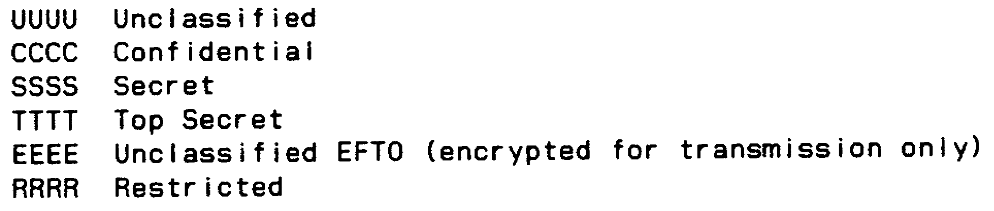

5 IT0667

(6) Step 6: The "SPECAT" (special category), "LMF" (last message furnished), and "CIC" (customer identification code) columns will be used in accordance with local SOP.

(7) Step 7: The "ORIG/MSG IDENT" (originator/message identifier) column will be prepared in accordance with (IAW) local SOP. However, a suggested message is to enter the Julian date (number of days from the first day of year) followed by the drafter time. For example: 1971030.

(8) Step 8: Message handling instructions, such as "SPECAT," "LIMDIS," "PERSONAL FOR," and so on, are completed IAW local SOP. For training purposes disregard this column.

(9) Step 9: The distribution column is used for desired distribution to other staff sections in your headquarters. For training purposes disregard this column.

(10) Step 10: Special instructions column is for information as to who classified the document or which staff coordination is required. For training purposes disregard this column.

(11) Step 11: Enter the drafters and releaser's name, rank, office symbol, and phone number. Additionally, the releaser must sign the message in black ink.

(12) Step 12: The FM addressee will be started on the ninth character of the second line. For example:

CDR 11TH MICO FT HUACHUCA AZ//ATSI-IA//

Remember: Skip the first line of the message form before starting this line.

(13) Step 13: The TO addressee will be started on the ninth character of the third line. For example,

CDR XXTH CORPS FLD LOC//ATAT-G2AIR//
CDR 20TH ARMD DIV/FLD LOC//ATAB-TSO//

Note: There could be more than one addressee and possibly more than one office symbol for each addressee.

(14) Step 14: The "INFO" addressee will be started on the ninth character of the following line. The "INFO" addressee is a party other than the requestor desiring to receive a report.

(15) Step 15: The abbreviated classification will be started on the first character line after the "INFO" or "TO" addressee. There should be a space between each letter of the classifications of confidential and higher. However, there is no space between each letter when the classification is unclassified (Table 1-2). The classification used must be the highest classification used within the message.

IT0667 6

TABLE 1-2. Classification Abbreviations

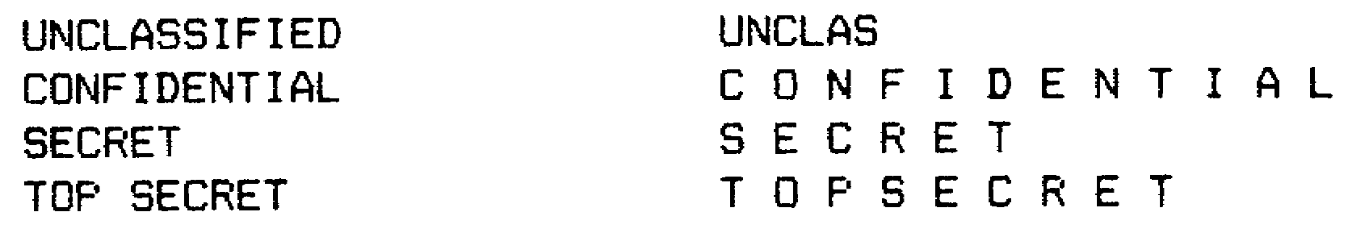

NOTE: The top and bottom portions of all JRF-1-0002 are completed in accordance with the instructions described in steps 2 through 11.

b. Text is the main body of the message which contains all information that is transmitted or received. Message text components include (Figure 1-4):

(1) SET. This is the basic building block of all USMTF messages. It acts a paragraph and carries information about one subject. The set begins with a set name and is continued with field entries. Each set meets one of the following conditions: mandatory, conditional, optional, or repeatable. You find these conditions in the "CAT" column of the message direction Table 1 (Appendix B).

(a) m - The field or set entry is mandatory. If the information is not available, then the field or set should be replaced by a hyphen (-).

(b) c - Conditional. These sets or fields must be filled in if certain conditions are met. In this case if the information is available, it should be presented. If the information is not available, replace the set or field with a (-), unless "UNK." If the field is the last with an entry and no "UNK" follows, then it can be ended with a double slant (//).

(c) o - The field or set is optional. The information in this set or field does not have to be included. However, keep in mind that the IA should be fully aware of the commander's intent before you decide whether the information is pertinent or not. If the information is available, provide it and let the commander decide whether they need it.

(d) r - Means repeatable and applies to fields or sets. This simply means a set or a field could repeat itself. Since all messages are not the same, consult your explanation column for that particular message format.

(2) FIELD entries are the basic building blocks of a set after the set name (identification). It acts like a sentence within a paragraph.

(3) LINEAR SET is just like a normal paragraph in a straight line from left to right.

(4) COLUMNAR SET is a set that contains fields in a columnar formation.

7 IT0667

(5) FREE-TEXT SET. Free text simply indicates the information following the set identifier can be written just as you would be writing a normal sentence or paragraph. The following set identifiers are authorized to use free text:

(a) AMPLIFICATION. Used only if it talks about one other set within the message.

(b) NARRATIVE. Used only if it talks about two or more sets in the message.

(c) REMARKS. Used if it talks about the whole message.

(d) GENERAL TEXT. Used only when the instructions call for it.

NOTE: These Free Text sets are used to report information that does not fit in the other types of sets, or to add details. For more detailed information, consult Appendix A.

(6) SET/FIELD NAME. Sets and fields have names to help you (and the computer) recognize them. These names acts the subject in a sentence. They tell you what the information in the set/field is about. In columnar sets field names are called column headers.

(7) AUTHORIZED ENTRY/AUTHORIZED ENTRY CODE. You must use only authorized entry codes to put information in fields. Chapters 3 and 4 in the JINTACCS (Appendices B and C) contain these codes (or tell you how to get to them). The entries are often abbreviations.

(8) HEADING. Sometimes sets are grouped under headings. This divides the message into several parts. Each part is about one major subject of a message.

c. Ending is simply the end sentence or word of the message. The guidelines on the ending sentences or words are completed IAW your unit SOP.

IT0667 8

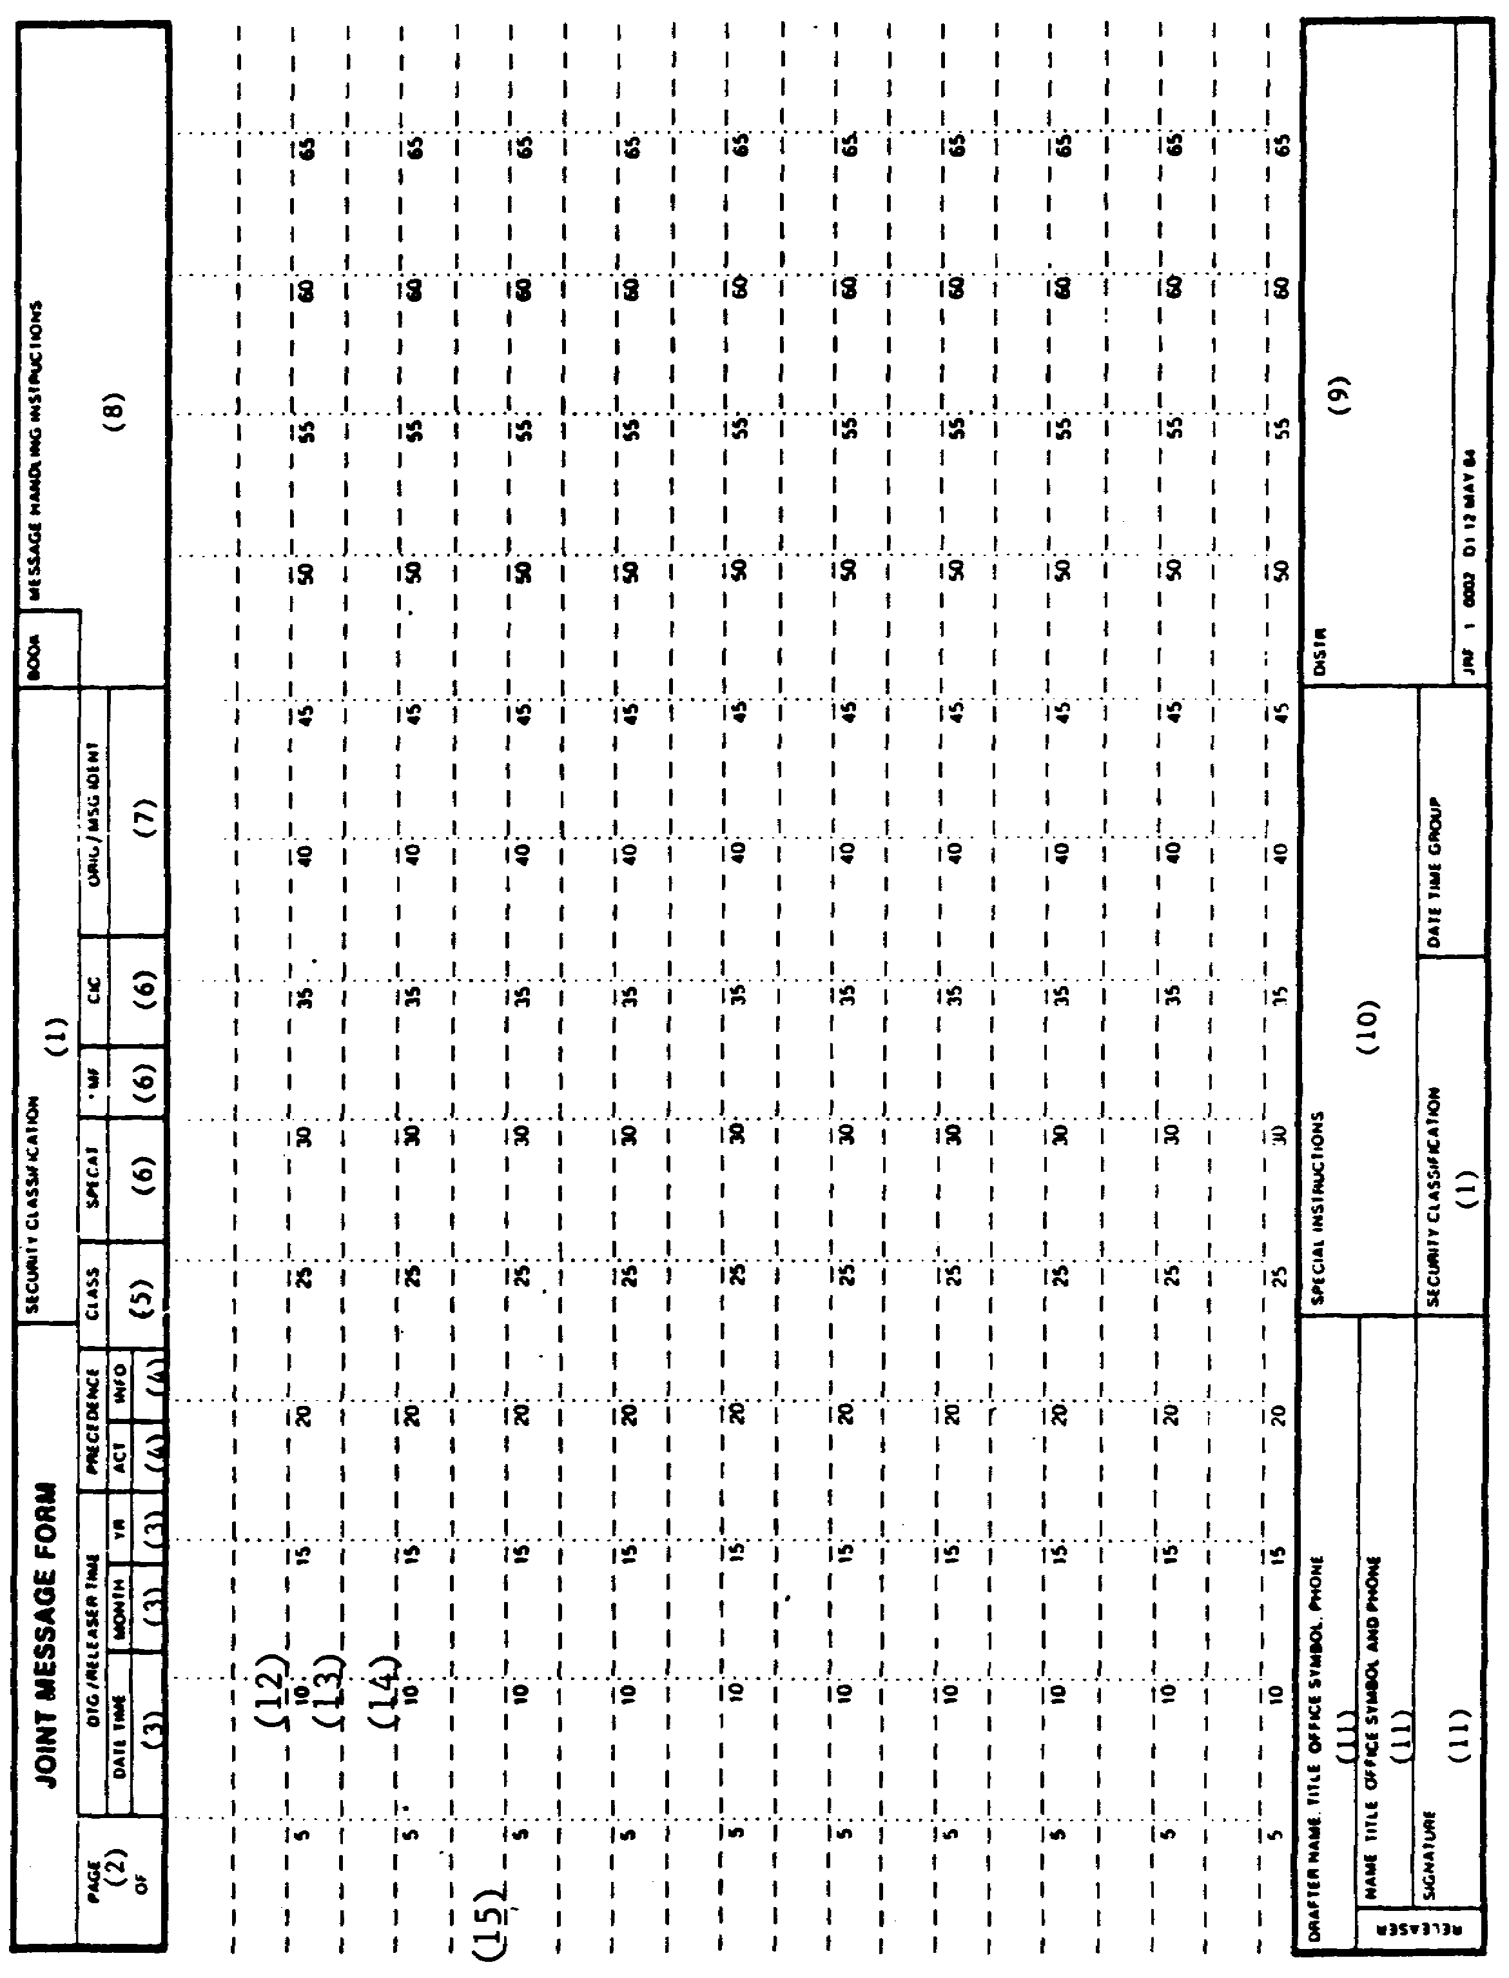

Figure 1-3. JRF-1-0002.

9 IT0667

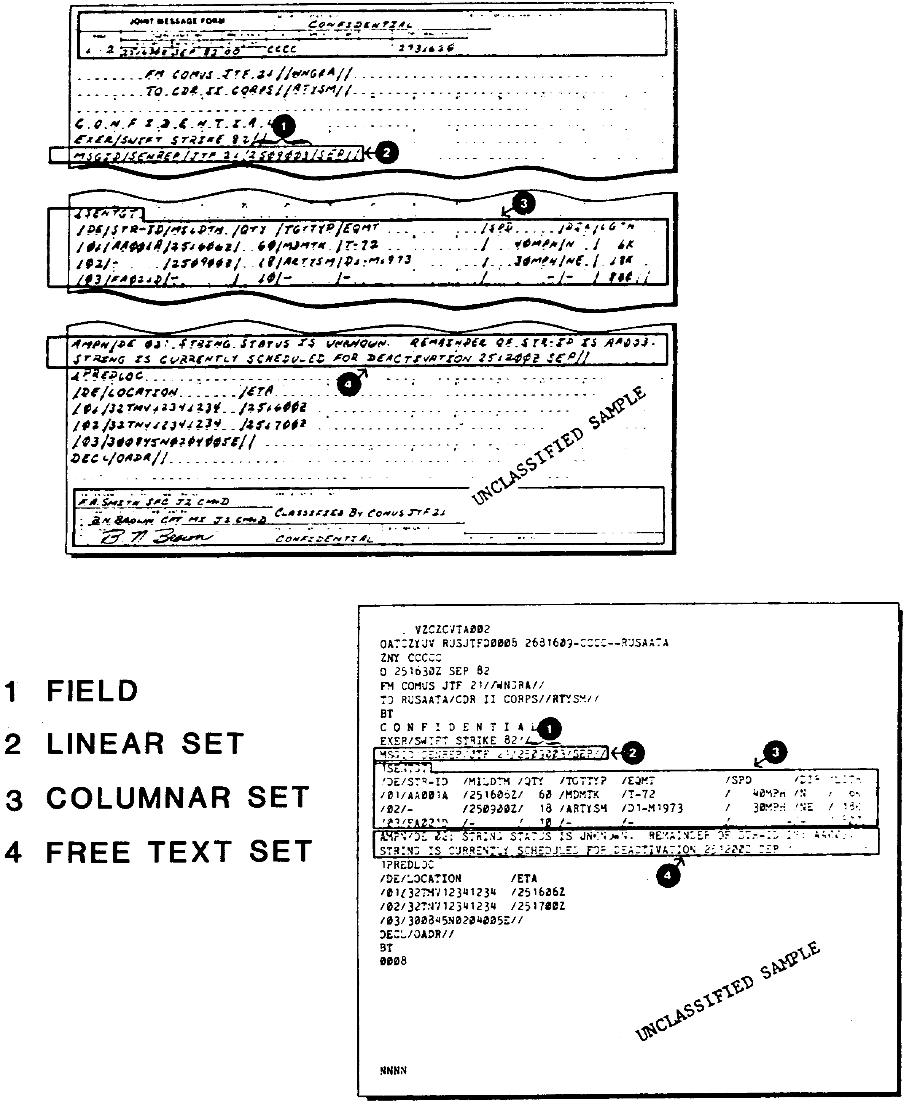

Figure 1-4. Message Text Components.

IT0667 10

2. Appendix A contains the general rules for all USMTF messages. Messages should be written in the English language, using the sentence as the basic structure. Listed below are authorized and unauthorized characters for use in USMTF messages (Tables 1-3 and 1-4).

Table 1-3. Authorized Characters.

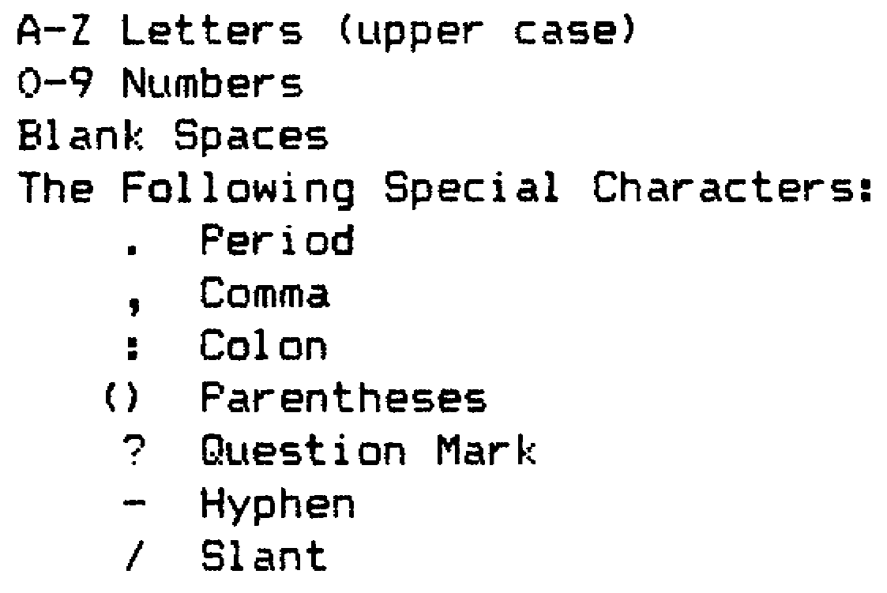

Table 1-4. Unauthorized Characters

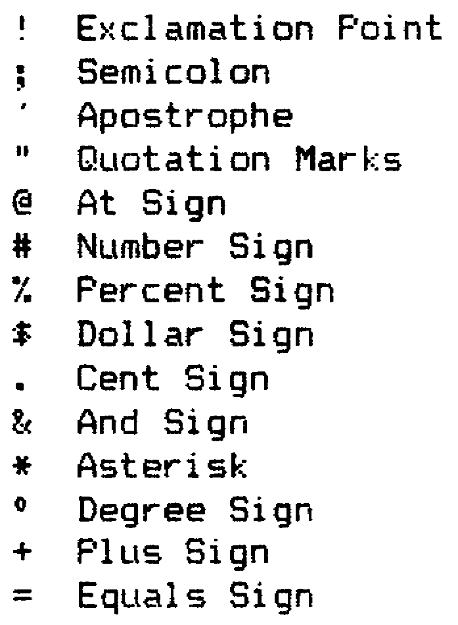

a. The field marker which is used to separate fields is symbolized by a slant "/" character. A double slant is to symbolize a set has ended and that nothing follows. For example: "//."

b. The slant is not authorized to describe equipment such as radio set AN/VRC-46. Instead the correct identification would be: AN-VRC-46. The hyphen (-) replaces the slant character. The hyphen is also used to replace fields which do not contain any information, or fields which are mandatory and no information is available.

NOTE: Fields which use the entry "UNK" cannot be replaced by a hyphen.

11 IT0667

3. Appendix B gives you detailed directions for each message pertaining to imagery analysis reports and requests. The initial sets (Annex 1 to Chapter 3) gives additional instructions for starting every USMTF message. Additionally, it shows you how to read the columns. The "EX" column has a number in it. Match it to the same number on the example and you will find a sample of how to fill in the field.

a. The "SET" name contains the set identifier and within it the "FIELD NAME."

b. The "CAT" is the category of each set and field (m for mandatory, c for conditional, o for optional).

c. Within the "CAT" are also an "s" for SET and an "f" for FIELD.

d. The next column is the "NR OF CHAR" which represents the number of characters for each field or set.

e. The last column is the "EXPLANATION" simply providing details on how to write and read the fields.

NOTE: As you look at the initial set instructions, remember the sets "EXER" and "OPER" are not used together; only one of them will apply. If there is no exercise or operation, then neither will apply and the first set will be "MSGID" (message identification).

4. Authorized entries pertaining to imagery analysis reports and requests are shown in
Appendix C, consisting of authorized security information, UTM/Geographic locations, bearing and range, sensor types, and so on. These are self explanatory and used in USMTF messages. The following reports are extracted from DA Pam 25-7 for use in this subcourse:

INFLIGHTREP Annex 68

RECCEXREP Annex 118

IIR Annex 67

JTACSURVREQ Annex 74

IT0667 12
LESSON 1

PRACTICE EXERCISE 1

The following items test your grasp of the material covered in this lesson. There is only one correct answer to each item. When you have completed the exercise, check your answers with the answer key that follows. If you answer any item incorrectly, study again that part of the lesson which contains the portion involved.

1. How is the ending of a set symbolized in a USMTF message?

A. //

B. /

C. .

D. !

2. What type of set is written like a normal paragraph in a straight line from left to right?

A. Columnar.

B. Heading.

C. Field.

D. Linear.

3. Which is an approved USMTF message DTG/Releaser time?

A. 221800Z.

B. 221800 MAR 87.

C. 121800Z MAR 87

D. 22 MAR 87 2200Z.

4. Which of the following sets applies to message identification?

A. MSG IDENT.

B. MSGID.

C. EXER.

D. OPER.

13 IT0667

LESSON 1

PRACTICE EXERCISE

ANSWER KEY AND FEEDBACK

ITEM CORRECT ANSWER AND FEEDBACK

1. A. The ending of a set is symbolized by "//" in USMTF messages (page 11, para 2a).

2. D. Liner set is written like a normal paragraph in a straight line from left to right (page 7, para (3)).

3. C. 121800Z MAR 87 is the approved USMTF message DTG/releaser time (page 5, para 1a(3)).

4. B. MSGID is the set which applies to message identification (page 12, note).

IT0667 14

LESSON 2

INFLIGHTREP PREPARATION

MOS MANUAL TASK: 301-338-1605
301-338-1606
301-338-3701

OVERVIEW

TASK DESCRIPTION:

In this lesson you will learn how to prepare an INFLIGHTREP in USMTF format.

LEARNING OBJECTIVE:

ACTIONS: Describe the procedures in preparing an INFLIGHTREP in USMTF format.

CONDITIONS: You will be given extracts from DA Pam 25-7, NATO STANAG 3377, NATO STANAG 3596, STP 34-96D1-SM, and STP 34 96D24-TG.

STANDARDS: Prepare an INFLIGHTREP in USMTF format IAW DA Pam 25-7, NATO STANAG 3377, NATO STANAG 3596, STP 34-96D1-SM, and STP 34-96D24-TG.

REFERENCES: The material contained in this lesson was derived from the following publications:

DA Pam 25-7.
NATO STANAG 3377.
NATO STANAG 3596.
STP 34-96D1-SM.
STP 34-96D24-SM-TG.

INTRODUCTION

The INFLIGHTREP is used by pilots or air crews to report mission results or any other tactical information sighted of such importance and urgency that the delay, if reported by normal debriefing, would negate the usefulness of the information. This report has its own unique standard format, which can be modified by each unit to meet particular mission requirements.

15 IT0667

PART A: INFLIGHTREP DESCRIPTION

The INFLIGHTREP is submitted by all units, wings, squadrons, or by the reporting agency. As an IA, you will encounter reports associated with intelligence gathering techniques. Therefore, it is essential to be thoroughly knowledgeable with the formats and their contents. The INFLIGHTREF is reported by the pilot or air crew through secure voice transmission, unless otherwise stated. Due to the urgency of the information, that cannot wait until the normal debriefing, the report is transmitted immediately upon observation of an important target or targets.

PART B: INFLIGHTREP PREPARATION IN USMTF FORMAT

1. Message preparation and interpretation of the INFLIGHTREP is a fairly simple process. This process is outlined in Figure 2-1. Unless otherwise specified or directed, the INFLIGHTREP will contain only 10 items of concern. Only one of the first three items is required (call sign, mission, request); however, any combination is authorized. Additionally, the security classification and the precedence should be underlined.

2. Refer to Figure 2-2 (the completed INFLIGHTREP) and the following instructions on completing the INFLIGHTREP.

a. Line 1: The assigned call sign of the aircraft.

b. Line 2: The mission number of that particular mission.

c. Line 3: Mission request number (extracted from the air reconnaissance request form).

d. Line 4: Target location (For example: "UTM," "GEO" coordinates, bearing and range, and so on).

e. Line 5: Time over target(s)(TOT), expressed by two digits for each the hour and the minutes and one digit for the time zone designator.

f. Line 6: Mission results and/or recommendations.

g. Line 7: Brief description of target(s) or sighting(s).

h. Line 8: Additional information about the target(s) or sighting(s).

i. Line 9: Time of message transmission expressed by two digits for the hour and minutes, followed by the time zone designator.

j. Line 10: Authentication code, as established by Joint Task Force (JTF) or local Standing Operating Procedure (SOP).

IT0667 16

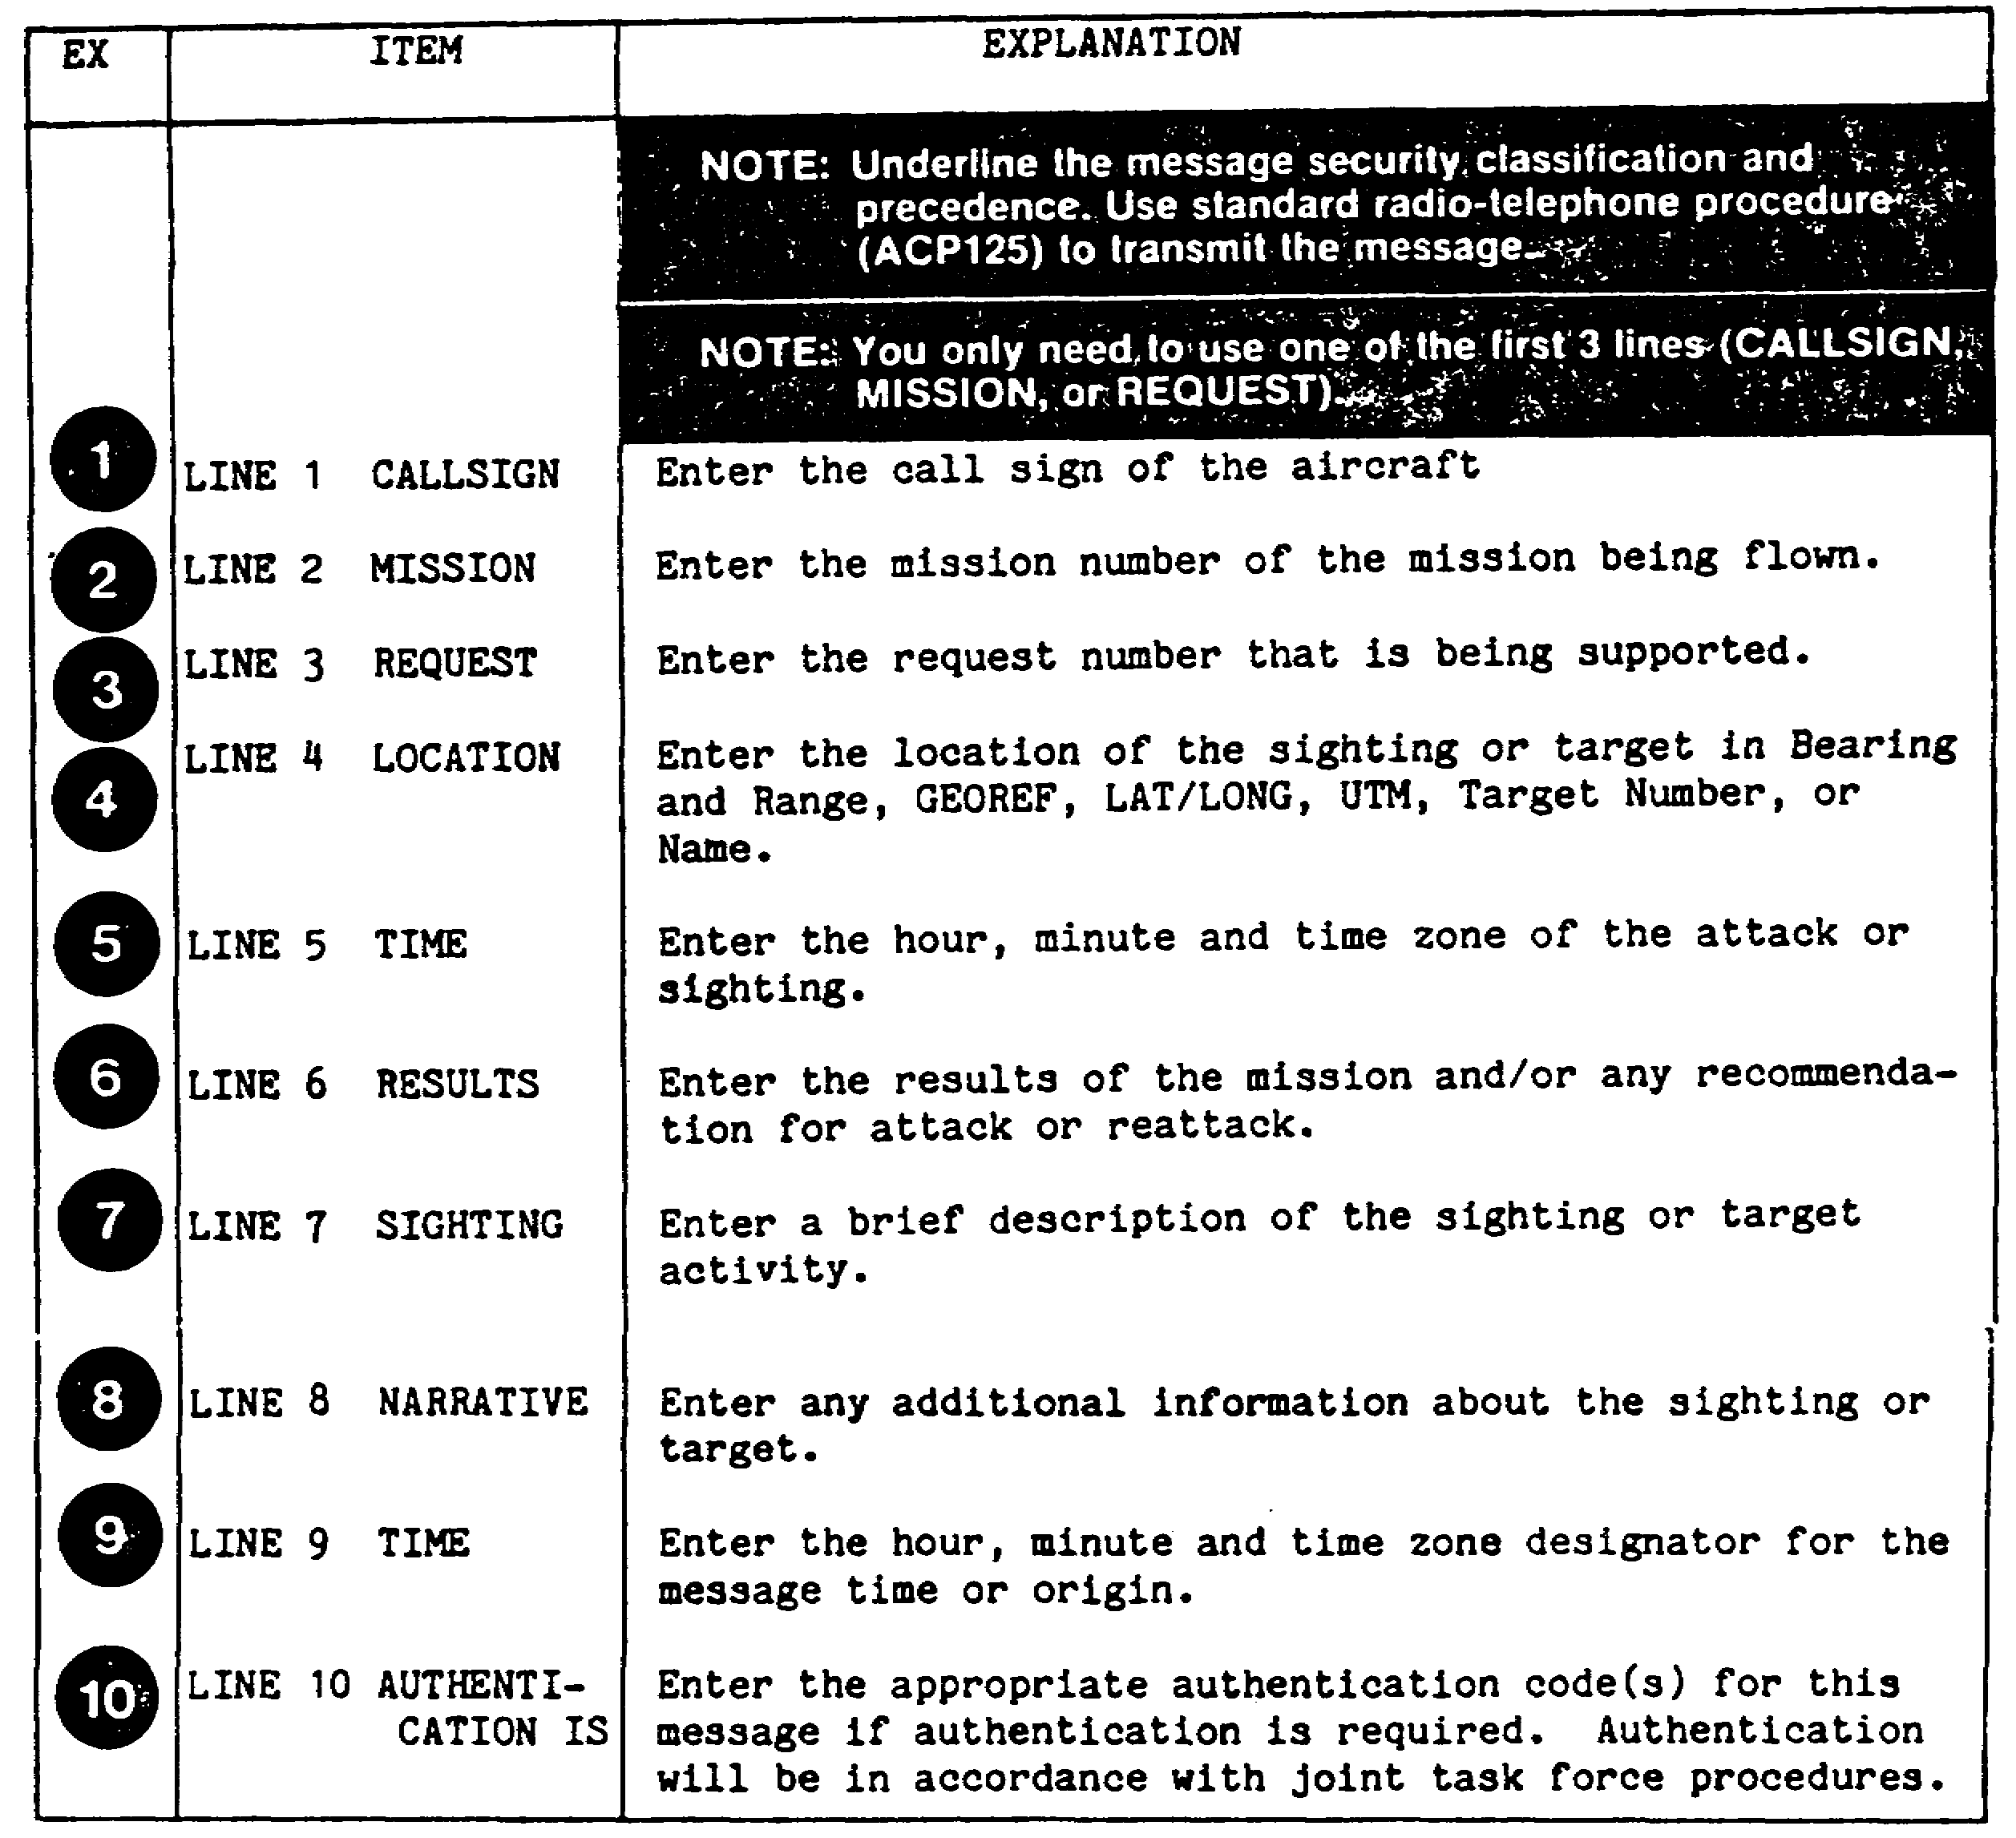

Figure 2-1. INFLIGHTREP Preparation Instructions.

17 IT0667

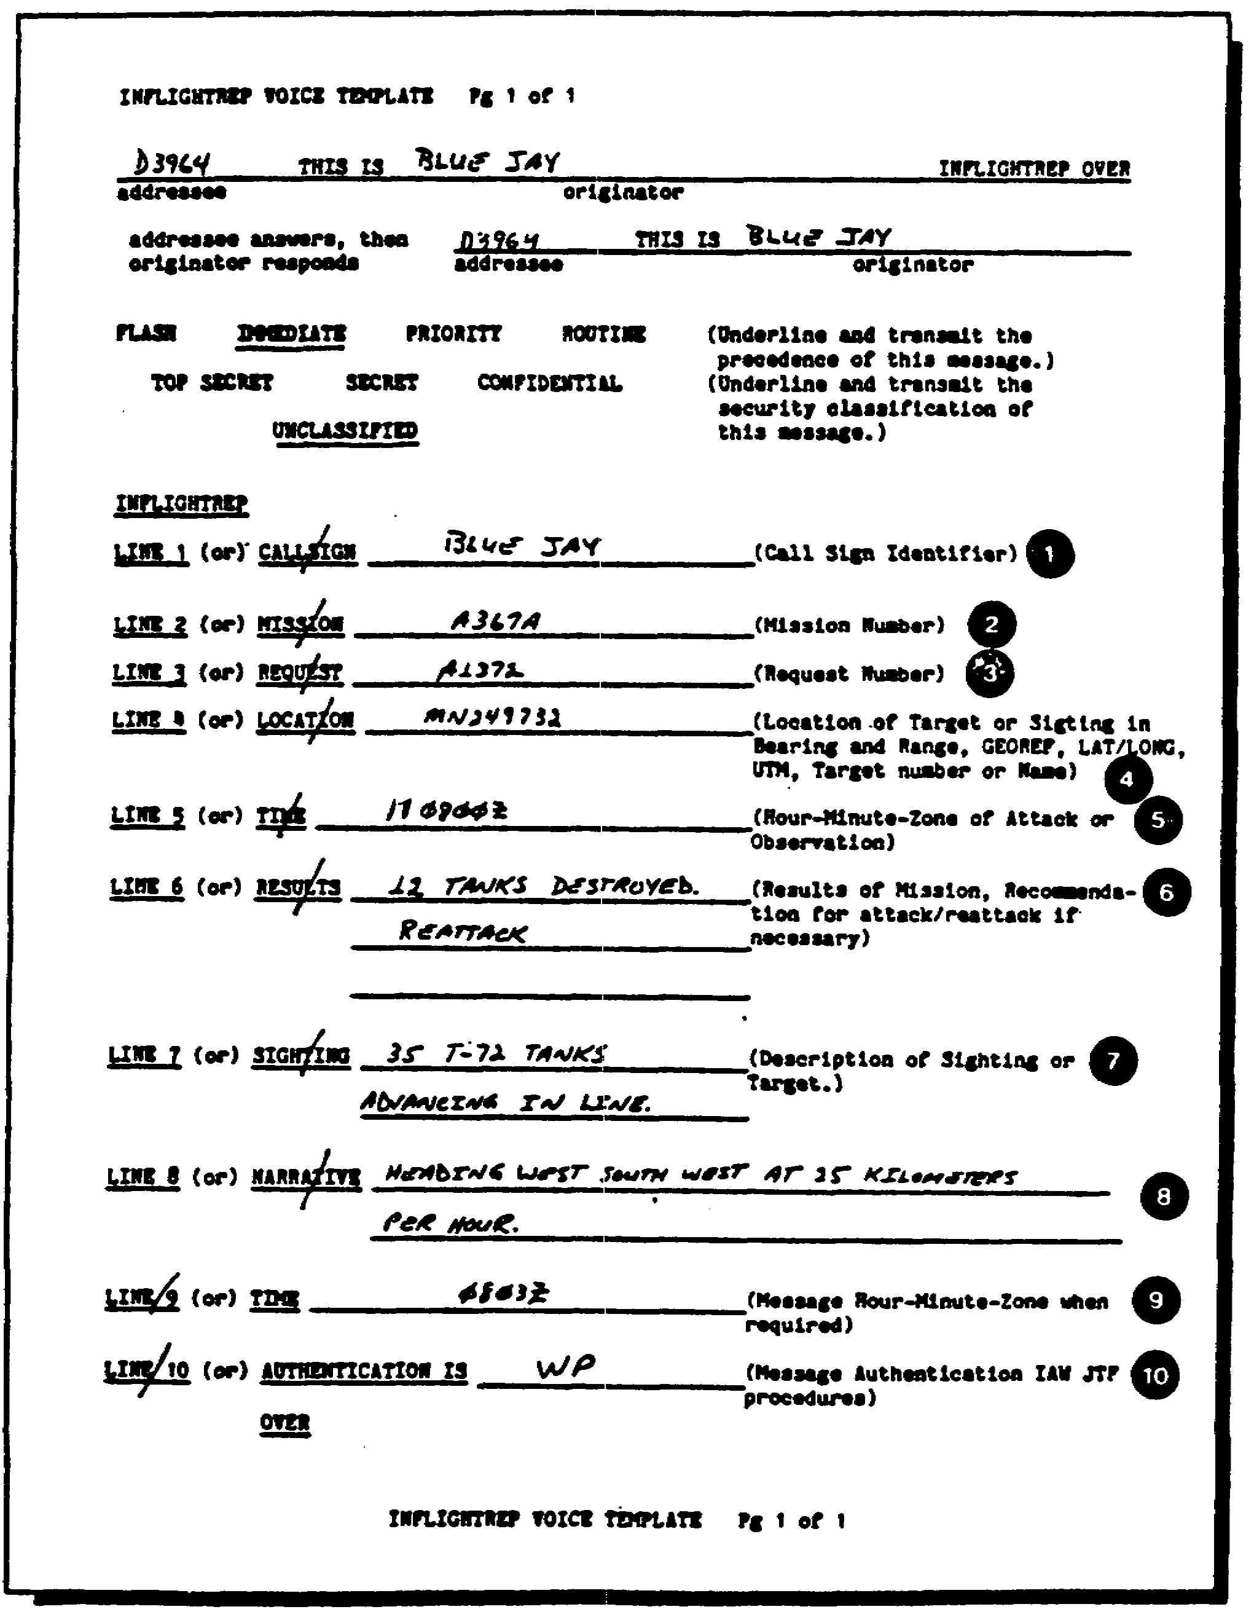

Figure 2-2. Completed INFLIGHTREP.

IT0667 18

LESSON 2

PRACTICE EXERCISE

The following items will test your grasp of the material covered in this lesson. There is only one correct answer to each item. When you have completed the exercise, check your answer with the answer key that follows. If you answer any item incorrectly, study again that part of the lesson which contains the portion involved.

1. In which manner is the precedence and security classification recorded?

A. Stamped.

B. Typed.

C. Underlined.

D. Circled.

2. How many lines of concern does the INFLIGHTREP normally contain?

A. 13.

B. 9.

C. 10.

D. 15.

3. Line 5 of the INFLIGHTREP contains which of the following items?

A. Location in UTM or GEO coordinates.

B. Hour, minute, and time zone.

C. Message time or origin.

D. Sighting.

4. Who will normally initiate an INFLIGHTREP?

A. The IA.

B. NCOIC of the IA section.

C. Receiving station.

D. Pilot.

19 IT0667

LESSON 2

PRACTICE EXERCISE

ANSWER KEY AND FEEDBACK

ITEM CORRECT ANSWER AND FEEDBACK

1. C. The security classification and precedence should be underlined (page 16, part B, para 1).

2. C. Unless otherwise specified or directed, the INFLIGHTREP will contain 10 lines of concern (page 16, part B, para 1).

3. B. Line 5 of the INFLIGHTREP contains the hour, minute, and time zone of the attack on sighting (page 16, para 2e).

4. D. The pilot normally initiates an INFLIGHTREP (page 16, part A).

IT0667 20

LESSON 3

RECCEXREP PREPARATION

MOS Manual Task: 301-338-1606
301-338-3701

OVERVIEW

TASK DESCRIPTION:

In this lesson you will learn the proper procedures in preparing a RECCEXREP in USMTF message format.

LEARNING OBJECTIVES:

ACTIONS: Describe the information and procedures in preparing a RECCEXREP in USMTF message format.

CONDITIONS: You will be given extracts from DA Pam 25-7, NATO STANAG 3377 NATO STANAG 3596, STP 34-96D1-SM, and STP 34-96D24-TG.

STANDARD: Prepare a RECCEXREP in USMTF message format IAW DA Pam 25-7, NATO STANAG 3377, NATO STANAG 3596, STP 34-96D1-SM, and STP 34-96D24-TG.

REFERENCES: The material in this lesson was derived form the following publications:

DA Pam 25-7.
NATO STANAG 3377.
NATO STANAG 3596.
STP 34-96D1-SM.
STP 34-96D24-TG.

INTRODUCTION

The RECCEXREP is the very first report prepared by an Imagery Analyst (IA). Preparation of a RECCEXREP is a detailed process involving numerous options to the message content. It is important that you as an IA understand this process to prevent delays in reporting time or processing of invalid information.

21 IT0667

PART A: RECCEXREP DESCRIPTION

1. As previously stated, the RECCEXREP is the first intelligence report submitted by IA. It is used to provide an abbreviated imagery intelligence report to the requester and is based on electro-optical, photo, infrared, and radar imagery. The information contained within the RECCEXREP is time sensitive, necessitating a time limit of 45 minutes after engine shutdown (ESD). This time limit includes interpretation of imagery, preparation and transmission of the report. A RECCEXREP could be preceded by an INFLIGHTREP.

NOTE: Mission results derived from radar imagery were formerly reported by RADAREXREP; however, when using the USMTF format all radar mission results are included in the RECCEXREP.

2. The intelligence compiled in a RECCEXREP will be submitted to the requesting unit G2 Air at echelons above corps (EAC) at corps, and the Tactical Surveillance Officer (TSO) at Division, who in turn will submit it to their respective collection management and dissemination (CM&D) section/all-source analysis section (ASPS) for processing and answering the commander's priority intelligence requirements (PIR) /information requirements (IR). This will enable the commander to predict enemy activity and/or best utilize his assets in the successful accomplishment of the mission.

PART B: RECCEXREP PREPARATION IN USMTF MESSAGE FORMAT

1. Preparation of a RECCEXREP is a detailed process, which involves numerous options of message content. DA Pam 25-7 authorizes tailoring of message content to best suit your unit's needs or missions. General information, message map, and entry lists for the RECCEXREP is shown in Appendices A -C.

NOTE: Refer to Appendix B for specific instructions in completing the RECCEXREP.

2. Once the heading is completed on the JRF Form-1-0002, to including the FROM, TO, INFO, and classification lines, the text will be worked. Follow the example in Figure 3-1 and the steps outlined in the following pages on completing a RECCEXREP.

a. The first set of the text is the '"Exercise" or the "Operation" set. As indicated in the JUH-MTF Manual only one of these sets will be used. Both set names cannot be used together. Additionally, these sets will be used only if there is actually an exercise or an operation in play. There will be situations where neither will apply, therefore, neither will be used.

(1) The exercise set will be started on the first character on the next line down from the classification with the letters "EXER" in capital letters. This set as indicated by the category column is a

IT0667 22

conditional set; however, if the information is provided, it should be transmitted in the report. Within the set there are two fields.

(a) The first field name or entry after "EXER" is the "exercise name." This field is mandatory.

(b) The second field entry after "EXER" is the additional identifier which is optional, again, if there is one it should be used.

(c) Following are examples of exercise sets:

EXER/JACK FROST/JACK SNOW//
EXER/JACK FROST/-//
EXER/-/-//
EXER/-//

(2) An operation set could be used in place of the exercise set. The operation set starts with the acronym "OPER," in capital letters and also starts on the first character on the next line down from the classification. Remember: Both the exercise and operation set cannot be used together.

(a) The first mandatory field entry after "OPER" follows which is the "name of the operation."

(b) The second optional field entry within this set is the "name of the headquarters" originating the plan and the plan number.

(c) The third optional field entry is the "option name," if one is provided by your local unit.

(d) The fourth optional field entry is the "second option name," if one is provided.

(e) Following are examples of operation sets:

OPER/GALACTICA BOOST/HQ, 101ST MI BN/MOON BOOST/-//
OPER/-/HQ, 191ST Ml BN/MOON BOOST/-//
OPER/-/HQ, 191ST Ml BN/-/-//
OPER/-/HQ, 191ST MI BN//

NOTE: You should consult the "CAT" columns of Appendix B to determine if the entries are mandatory (m), conditional (c), optional (o), and/or repeatable (r). You should check these columns for each entry to determine if it must be used.

b. The second set is the message identification "MSGID" set. This mandatory set will provide specifics about the message. The set entry is the set identification "MSGID" in capital letters.

23 IT0667

(1) The first field entry after "MSGID" is the title "RECCEXREP."
This entry is mandatory and is further cited in the explanation column.

(2) The second field entry is the "originator" of the message, which normally is your unit. This entry will be expressed, such as, CO B, 3RD MI BN, using unit abbreviations. Number of characters is limited to 20. This entry is also mandatory.

(3) The third field entry is the "serial number" assigned to the message. If a serial number is not assigned to the message, refer to initial sets (Appendix B) for guidance on how to assign a serial number. Numbers such as two digits are used for the day, two for the month, and three for the message number. This is an optional entry. For example: 2205001.

(4) The fourth field entry is the "month" of the message, expressed by three alpha characters such as AUG (optional entry).

(5) The fifth field entry is the "qualifier," expressed by three alpha characters. For example: AMP (amplifies basic message).

(6) The sixth field entry is the "qualifier serial number," expressed by up to three numeric characters. See initial sets for further guidance (Appendix B).

(7) Following are examples of "MSGID" sets:

MSGID/RECCEXREP/CO B, 3D Ml BN/2205001/MAY/AMP/001//
MSGID/RECCEXREP/CO B, 3D MI BN/2205001/MAY/-/-//
MSGID/RECCEXREP/CO B, 3D Ml BN/1105001/MAY//

c. The third set is the "REFERENCE" set. This set is used to reference other messages. If there are no messages to reference, then this set will not be used. It should be noted that this set is an optional and repeatable set, in the event there are more than one message to reference. The first entry is the set identification "REF."

(1) The first field entry after the set identification REF is one alpha character such as "A." These alpha characters are assigned to referenced messages in sequence of "A" representing the first referenced message, "B" representing the second message, and so on (mandatory).

(2) The second field entry is the "message title" or "reference type" (mandatory entry). If the message title is used, it should be extracted from the USMTF message titles. If a reference type is used, consult your initial sets for authorized acronyms such as LTR (letter) or RII (reconnaissance-image interpretation), and so on.

(3) The third field entry of the reference set is the "originator" (mandatory). In this field the name of the unit that originated the message referenced, such as CO A, 3D MI BN.

IT0667 24

(4) The fourth field entry is the "DTG" of the referenced message (mandatory entry). For example: 220733MAY88.

(5) The fifth field entry is the "serial number" of the referenced message, such as 1505002 (optional entry).

(6) The sixth field entry is the "special note" of the message (optional entry). The entry here will either be "PASEP" (meaning reference was or will be passed separately) or "NOTAL" (meaning reference was not and will not be passed to all addressees of this message).

(7) The seventh (last) field entry is the "nasis" code, which applies for NATO use only. For training and test purposes, we will not use this field entry.

(8) Following is a completed REFERENCE set:

REF/A/LTR/CO A, 3D MI BN/220733ZMAY87/150500Z/PASEP/-//

d. The fourth set, which is conditional, is used to explain the "reference" if it is not a USMTF message. Free text will be used following the set identification "AMPN." Since all our messages for training and test purposes are based on the JUH-MTF, this set will not be used.

e. The fifth set, which is conditional, is used to explain the "reference" if it is not a USMTF message. Free text will be used following the set identification "NARR." Since all our messages for training and test purposes are based on the JUH-MTF, this set will not be used.

f. The sixth set is used for the mission identification set and is called "MISSNID." This is a mandatory set. Using a new line, the set will start with "MISSNID" in capital letters (4).

(1) The first field entry after the set identification "MISSNID" is the "type of mission" that was flown, such as REC (RECONNAISSANCE), SLAR (SIDE LOOKING AIRBORNE RADAR), IMAGE (IMAGERY), and so on. See Appendix C, entry list 107A (page 239).

(2) The second field entry is the "name of the unit" or the agency that requested the mission. For example: 2D INF BDE.

(3) The third field entry is the "serial number," that the unit assigned to the request (if applicable). For example: 359.

(4) The fourth field entry is the two letter "project identifier code," IAW DIAM 57-5-1. Often these codes are combined with the mission number such as mission CH-002 (CH is the project code identifier). If more than one mission was used, enter "MI," to indicate mission independent.

25 IT0667

(5) The fifth field entry is the "mission number," just as previously mentioned in field entry number four, mission CH-002. Mission numbers are normally from 001-999.

(6) The sixth field entry indicates the "mission date" expressed with two digits for the year, month, and the date in that sequence. For example: 870522.

(7) Following is an example of a MISSNID set:

MISSNID/REC/2D INF BDE/359'/CH-002/870522//

g. The seventh set is the "ITEM" set. This set talks about the particular subject or object of concern. This set is a mandatory and repeatable set, which can be used to report more than one target. This set starts with the word "ITEM" which is capitalized.

(1) The first field entry after "ITEM" is the item number. For example: the first item is 001, the second item is 002, and so on.

(2) The second field entry is the "target name," expressed IAW Basic Encyclopedia (BE) installation name. If the BE name is not available, make up one that will include the place name and a special feature or function (IAW DDM 2600-312-80).

NOTE: For training and test purposes we will not use the BE; however, we will make up a name such as TANK, FIRING RANGE, MISSILE SITE.

(3) The third field entry is the "category code." The category code list is found in Appendix C, entry list 1218. These codes will be expressed as five numerical digits such as 00001 (Airfield), 00002 (missile systems), 00003 (electronic installations), and so on. Since this field starts with "CAT," this entry will also be recorded on your JRF-1-0002, followed by the colon, then the appropriate category code.

(4) The fourth field entry is the "country." Appendix C, entry list number 59, has a list of authorized country codes. Enter "CTY: " and the country code. For example: "IZ" for Iraq. The last field entry on this line identifies if the report is a national tasking or not. Enter "Y" for yes or "N" for no.

(5) Following is an example of a complete set for the "ITEM" line:

ITEM/001/CONVOY/-/CAT:00006/CTY:US/N//

NOTE: The "ITEM" line may run over one or two lines.

h. The eighth set is for the "location information." This mandatory set starts with the set identifier "LOC," in capital letters.

IT0667 26

(1) The first field entry after "LOC" is the geographical location expressed in latitude and longitude and in degrees, minutes, and seconds (Appendix C, entry list 11). Since GEO: is capitalized, it will be first entered in the field, followed by the entry. For example:
GEO: 310912N213345W.

(2) The second field entry are the "UTM" coordinates. Since UTM is capitalized, this would be the first entry, followed by the numerical coordinates (Appendix C, entry list 11). For example: UTM: 41STW32414135.

(3) Following are examples of completed location sets:

LOC/GEO: 310921 N213345W/UTM:41STW32414135//
LOC/-/UTM:41STW32414135//
LOC/GEO:310921N213345W//

i. The ninth set is the "Time over Target" (TOT) information set. This mandatory set begins by its identification of "TOT" and is expressed in Zulu "Z" time.

(1) The first field entry after the set identification "TOT" is the TOT expressed-with two digits for the day, hour, and minute, followed by the time zone designator. For example: 221525Z.

(2) The second field entry is the "time the camera was turned on over the target." For example: 221525Z.

(3) The third field entry is the "time the camera was turned off" over the target. For example: 221545Z.

(4) Following is complete TOT information set:

TOT/221525Z/221525Z/221545Z//

j. The 10th set is the "Narrative" portion. This mandatory set is used to report target status, mission results, target description or remarks, OB information, and so on. This will also include whether the essential elements of information (EEI) /PIR were satisfied or not and if a follow on report is required. Free Text is used after the set identification of "NARR." Following is an example of this set:

NARR/EEI MET. TGT IS NOT STATIONARY, BUT MOVING NW ALONG DIRT ROAD FOLLOW ON RPT IS NOT REQUIRED//

k. The 11th set is the "Target Weather Indicator" (TARWI) set. "TARWI" is obtained from the debriefing form. This information is normally encoded, which pilots/air crews and the debriefer are familiar with (Appendix C, entry list 45C shows the decoding/encoding process). This information is all related to general weather conditions. Since all this information is given, it is a fairly simple process. The set is optional and starts with the set identifier of "TARWI."

27 IT0667

(1) The first field entry after the set identification "TARWI" is the "low cloud cover," expressed by one numerical character.

(2) The second field entry is the "low cloud base height," which is also expressed by one numerical character.

(3) The third field entry is the "surface visibility," this is also expressed by one numerical character.

(4) The fourth field entry is the "weather conditions." This field is used for the major weather conditions, expressed by one numerical character.

(5) The fifth field entry is used for "weather remarks," using one alpha character.

(6) Following is an example of a "TARWI" set:

TARWI/0/0/8/1/X//

NOTE: All fields within the "TARWI" set are mandatory.

1. The 12th set is the "Imagery Data" set. This set is optional and starts with the acronym "IMDAT."

(1) The first field entry after the identification "IMDAT" is used to indicate what "type of imagery" was used, such as IR (infrared), (EO) electro-optical, FL (forward-looking radar), and so on. These will be encoded with their authorized abbreviations using two alpha characters, found in Appendix B.

(2) The second field entry is the sensor position (Appendix C, entry list 564). Up to four alpha or numerical characters are authorized.

(3) The third field entry is the "image number(s) " used to reference the particular target(s). The first image separate from group images, indicates the best frame or frames. Following that, will be a group of images. For example: 310, 301-.315. In this example 310 is the best of the images and 301-315 is a group of images.

(4) The fourth field entry is the "National Imagery Interpretability Rating" Scale (NIIRS) rating of the imagery. In this field, NIIRS is entered, as two numerical characters. It will be shown, with the authorized code, using one alpha character ranging from "00" (useless for interpretation due to cloud cover, poor resolution) to "09" (minimum ground resolved distance is less than 10 centimeters).

(5) The fifth field entry is the "scale size." The scale of the imagery is expressed by up to two alpha characters, as authorized in the field entry explanation column (Appendix B). For example: M (scale 1:10,000 to 1:29,999).

IT0667 28

(6) The sixth field entry is the "percentage of coverage" of the target. In this case, the percentage will be entered, using up to three numeric characters. For example: 50 percent would be indicated as so.

NOTE: Do not use the percentage symbol since it is an unauthorized symbol.

(7) The seventh field entry is the "Weather." This field is used only if the TARWI set was not used earlier. The major weather condition should be reported using the authorized codes, with only two alpha characters (Appendix B). For example: CL (clear).

(8) The eighth field entry is "Other Weather." This is used to mention other weather conditions which had an effect on the imagery over the target(s). This will be expressed with two alpha characters, as authorized in Appendix B, such as SH (shadow).

(9) An example of a completed imagery data line is as follows:

IMDAT/FR/HPAN/310, 301-315/05/VL/90/-/SH//

m. The 13th set is conditional and used only if this message is classified. For an unclassified message, the previous set would have been the last set. If the message is classified, this set is used to enter declassification or downgrading instructions as indicated in Appendix C RECCEXREP.

(1) This set will start with "DECL," it is capitalized to indicate the set identification.

(2) The first and only field entry after "DECL" are the declassification or downgrading instructions, using up to 25 alpha or numeric characters. OADR stands for Originating Agency's Determination Required.

(3) Following is example of this set:

DECL/OADR//

29 IT0667

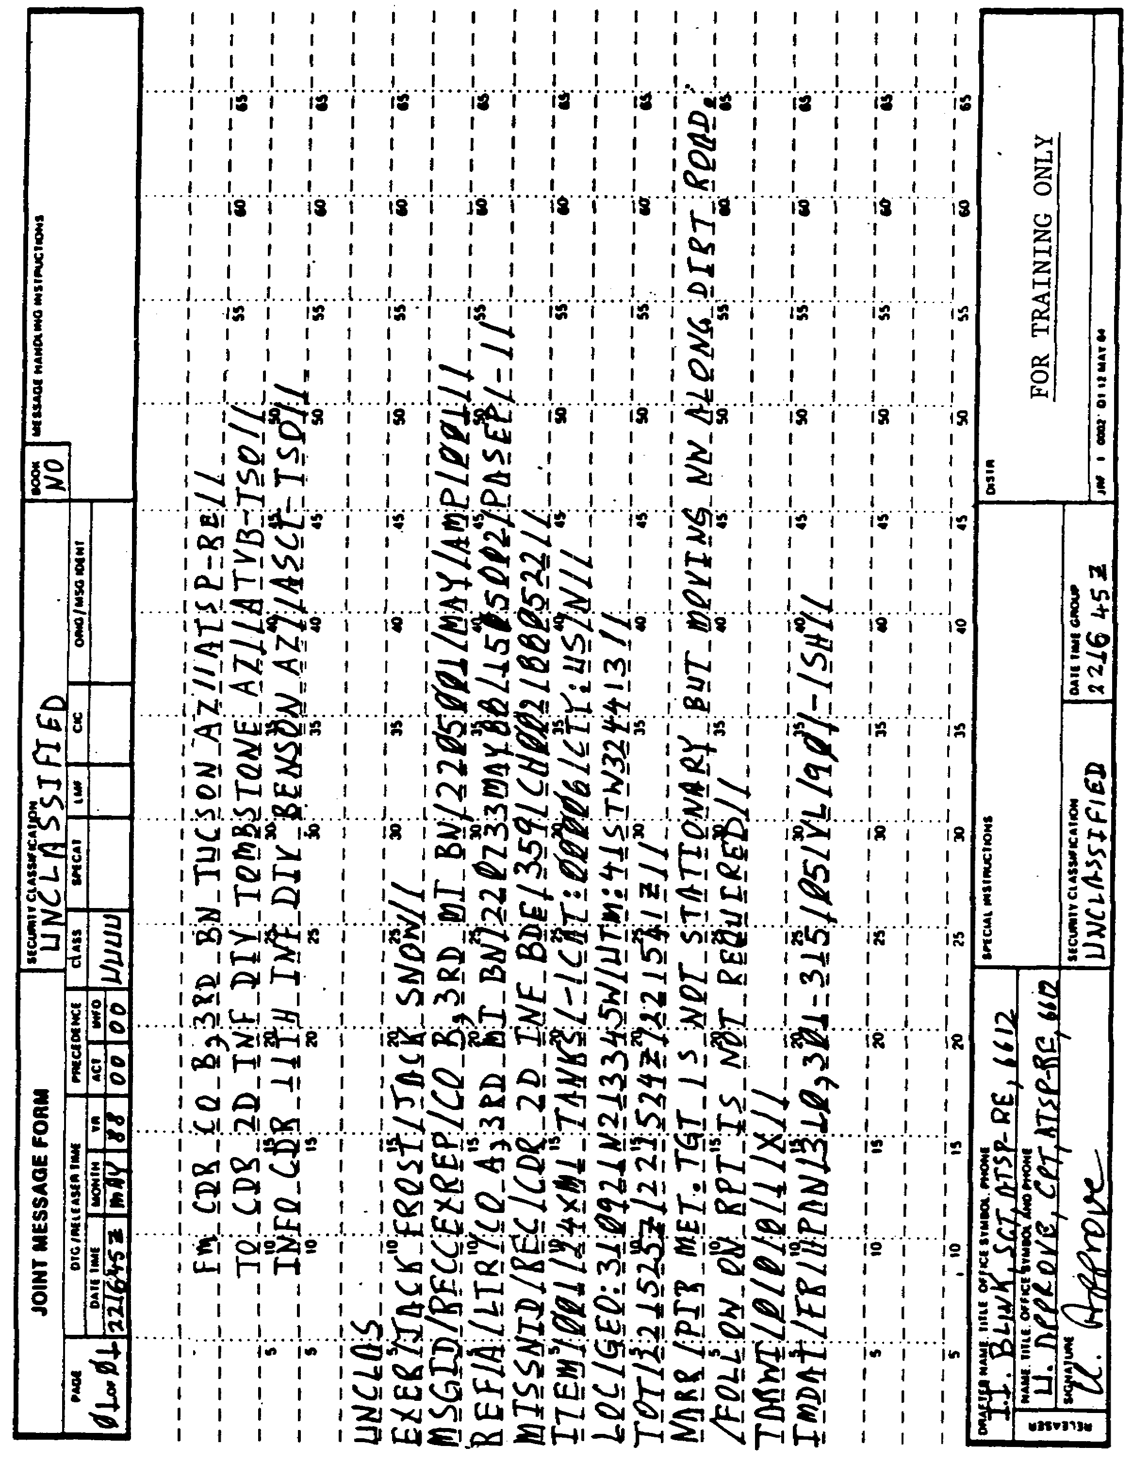

Figure 3-1. Typical RECCEXREP.

IT0667 30

PART C: RECCEXREP VOICE TEMPLATE PREPARATION

The RECCEXREP Voice Template is used to get the requested information to the requester as soon as possible. It is transmitted by voice only, using standard radio procedures (Figure 3-2).

NOTE: You must underline the message security classification and precedence.

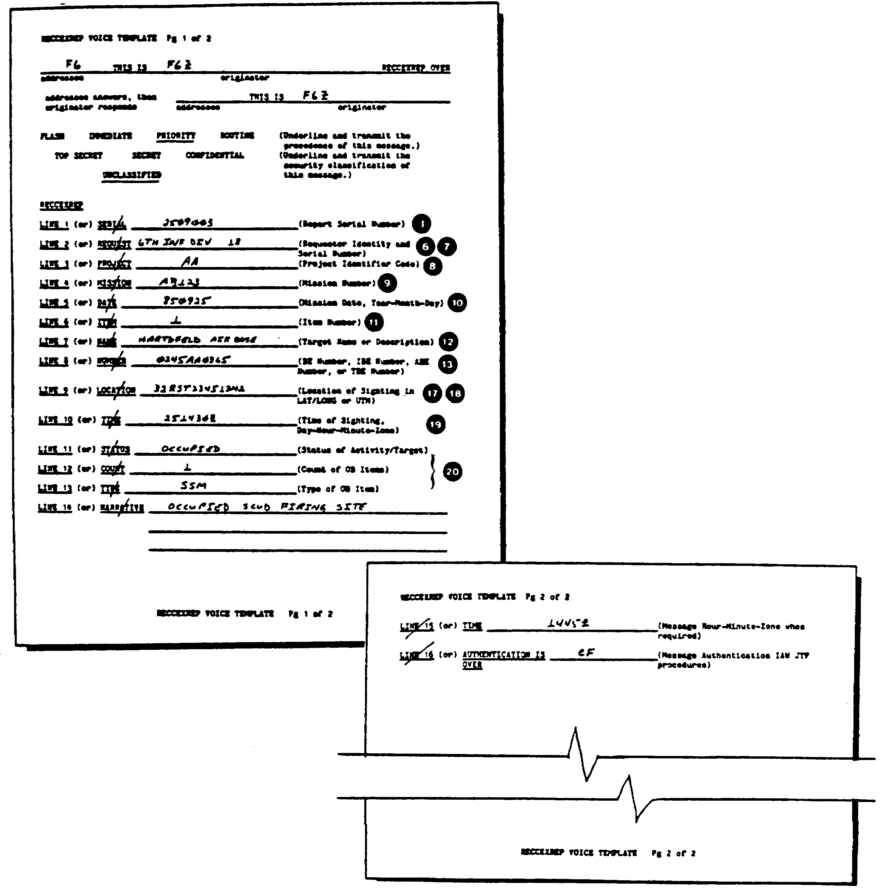

Figure 3-2. RECCEXREP Voice Template.

31 IT0667

LESSON 3

PRACTICE EXERCISE

The following items will test your grasp of the material covered in this lesson. There is only one correct answer to each item. When you have completed the exercise, check your answer with the answer key that follows. If you answer any item incorrectly, study again that part of the lesson which contains the portion involved.

For questions 1-10 refer to Figure 3-3.

1. What is the fourth field entry after set identification in line 7?

A. Aircraft number.

B. Message number.

C. Unknown.

D. Project identifier code.

2. What is (are) the error(s) in line 6?

A. Classification not spelled out.

B. No error(s).

C. Missing mandatory third field.

D. No double slants after the fourth field.

3. Which errors are in lines 1 - 4?

A. Double slants after FM addressee only authorized at end of set.

B. No errors noted.

C. Only single slant authorized between office symbols.

D. Hyphens not authorized.

4. What error(s) is (are) on line 8?

A. First field entry after set identification is incorrect.

B. No error(s).

C. Missing mandatory third field entry.

D. Category incorrect.

IT0667 32

5. What does "00" represent in the precedence column?

A. Routine.

B. Immediate.

C. Optional.

D. Priority.

6. Why is the "DECL" set missing?

A. It was forgotten.

B. Message is unclassified.

C. Instructions not provided.

D. Message is classified.

7. What is the error in the narrative set?

A. Slant character not authorized at beginning of line 12.

B. No error.

C. Abbreviation RPT not authorized.

D. Periods not authorized.

8. What is represented by the "1" in the "TARWI" set?

A. 500 ft or less.

B. Under 2 km.

C. No significant weather.

D. Weather unsuitable for mission.

9. What is (are) the error(s) in the "IMDAT" set?

A. Unauthorized second field entry.

B. Unauthorized entry in the last four fields.

C. No error(s).

D. Too many characters in the second field entry.

33 IT0667

10. What is (are) the error(s) in lines 9 and 10?

A. Incorrect entry for the GEO field.

B. Incorrect entry for the camera on field.

C. No error(s).

D. Z time should be local time.

11. How many characters including the slants and set identification are in the "TARWI" set?

A. 12.

B. 5.

C. 17.

D. 10.

12. Which of the following country codes is NOT authorized?

A. TU (Turkey).

B. HI (Haiti).

C. FR (France).

D. CG (Zaire).

13. The RECCEXREP must be completed and transmitted within which time frame after ESD?

A. 40 minutes.

B. As soon as possible.

C. Four hours.

D. 45 minutes.

14. What must be done if a BE number or installation is not listed in available documents while completing a RECCEXREP?

A. Make up a name.

B. Call higher headquarters for a name.

C. Submit a request for appropriate document.

D. Omit the BE number.

IT0667 34

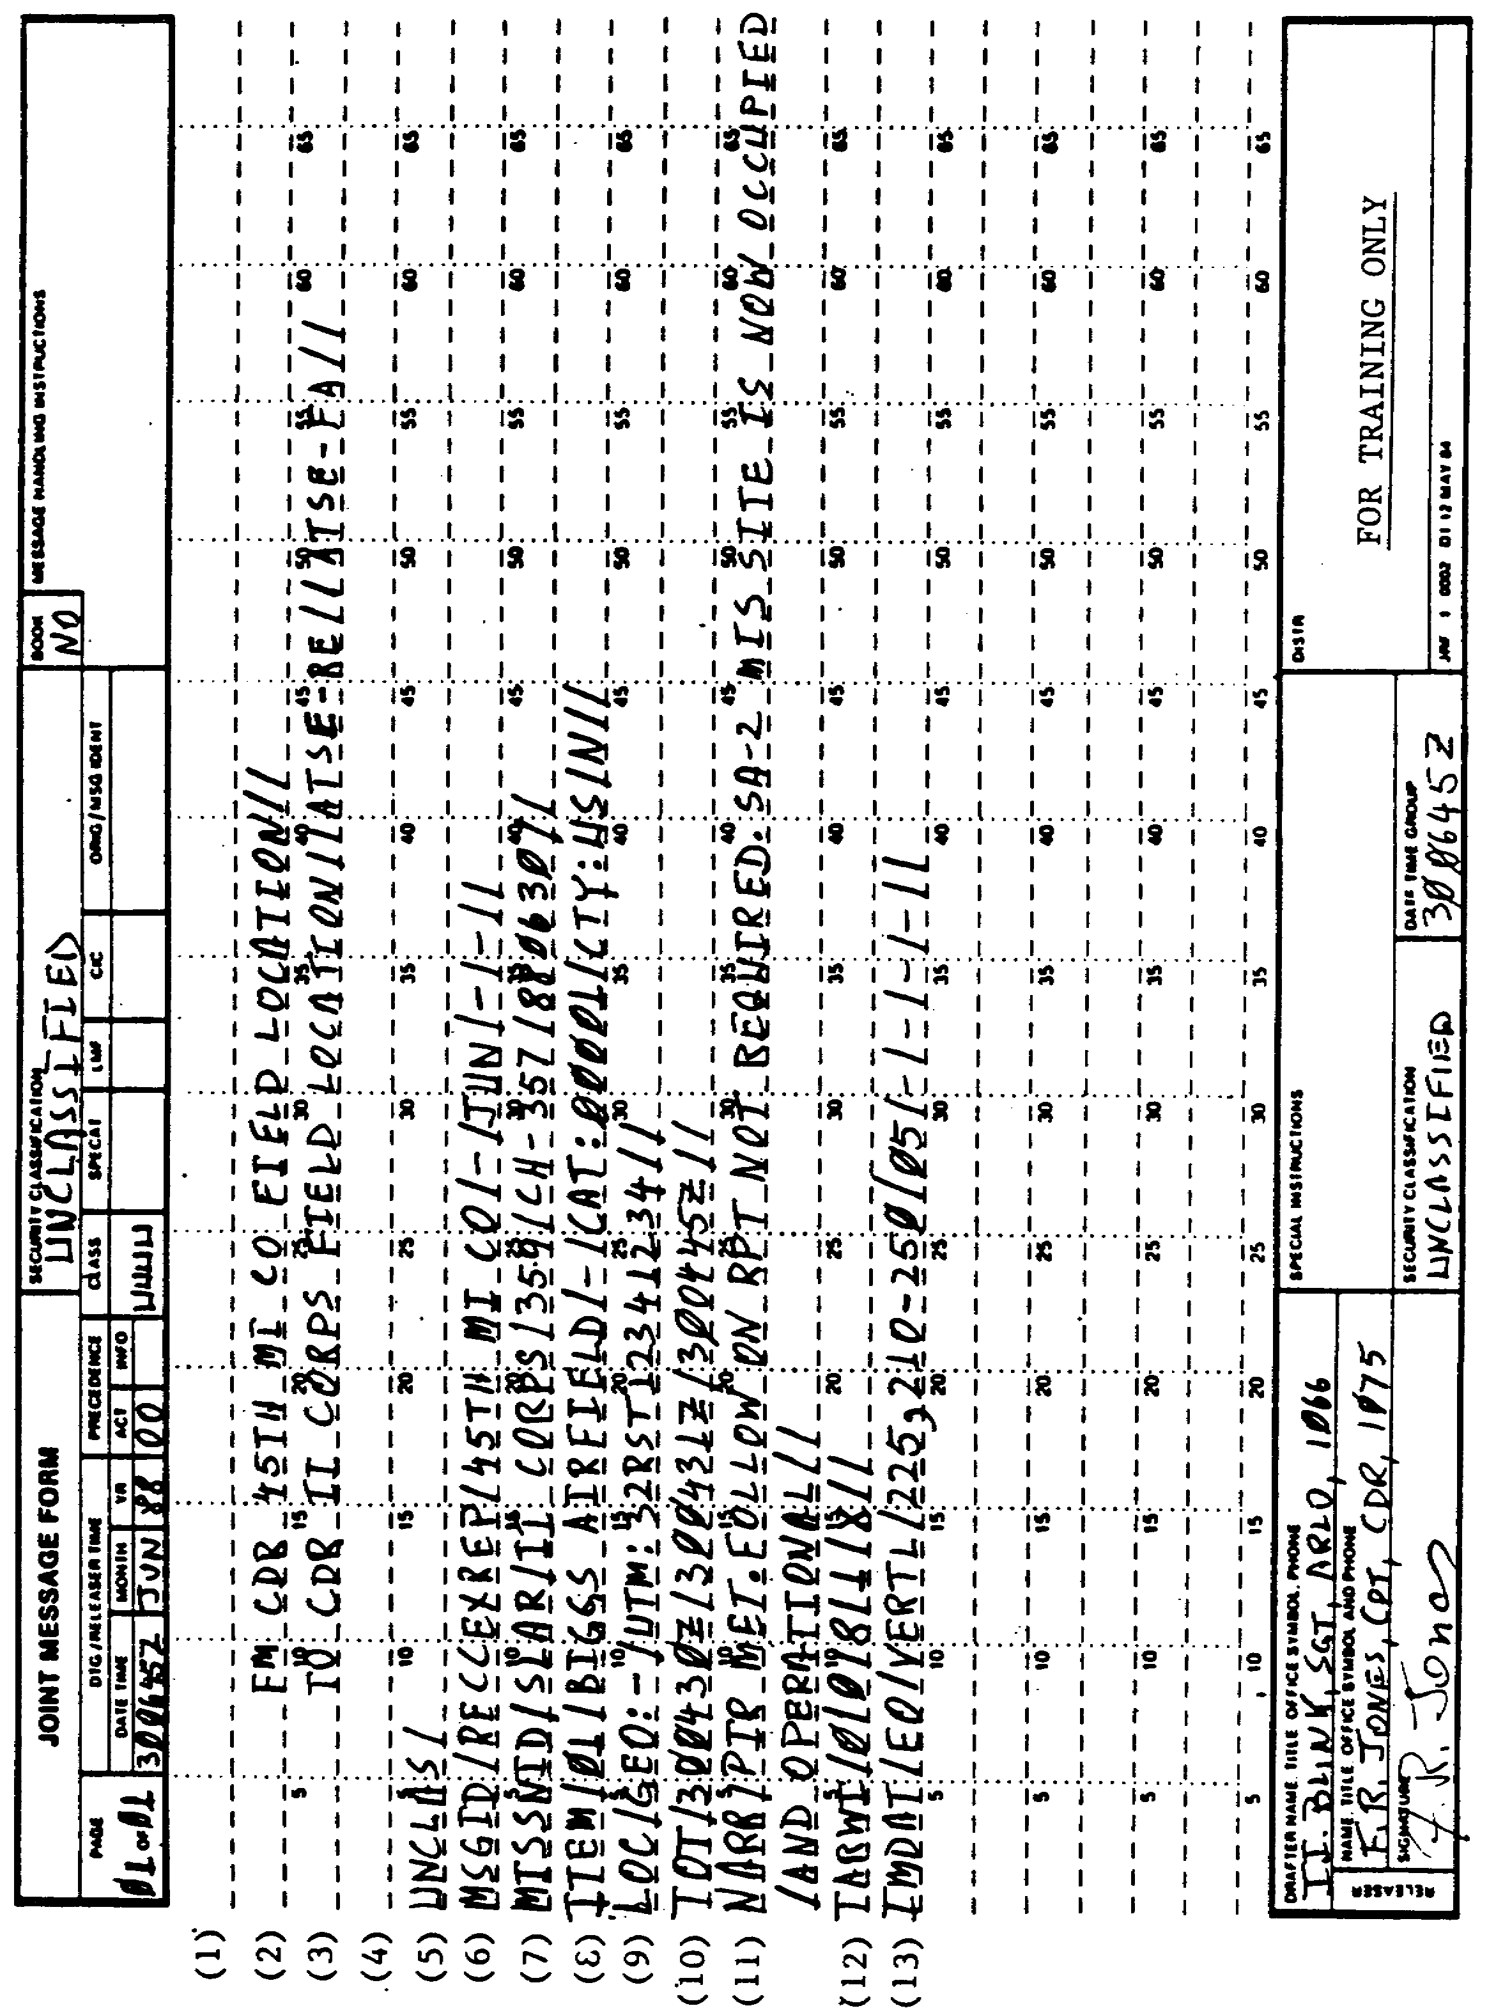

35 IT0667

LESSON 3

PRACTICE EXERCISE

ANSWER KEY AN[) FEEDBACK

ITEM CORRECT ANSWER AND FEEDBACK

1. D. The fourth field entry after the set identification of line 7 set is the project identifier code (page 25, para f(4)).

2. B. There are no errors in line 6 (page 23 para b).

3. C. In lines 1-4 only a single slant is authorized between office symbols (page 134, appendix B).

4. A. In line 8 the first field entry after set identification is incorrect (page 26, para g(2)).

5. B. "00" in the precedence column represents immediate (page 237, appendix C, entry list 59).

6. B. "DECL" is messing since the message is unclassified (page 29, para m).

7. B. There are no errors in the narrative set (page 27, para j).

8. C. In the "TARWI" set, the "1" represents no significant weather (page 193, appendix B).

9. D. There are too many characters in the second field entry of the "IMDAT" set (page 28, para 1(2)).

10. A. In lines 9 and 10 there is an incorrect entry for the GEO field (page 27, para h(1)).

11. C. There are 17 characters including slants and set identification in the "TARWI" set (page 28, para k(6)).

12. B. HI is an unauthorized entry code (page 237, Appendix C, entry list 59).

13. D. The RECCEXREP must be completed and transmitted within 45 minutes after ESD (page 22, para 1).

14. A. While completing a RECCEXREP, you should make up a name if a be number of the installation is not listed in available documents (page 26, para g(2)).

IT0667 36

LESSON 4

IIR PREPARATION

MOS Manual Tasks: 301-338-1607
301-338-3701

OVERVIEW

TASK DESCRIPTION:

In this lesson you will learn how to prepare an IIR in USMTF message format.

LEARNING OBJECTIVE:

ACTIONS: Describe the procedures involved in preparing an IRR in USMTF format.

CONDITIONS: You will be given access to extracts from DA Pam 25-7, NATO STANAG 3377, NATO STANAG 3596, STP 34-96D1-SM, and STP 96D24-SM-TG.

STANDARD: Prepare an IIR in USMTF format IAW DA Pam 25-7, NATO STANAG 3377, NATO STANAG 3596, STP 34-96D1-SM, and STP 96D24-SM-TG.

References: The material contained within this lesson was derived from the following publications:

DA Pam 25-7.
NATO STANAG 3377.
NATO STANAG 3596.
STP 34-96D1-SM.
STP 34-96D24-SM-TG.

INTRODUCTION

The IIR is the second report prepared by an IA. It is a single message format which is used to report initial programmed interpretation reports (IPIR) and supplemental programmed interpretation reports (SUPIRS).

37 IT0667

PART A: IIR DESCRIPTION

The IIR includes two types of reports: IPIR and SUPIR. The IPIR is designed to provide results of first phase exploitation of imagery. It is formatted to allow direct data base entry and human readability. The IPIR can report single or multi-mission data. The SUPIR is designed to provide results of second phase exploitation of imagery. It is formatted to allow direct data base entry and human readability. The SUPIR can report single or multi-mission data.

NOTE: The IPIR must be prepared and transmitted within four hours after ESD. The SUPIR does not have a time limit; however, it should be prepared and transmitted as soon as possible (ASAP) after the IPIR.

PART B: IIR PREPARATION IN USMTF FORMAT

1. Headings and endings of USMTF messages for imagery analysis reports are similar. The sets "EXER" and "MSGID" discussed previously are almost the same for imagery analysis messages. Follow these instructions along with Figure 4-1 on now to complete IIR 'reports.

2. Following the conditional "EXER" set or the "MSGID" set as discussed in design three, the third set is the "IRPTID" set. This set is mandatory and used to identify the report identification. It contains six fields:

a. "Report type." This is the first field entry after the set identification "RPTID." We will use "IPIR."

b. "Rpt unit" is the second field entry. This identifies the unit of the section preparing the report, such as 2d MI BN, which should be recorded as 2MI BN, since only six characters are authorized.

c. The third field entry is the "SER." This is the report serial number. This field starts with "SER" in capital letters followed by two alpha characters, then four numeric characters IAW your local unit SOP. For example:

SER:AS1234

d. Field entry number four is the project "PRJ." This is two alpha characters, normally obtained from the mission number. Since "PRJ" is capitalized, the field begins with "PRJ," followed by the two alpha characters that normally precede the mission number. For example:

PRJ:CH

e. Field entry number five is "MSN." This field indicates the number assigned to that specific mission. If more than one mission were used, then a hyphen (-) should be entered for that field. For example:

MSN:CH213

IT0667 38

f. The last field entry is the "date(s)." This field contains the mission date(s). The dates are recorded as year, month, and date. An example of only one mission date is 870527. An example of multiple mission dates is 870527-870529, using the start and the end dates of the missions.

g. Following is an example of a complete "RPTID" set:

RPTID/IPIR/2MI BN/SER:AS1234/PRJ:CH/MSN:CH-213/870527//

3. The fourth set is the "HILITES." This optional set is used to very briefly mention the highlights of this message; such as indications and warnings, new items, bonus items, and other significant activity. The set starts with the set identifier "HILITES" and is followed by the item type. Looking at Appendix B there are eight different item types. The item types are listed in the sequence as they should appear on the report(s). For example:

HILITES/ARMOR SIGHTED MOVING SOUTH ALONG HWY. NEW SAM SITE AT /32UMA907115. SAM SITE (SA-3) PREVIOUSLY OCCUPIED IS NOW /UNOCCUPIED.

NOTE: No ADHOC or perishable items will appear in this set.

4. The fifth set is the "ITEMTYP" set. This mandatory set is the first of repeatable sets, and may be repeated if there are more than one item type. Looking at Appendix B there are eight different item types. The item types are listed in the sequence as they should appear on the report(s). For example:

ITEMTYP/PERISHABLE ITEMS//

5. The sixth set is the mandatory "ITEM" set. This set identifies the particular target and provides specifics. The first entry on this set is the set identifier "ITEM."

a. The first field entry after "ITEM" is the "item number," for example, the first target would be recorded as item number 001, the next target 002, and so on.

b. The second field entry is the "target name." Since we do not have a BE on hand, we will not use it, but assign names such as ARMOR, CONVOY, MSL SITE, and so on.

c. The third field entry is the "BE number." It will be entered according to several authorized methods based on the BE. For training purposes we will replace this field entry with a hyphen (-).

39 IT0667

d. The fourth field entry is the "CAT." This identifies a category for that particular target (Appendix C, entry list 1218). This list provides authorized codes for specific targets. For example, TANKS or ARMOR are listed as:

CAT:00006 (military activity)

e. The fifth field entry is the "CTY." This field identifies the country where the target(s) was sited (Appendix C, entry list number 59). For example:

CTY:GE

f. The last field entry is the "national tasking." This identifies whether this target was tasked by national authorities or not. Enter either an "N" (for no) or a "Y" (for yes) in this field.

g. Following is an example of a sixth set:

ITEM/C001/ARMOR/-/CAT:0006/CTY:GE/N//

6. The seventh set is the mandatory "LOC" set. This identifies the location of the target listed in the item. The location can be expressed in "GEO" or "UTM" coordinates. If both types are available, list them. The first entry of this is the set identifier "LOC."

a. The first field entry after "LOC" is "GEO." Notice that "GEO" is capitalized; therefore, it is recorded as the first part of this field entry followed by the GEO coordinates. For example:

GEO:451525N153289E

NOTE: If the GEO coordinates are not available, a hyphen will replace the field.

b. The second field entry is "UTM." UTM is capitalized; therefore, it is recorded as the first part of the field entry followed by the UTM coordinates. For example:

UTM:32SMV12341234

c. When both UTM and GEO coordinates are present the "LOC" set will look as follows:

LOC/GEO: 451525N153289W/UTM: 33SMV 12341234//

IT0667 40

7. The eighth set is the "OTID." This conditional set is used only when identifying a new target or the target length, width, or azimuth has changed significantly. The set starts with the set identification "OTID."

a. The first field entry after "OTID" is the "LTH." This is the length of that particular target. The field entry starts with "LTH," followed by the length of the target, which is usually the longest measurement expressed in feet, yards, statute or nautical miles, meters (m), or kilometers (km). Decimal points are authorized. For example:

LTH:23.5NM

b. The second field entry is the "WTH." This is the width of that particular target. The width is usually the shortest measurement, which will be expressed in the same unit of measurement as the "LTH." For example:

WTH:88.7YD

c. The third field entry is the "AZM." The azimuth of the target will be expressed in degrees from 000-179. For example:

AZM:159

d. The fourth field entry is the "ELE." This is the elevation above sea level, expressed in meters. A minus (-) proceeding the sea level indicates below sea level. For example:

ELE:-3.2

e. The fifth field entry is the "CMX." This is used for nationally tasked targets such as "DSA," "LOC," and "BAS," For training and test purposes we will not use this field, and replace it by a hyphen (-).

f. The sixth field is the Military Region Code (MRG) or the Air Defense District Code (ADD). This set will start with "MRG" or "ADD," followed by the three digit numeric code. For example:

MRG:323 or ADD:124

g. Following is an example of a complete "OTID" set:

OTID/LTH:23.5NM/WTH:88.7YD/AZM:159/ELE:-3.2/-/MRG:323//

8. The ninth set is the "TPREF." This is used to name topical reports on intelligence problems the target resides in. This optional set will start with the set identifier "TPREF."

41 IT0667

a. The first field entry after "TPREF" is the "ip nr." This is the intelligence problem number or the topic number. For example:

ABCDE12345

b. The second field entry is the "ip name." This is the intelligence problem name or the topic name. For example:

MOTOR POOL

c. The third field entry is the "ip date." This is the date of the latest topical report with information on that particular target. The date will be expressed as the year, month, and the date. For example:

870528

d. The fourth field entry is the "reporting product code." This is the reporting product code extracted from DIAM 57-5. For example:

AB

e. Following is an example of a complete "TPREF" set:

TPREF/ABCDE12345/MOTOR POOL/870528/AB//

9. The 10th set is the "STATACT." This is mandatory and used to report the target activity status. This set starts with the set identifier "STATACT."

a. The first field entry after "STATACT" is the "operational status" that best describes that particular target. This information is encoded and should be recorded as indicated in Appendix C, entry list 983. For example:

TRN (which means transitory).

b. The second field entry is the "secondary status." This is used if the target is camouflaged, concealed, or deception is observed. The entry recorded will also be from Appendix C, entry list 983; however, it must be different than the one listed in the previous field. For example:

OCC (which means occupied)

c. The third field entry is the "SGN:," which is used to report the target as indicated below (Table 4-1). Since SGN is capitalized, this is be the first entry in the field, followed by one of the codes above. For example:

SIG: UNK

IT0667 42

Table 4-1. SGN Change and Code.

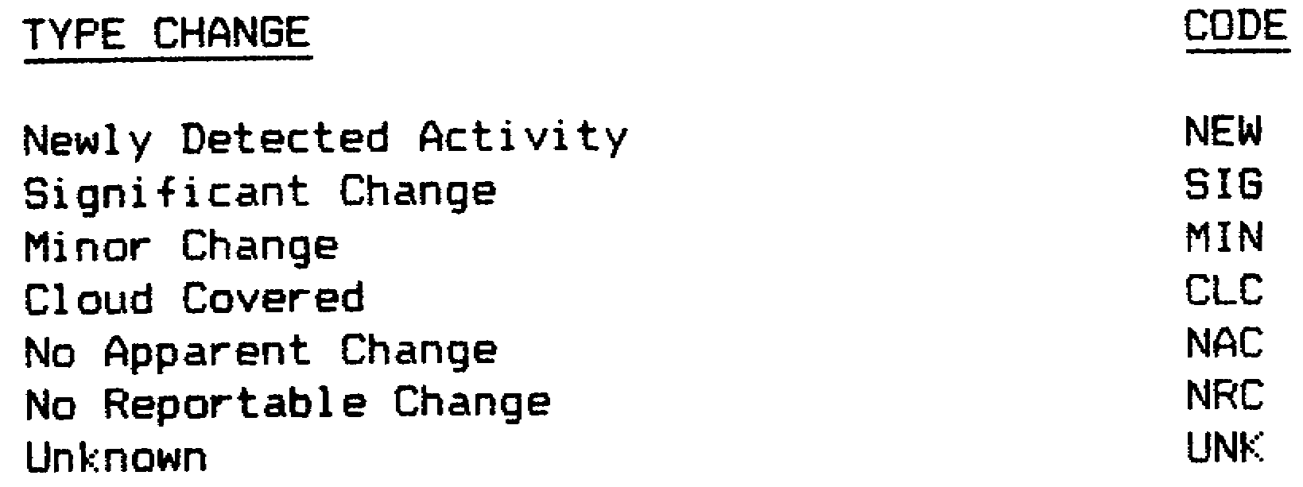

NOTE: If the status is unknown, the UNK should be used. Do NOT use a hyphen or no data sign for this field.

d. The fourth field entry is the "PRJ," which is used only if NAC (no apparent change) was used in the previous field and a project ID code is available. If more than one mission was used, use the "MI" to indicate mission independent. If this field is not used, replace it with a hyphen (-) or if this was the last field, it could have ended with a double slant to indicate end of set. For example:

PRJ:MI

e. The fifth field entry is the "MSN," which is also used only if NAC was used in the third field entry. The mission number would be entered in this field. If the mission was independent a hyphen (-) would be entered. For example:

MSN:CH-498

f. The sixth field entry is the "DTE," which is used only if "NAC" was entered in the third field entry. In this field the date of the mission is used, expressed by two digits for the year, month, and day. For example:

DTE:870527

g. The seventh field entry is the "NRG" (National Basic Reference Group) or the "ATG" (Automated Tactical Target Graphic). Only one of these fields will be used, whichever is applicable. This information will be obtained from your local unit/section. Note that slants are not authorized characters and that a hyphen (-) will replace a slant character. For example:

NRG:NIDA04-0014-5 or ATG:FP-999-08000

43 IT0667

10. The 11th set is either the "Description" or "Remarks" set both of which are conditional.

a. The Description set is used when an installation is covered for the first time, or when an installation is reported as abandoned or destroyed. This set should not be used when the image quality is poor, unless you are reporting this installation for the very first time. This set is used to describe the physical installation.

b. The Remarks set is most frequently used for items that are perishable or transitory. This set is used when the "description" set is not used. Additionally, this set is used if the activity is camouflaged, concealed, or if new activity or change is observed.

c. Following is an example of each set:

DES/SCATTERED UNDERGROUND CONCRETE BUNKERS WITH INTERCONNECTING
/TUNNELS AND PROTECTIVE PERIMETER POSITIONS INCLUDING TANK TRAPS
/AND AIR DEFENSE LAUNCH SITES//

OR

RMK/CONVOY OF ARMOR WAS HEADING IN A NORTHERLY DIRECTION FROM /UTM
J2MNV12341234 ALONG SECONDARY ROAD//

NOTE: Notice that on each of these sets (DES or RMK) a slant character starts off each additional line; as many lines as necessary are authorized.

11. The 12th set is the "DFC." The conditional defense set, which contains defense or defenses that are not organic to that particular target. An example of equipment/items that are not organic are AAA Guns attached to a missile site or air defense weapons assigned to other than air defense artillery (ADA) units. This set will not always be used. However, it should be used when non-organic defenses are observed. For example:

DFC/COMPANY SIZE BIVOUC WAS SURROUNDED BY 280 FOOT BY 300 FOOT
/SECURITY FENCE//

12. The 13th set is the conditional "OBID" set. This set is used for reporting Order of Battle (OB) items. The set will start with the set identifier "OBID."

a. The first field entry after "OBID" is one of the following OB type codes shown in Table 4-2. For example:

OBID/GFW

IT0667 44

Table 4-2. OB Type and Code.

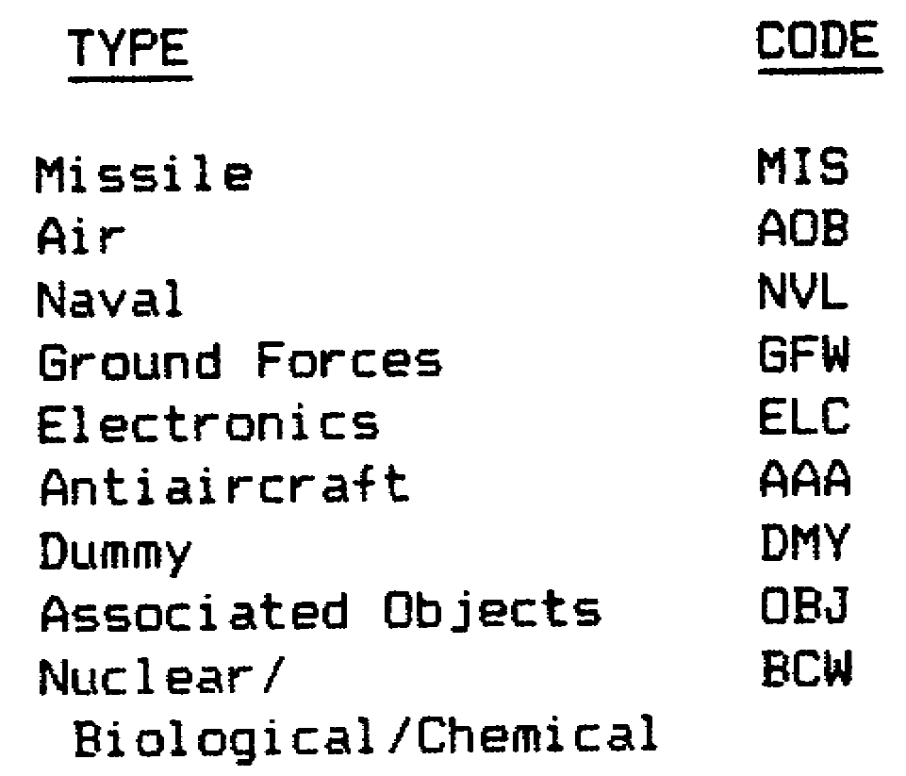

b. The second field entry is the "date." This is the date of coverage, indicated by two digits for the year, month, and date, respectively. For example:

870529

c. The third field entry is the "TOT." This field entry will start with the field name "TOT" followed by two numbers each for the hour and minute followed by "Z" (Zulu time). For example:

TOT:1430Z

d. The fourth field entry is the "attg/nbrg." This field entry is used if OB is reported by NBRG or ATTG area. This information is about the area or location. When this field is entered, it should begin with the area listed, such as: AREA A, STORAGE DEPOT; AREA B, MOTOR POOL, and so on. When areas are not available for use as references, reporting by location is allowed, for example: north end of runway.

e. The fifth field entry is the "SGN," which is used to indicate the amount of activity within that particular target. Following is a list of the authorized codes (Table 4-3) which will be used as entries in this field.

Table 4-3. Activity Codes.

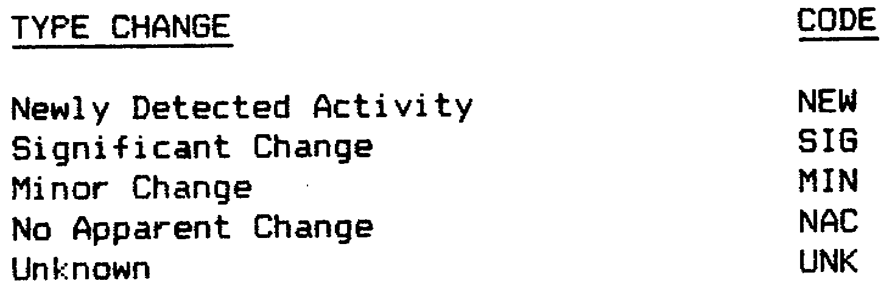

45 IT0667

f. The sixth field entry is "PRJ." This is the project ID code. This code should be extracted from the debriefing form, unless otherwise specified. If more than one mission was used, then list "MI" for mission independent. For example:

PRJ:CH

g. The seventh field entry is the "MSN." This is the mission number. Again this could be extracted form the pilots debriefing form. This field is used only if the comment field in the "ATTG/NBRG" was used, or anything, but UNK in the fifth field of this set. If MI was used in the previous field, then use a hyphen (-) in this field. For example:

MSN:CH-101

h. The eighth field entry is the "DTE," which is used only if an entry other than UNK was used in the fifth field. The date is recorded in this field as two digits for the year, month and date, respectively. For example:

DTE:870601

Following is an example of a complete "OBID" set follows:

OBID/GFW/870529/TOT:1430Z/AREA B, MTR POOL/SGN:SIG/PRJ:CH/
MSN:CH-101/DTE:870601//

13. The 14th set within the IIR is the "OBEQ." This set is conditional and repeatable; it is used if you entered NEW, MIN, or SIG in the fifth field of the previous set (OBID). This set used to list each type of equipment.

a. The first field entry after OBEQ set is the "count." This indicates the number of objects observed, use numbers 0000-9999. For example:

0025

b. The second field entry is the "validity." This should be entered as "CONF" (Confirmed), "PROB" (Probable), or "POSS" (Possible). For example:

PROB

c. The third field entry is the "equip name," the name of the equipment. For example:

T-64 TANKS

IT0667 46

d. The fourth field entry is the "object code." This field will not be used. If an entry is made in the next field, then a hyphen will replace this field.

e. The fifth field is the "comments." This is used to enter comments about the OB equipment listed in the third field of this set. For example:

T-64 TANKS WERE IN THE PROCESS OF REFUELING

f. Following is an example of a complete "OBEQ" set:

OBEQ/0025/PROB/T-64 TANKS/-/T-64 TANKS WERE IN THE PROCESS OF
REFUELING//

14. The 15th set is the "OBID." This set is conditional and is used to report OB items. The exact same instructions apply as to the 13th set.

15. The 16th set is the "UNITID." This set is optional and repeatable; it is used to link unit names with the equipment item(s) reported. This set relates to the "OBID" and "OBEG" sets just entered. The only field entry is the "unit name(s)." This identifies the unit related to equipment listed in the previous sets "OBID" and "OBEQ." For example:

UNITID/3D REGT,4TH INF DIV//

16. The 17th set is the "IMR." This set is mandatory and used to describe the mission.

a. The first field entry after "IMR" is the "DTE," the date of coverage, expressed by two digits for the year, month and day. For example:

DTE:870601

b. The second field entry is the "PRJ." This is used to list the project ID code. This information should be extracted from the pilot debrief, unless otherwise stated. If more than one mission were used, then "MI" would be entered to indicate mission independent. For example:

PRJ:CH

c. The third field entry is the "MSN." This is used to enter the mission number. This information is extracted from the pilot debrief, unless otherwise stated. If more than one mission were used and MI was entered in the previous field, then a hyphen would be entered in this field. For example:

MSN:CH-101

47 IT0667

d. The fourth field entry is the "type." This is used to report the image type used, as one of the codes listed below (Table 4-4):

Table 4-4. Image Types and Codes.

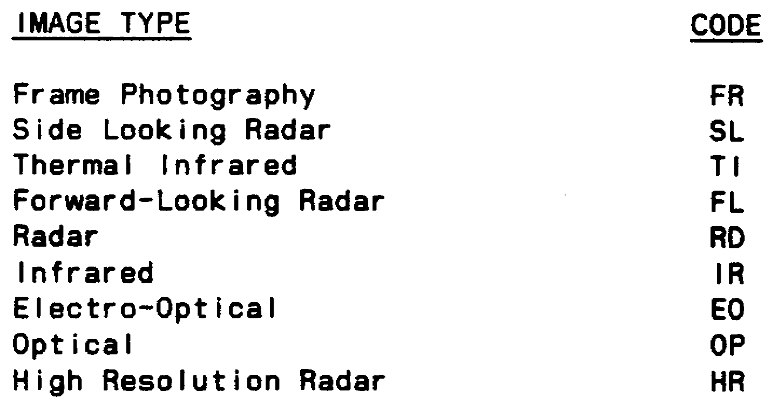

e. The fifth field entry is the "sensor position." This lists the position of the camera or sensor. See Appendix C, entry list 564, for authorized codes.

f. The sixth field entry is the "image nr." This is used to enter the image number(s). Enter the number of the best image first, followed by a comma, then group image numbers. Use a hyphen to separate the first and last numbers of a group of images. For example:

480,450-501

g. The seventh field entry is not used and should be replaced by a hyphen (-).

h. The eighth field entry is the "'index nr." This is used to get the Universal Reference Grid (URG) coordinates. The index or image segment code should be entered in this field. For training and test purposes we will not use index nr and replace this field with a hyphen (-).

i. The ninth field is the "URG." This is where the Universal Reference Grid coordinates will be entered. For example:

URG:123123

j. The 10th field entry is the "TOT." This will be entered with two digits for the hour and minute, followed by "Z" (Zulu time). For example:

TOT:1410Z

k. Following is an example of a complete "IMR" set:

IMR/DTE:870601/PRJ:CH/MSN:CH-101/FR/LPAN/480, 450-501/-/-/
/URG:123123/TOT:1410Z//

IT0667 48

17. The 18th set is the "IMDATA." This is mandatory and used to report imagery data.

a. The first field entry after "IMDATA" is the "coverage" field. This information will be obtained from the debriefing form. Table 4-5 illustrates the codes which will apply.

Table 4-5. Coverage Codes.

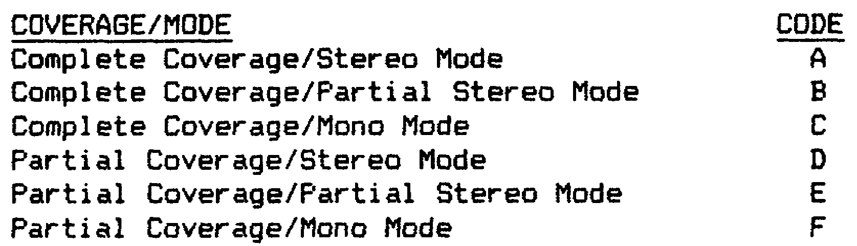

b. The second field entry is the "inter scale." This is used to report the NIIRS rating, expressed with two numerical digits from 01-10. For example:

05

c. The third field entry is the "weather." This is used to report the major weather conditions at the target location. This field will be entered with one of the authorized codes shown in Table 4-6.

Table 4-6. Weather Codes.

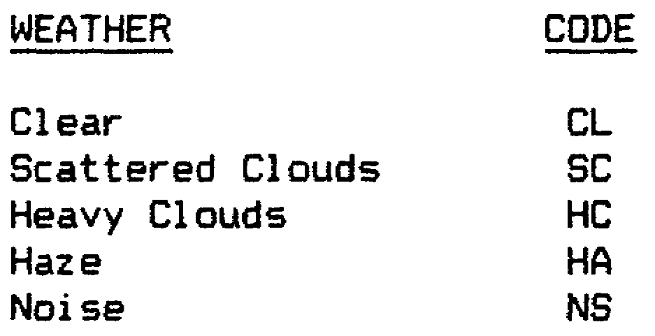

d. The fourth field entry is the "other weather." This indicates other weather conditions that had an effect on the imagery over the target. One of the codes listed in Table 4-7 will apply:

Table 4-7. Other Weather Codes.

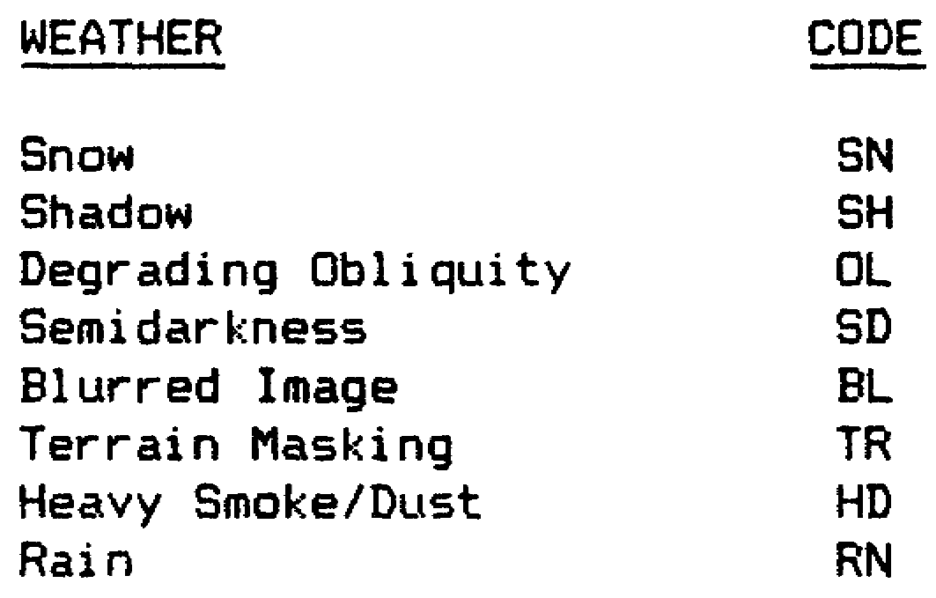

49 IT0667

e. The fifth field entry is the "cov angle." This is used to enter the coverage angle. Only one alpha character will be entered, "0" for oblique, or "V" for vertical.

f. The sixth field entry is the "'part cover." This is used to enter the percentage of the coverage, if codes D, E, or F, applied in the first field of this set. What this field does is to state the percentage of coverage that was obtained, if complete coverage was not obtained. For example:

95

g. The seventh field entry is the "image qualifier." This indicates the type of imagery that is to be viewed. Use one of the codes listed in Table 4-8.

Table 4-8. Image Qualifier Codes.

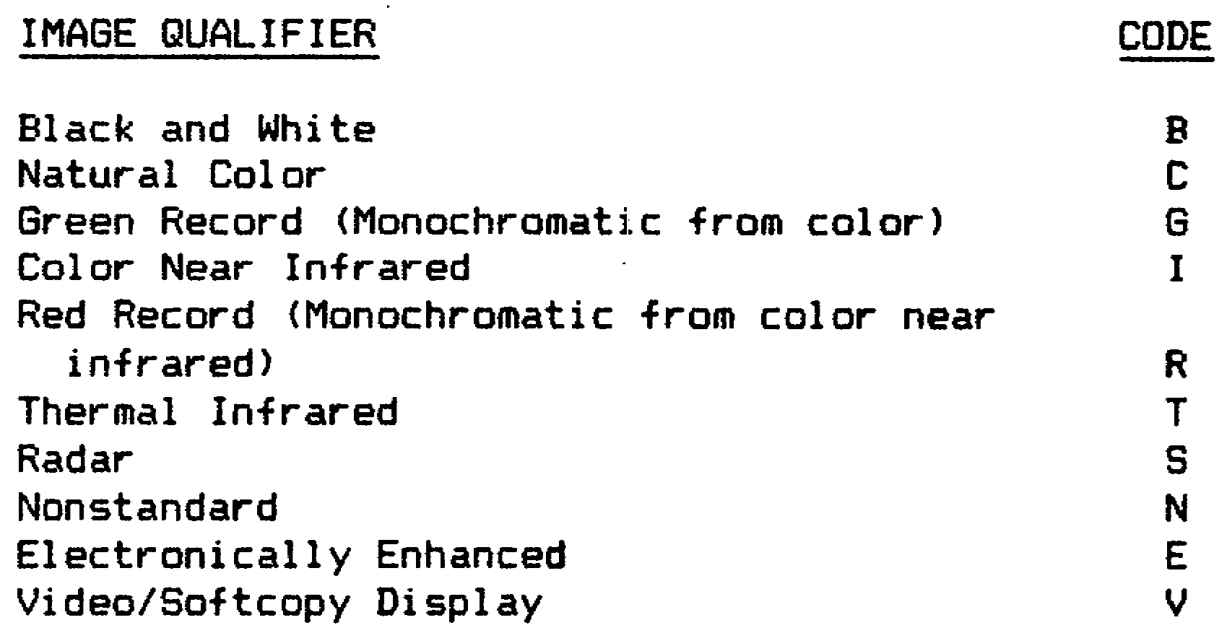

h. The eighth and last field entry for this set is the "image nr." This is used to enter the image number(s). Enter the number of the best image first, followed by a comma, then group image numbers. Use a hyphen to separate the first and last numbers of a group of imagers. For example:

320, 300-345

i. Following is an example of a complete "IMDATA" set:

IMDATA/E/05/SC/SH/V/80/B/320,345//

IT0667 50

18. The 19th set is the "IDC." This set is conditional and is used to report major differences in coordinates between those observed and those recorded in the Automated Installation Intelligence File (AIF) or other responsible source document.

a. The first field entry after "IDC" is the "GEO." This is used to enter the geographical coordinates of the target. For example:

GEO:452315N231534W

b. The second field entry is the "UTM." Use this to record the UTM coordinates. For example:

UTM:43NSC12341234

c. The third field entry is the "REF." Use this to reference maps or systems, when softcopy systems are used. For example:

REF:SERIES V2233

d. Following is an example of the "IDC" set:

IDC/GEO:452315N231434W/UTM:43NSC12341234/REF:SERIES V2233//

19. The 20th set is the "HEADING." This set is conditional and used to state what objectives were satisfied. The only mandatory field entry after the set name is outlined for you. For example:

HEADING/COLLECTION OBJECTIVES SATISFIED//

20. The 21st set is the "AMPN." This set is conditional and used only if "COLLECTION OBJECTIVES SATISFIED" was used in the previous set. Free text comments should be entered relating to the conditions or results you are reporting. These comments are related to the objectives satisfied in the previous set. For example:

AMPN/BN SIZE CONVOY LOCATED AND UNIT ID VERIFIED//

21. The 22nd set is the "HEADING." This set is conditional and used to tell what collection objectives were not satisfied. This set will be used only if objective(s) were not satisfied. The only field entry is outlined for you and should read. For example:

HEADING/COLLECTION OBJECTIVES NOT SATISFIED//

22. The 23rd set is the "AMPN." This set is conditional and required only if "COLLECTION OBJECTIVES NOT SATISFIED" was used. Following the set identifier "AMPN," enter free text comments to identify collection objectives not satisfied. For example:

AMPN/FOLLOWING TARGETS WERE NOT FOUND DUE TO CAMERA MALFUNCTION//

51 IT0667

23. Following the "AMPN" set, the "ITEM" set through the "IMDATA" set will be used if applicable. The "ITEM" and "LOC" sets are mandatory. The following sets are used only in relation to the OBJECTIVES NOT SATISFIED set. If all objectives were satisfied, then the end of message should be entered after "AMPN" of the first "HEADING."

a. The 24th set is the "ITEM" set. This is exactly like the previous "ITEM" sets. All fields are also identical and should be completed as before. The ITEM set, with its field entries, is mandatory.

b. The 25th set is the "LOC." This is also a mandatory set, which is identical to previous "LOC" sets, with all its field entries.

c. The 26th set is the "IMR." This is a conditional set and should be completed if the information is available. Again, everything in this set is the same as previous "IMR" sets.

d. The 27th set is the "IMDATA" set is also a conditional set. If the information is available, it should be indicated in the message. This set is like the previous IMDATA set.

e. The 28th set is the "RMKS," is used to enter general mission statement(s). This is an optional set where free text is used. For example:

RMKS/INTERFERENCE TO COLLECTION OBJECTIVES WAS ATTEMPTED//

24. The 29th and last set is the "DECL." This set is conditional and used if the message is classified. Use this set to enter declassification or downgrading instructions. There is only one field entry within this set. Table 4-9 list entries for this set.

Table 4-9. Declassification Instructions.

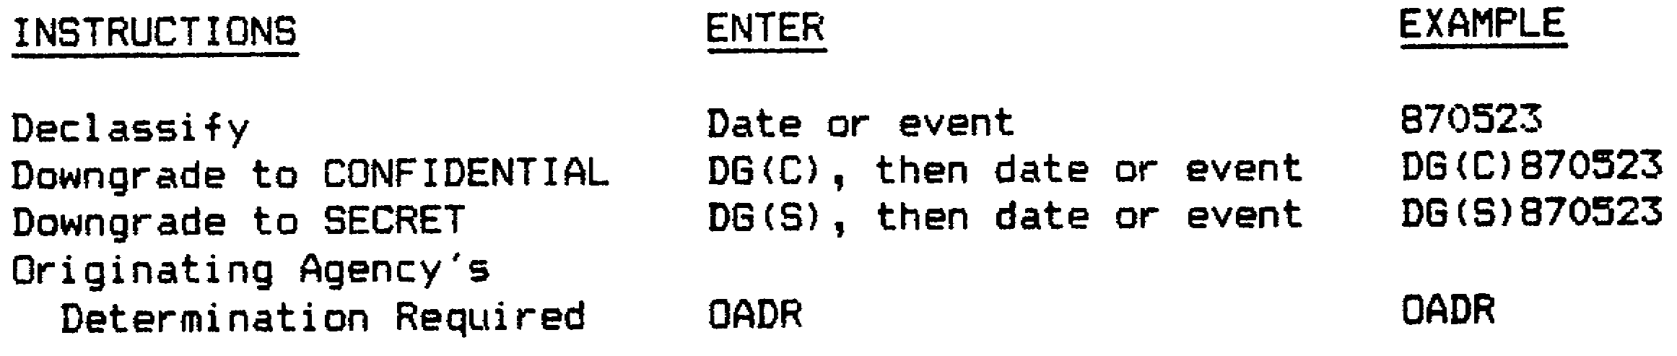

IT0667 52

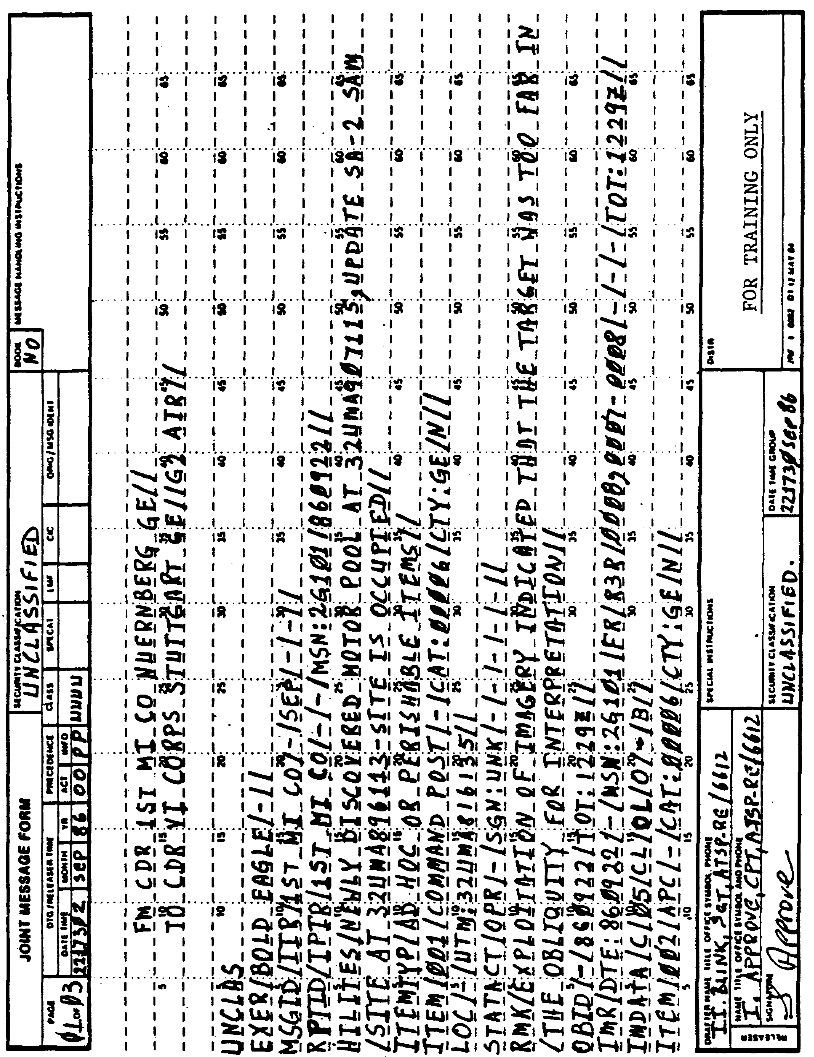

Figure 4-1. Typical IIR.

53 IT0667

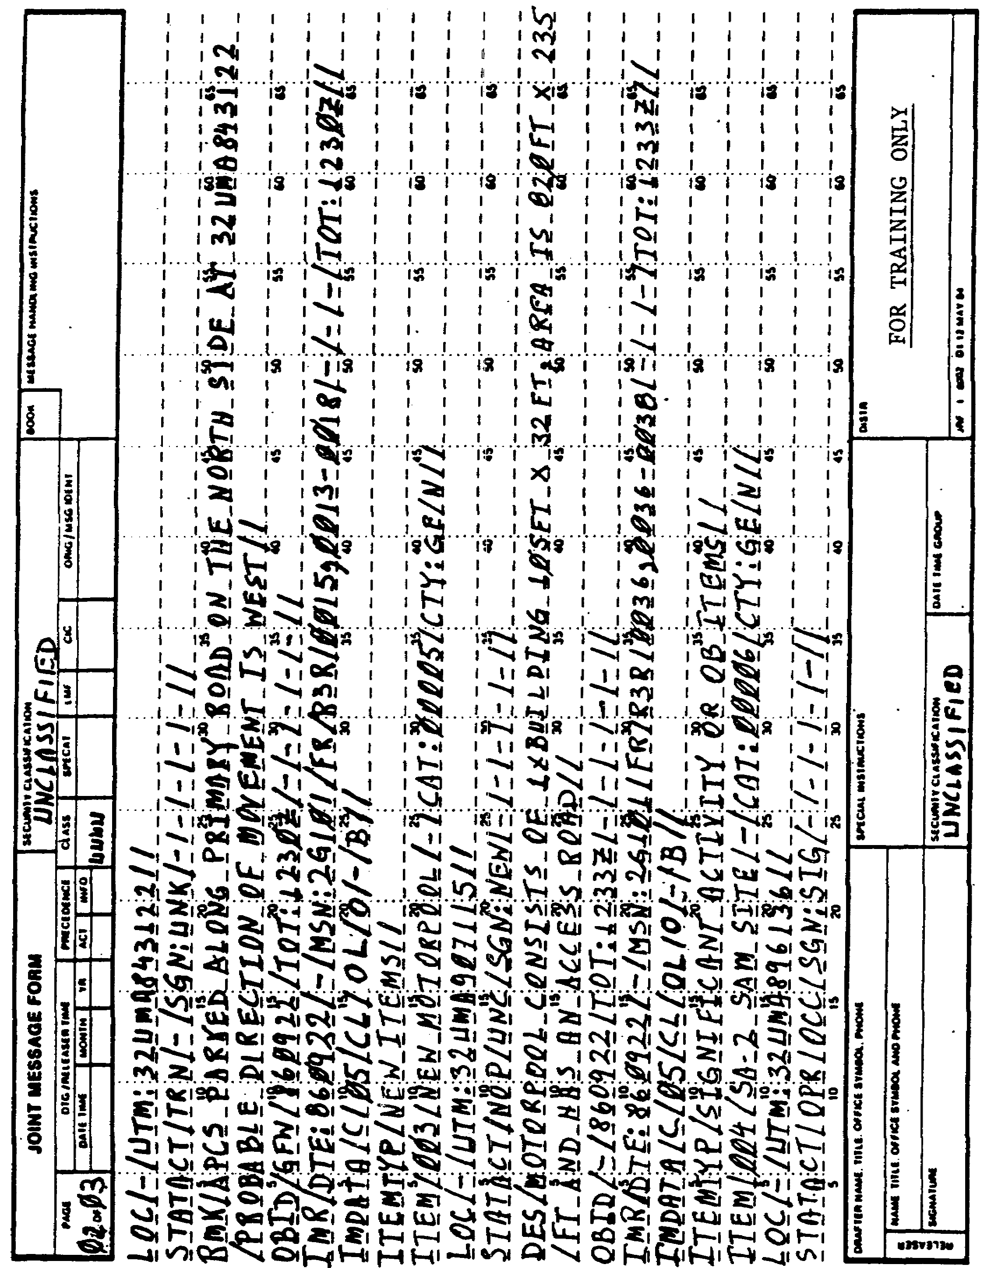

Figure 4-1. Continued.

IT0667 54

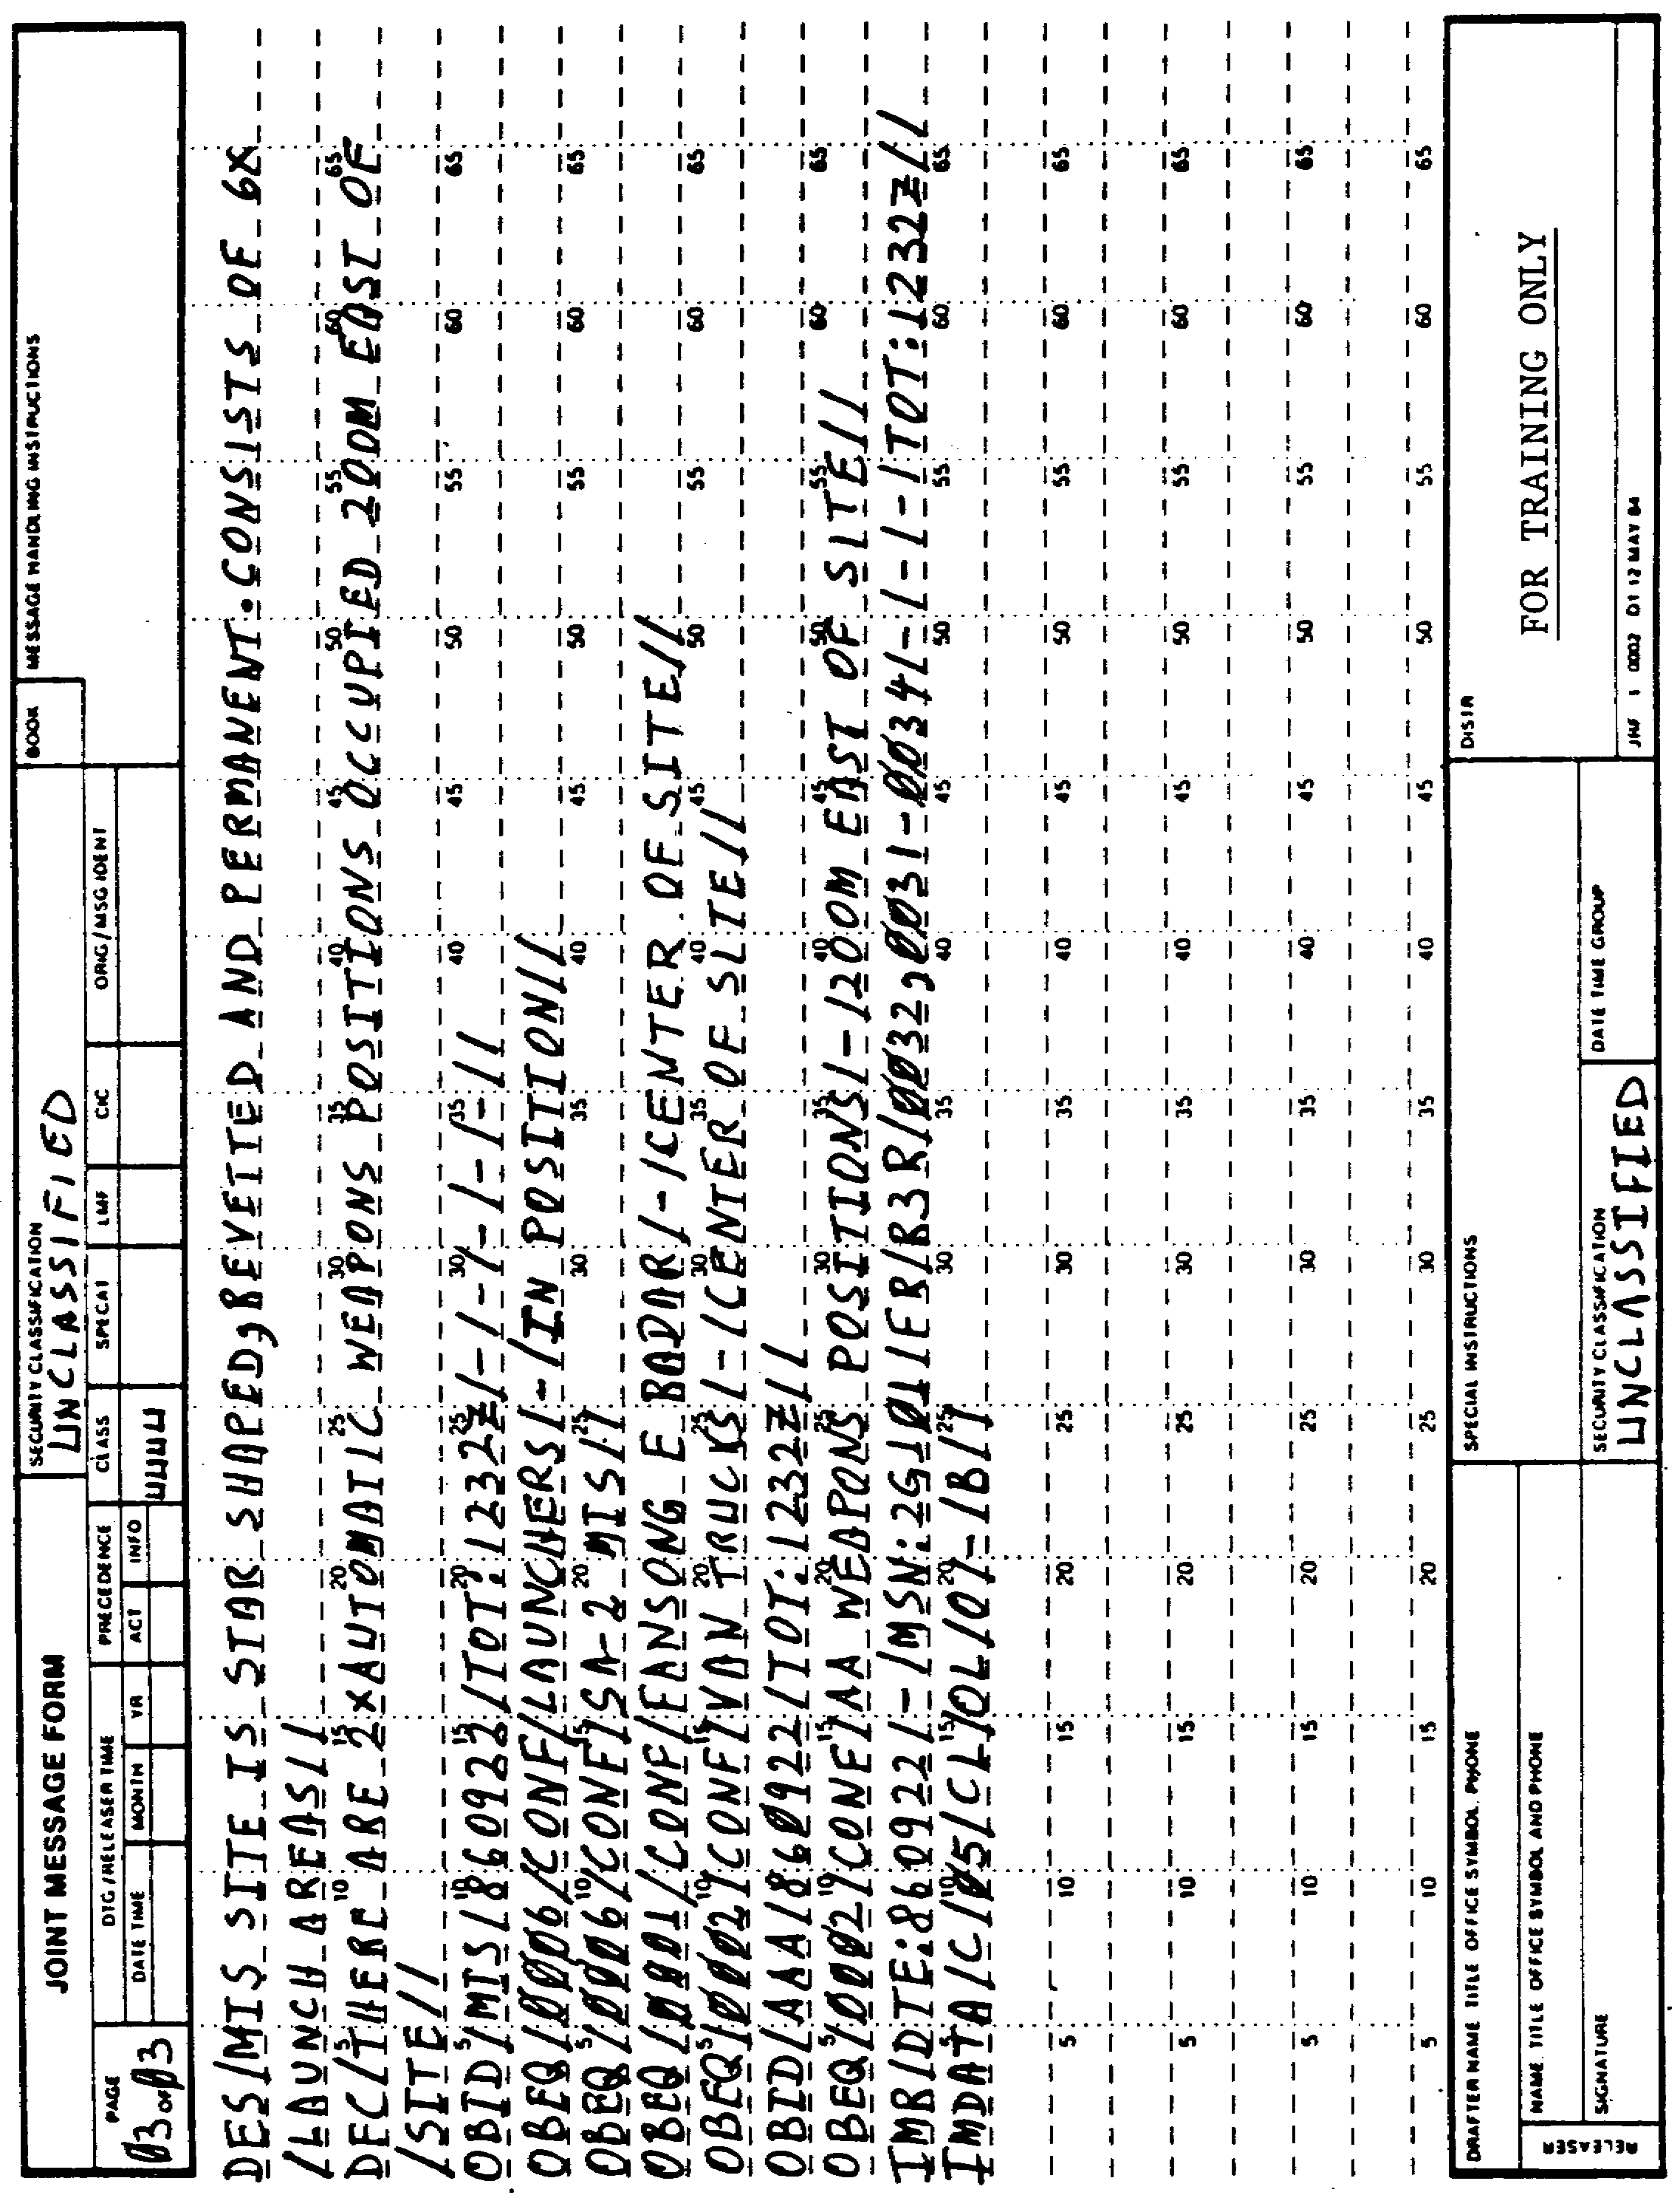

Figure 4-1. Continued.

55 IT0667

LESSON 4

PRACTICE EXERCISE

The following exercise will test your grasp of the material covered in this lesson. There are 23 mistakes or omissions in the following IIR (Figure 4-2). By using the message map (Figure 4-3) enter the mistake or mistakes in their appropriate spaces. Compare this figure with the correct IIR (Figure 4-4) and the answer key that follows.

When you have completed this exercise, check your answers with the answer key that follows. If you answer any item incorrectly study again that part of the lesson which contains the portion involved.

IT0667 56

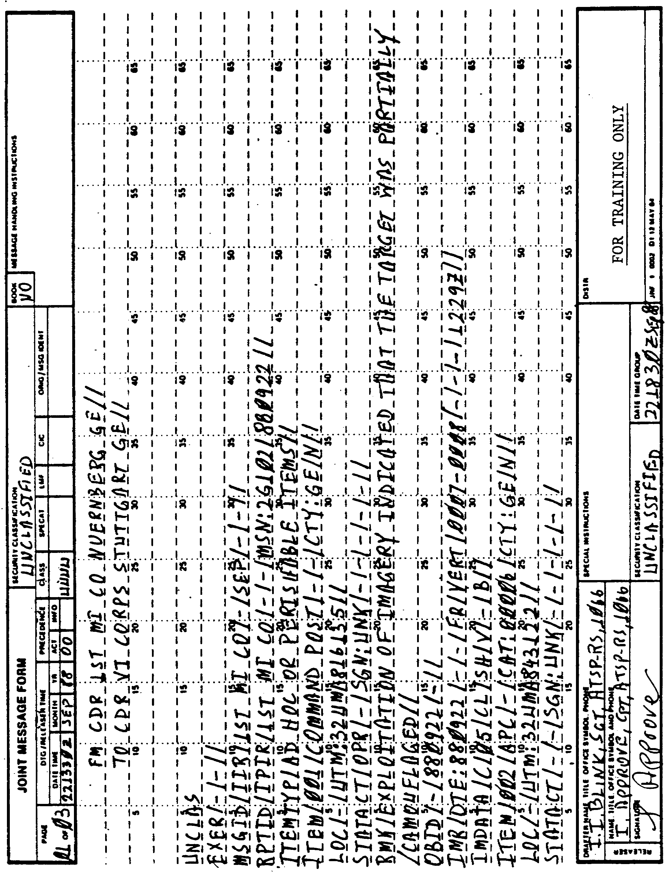

Figure 4-2. IIR with Mistakes.

57 IT0667

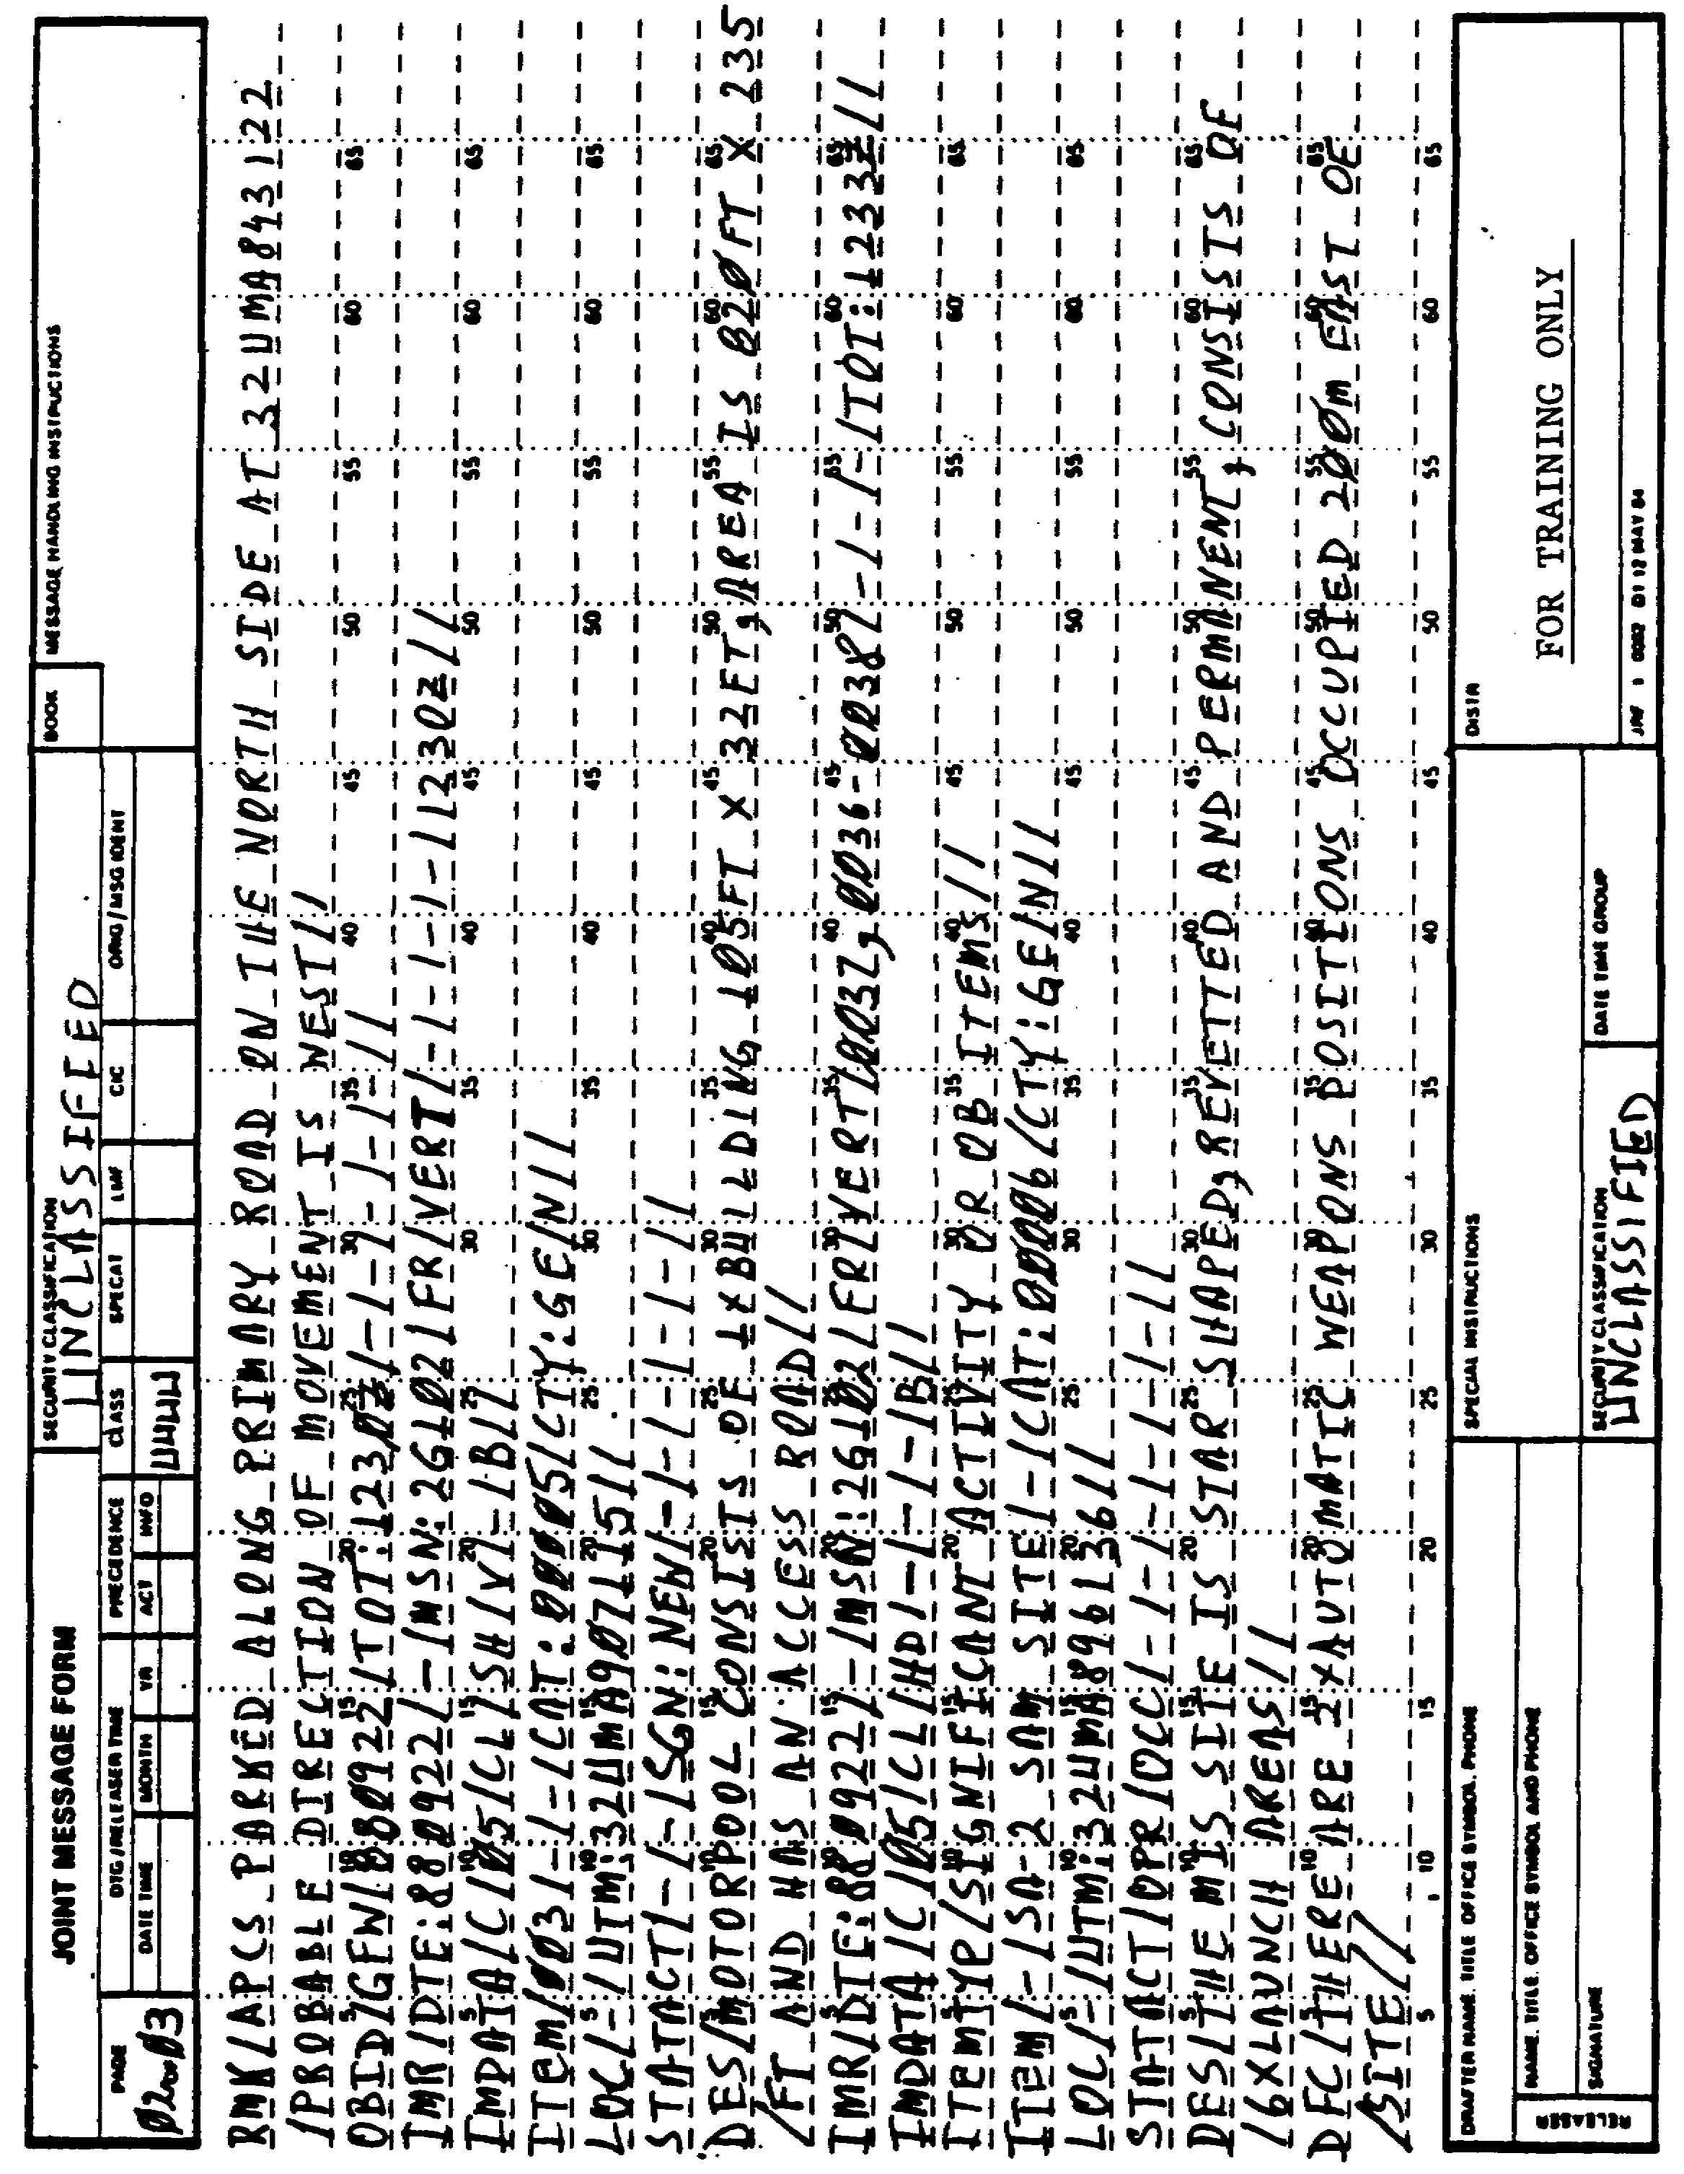

Figure 4-2. Continued.

IT0667 58

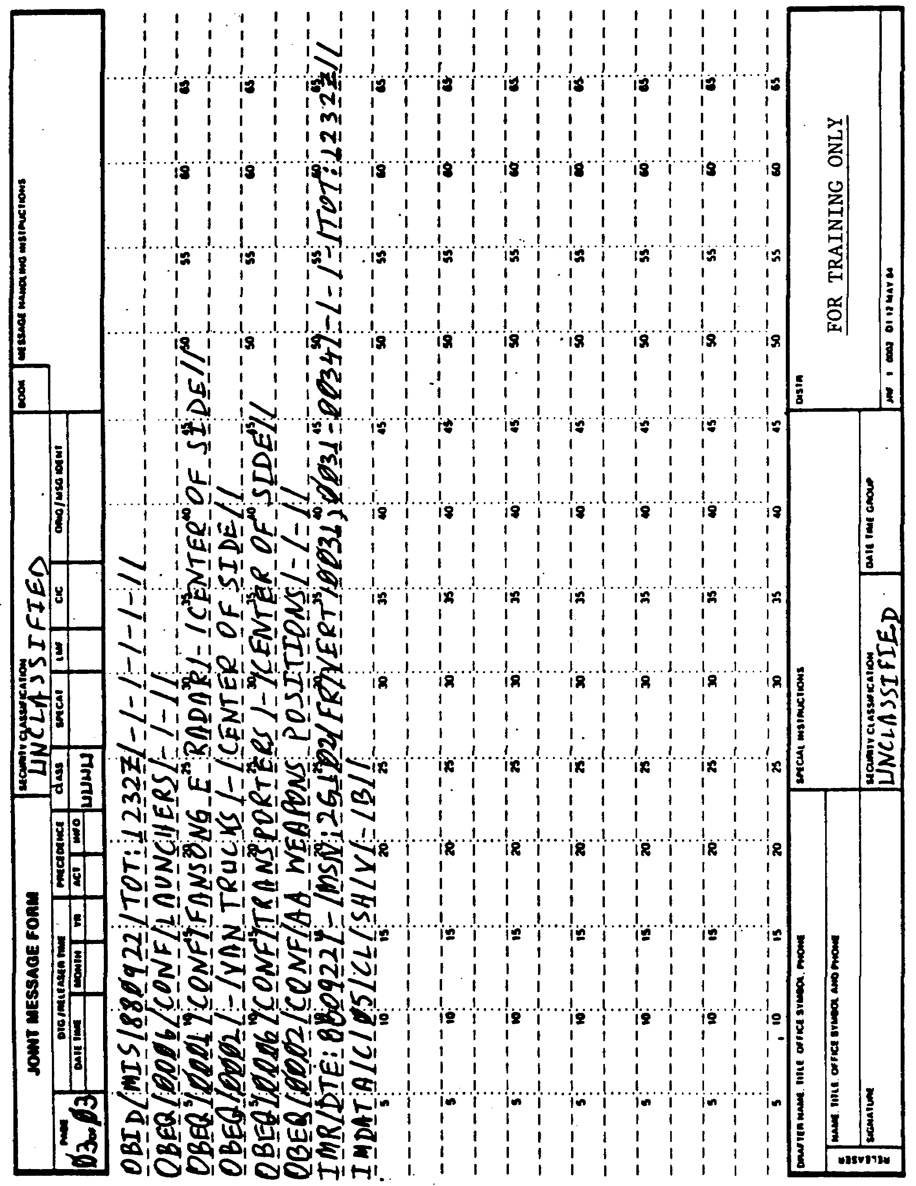

Figure 4-2. Continued.

59 IT0667

Use the message map (Figure 4-3) on pages 60-62 to record the mistakes or omissions on the IIR (Figure 4-2) by comparing the latter to the correct IIR in Figure 4-4.

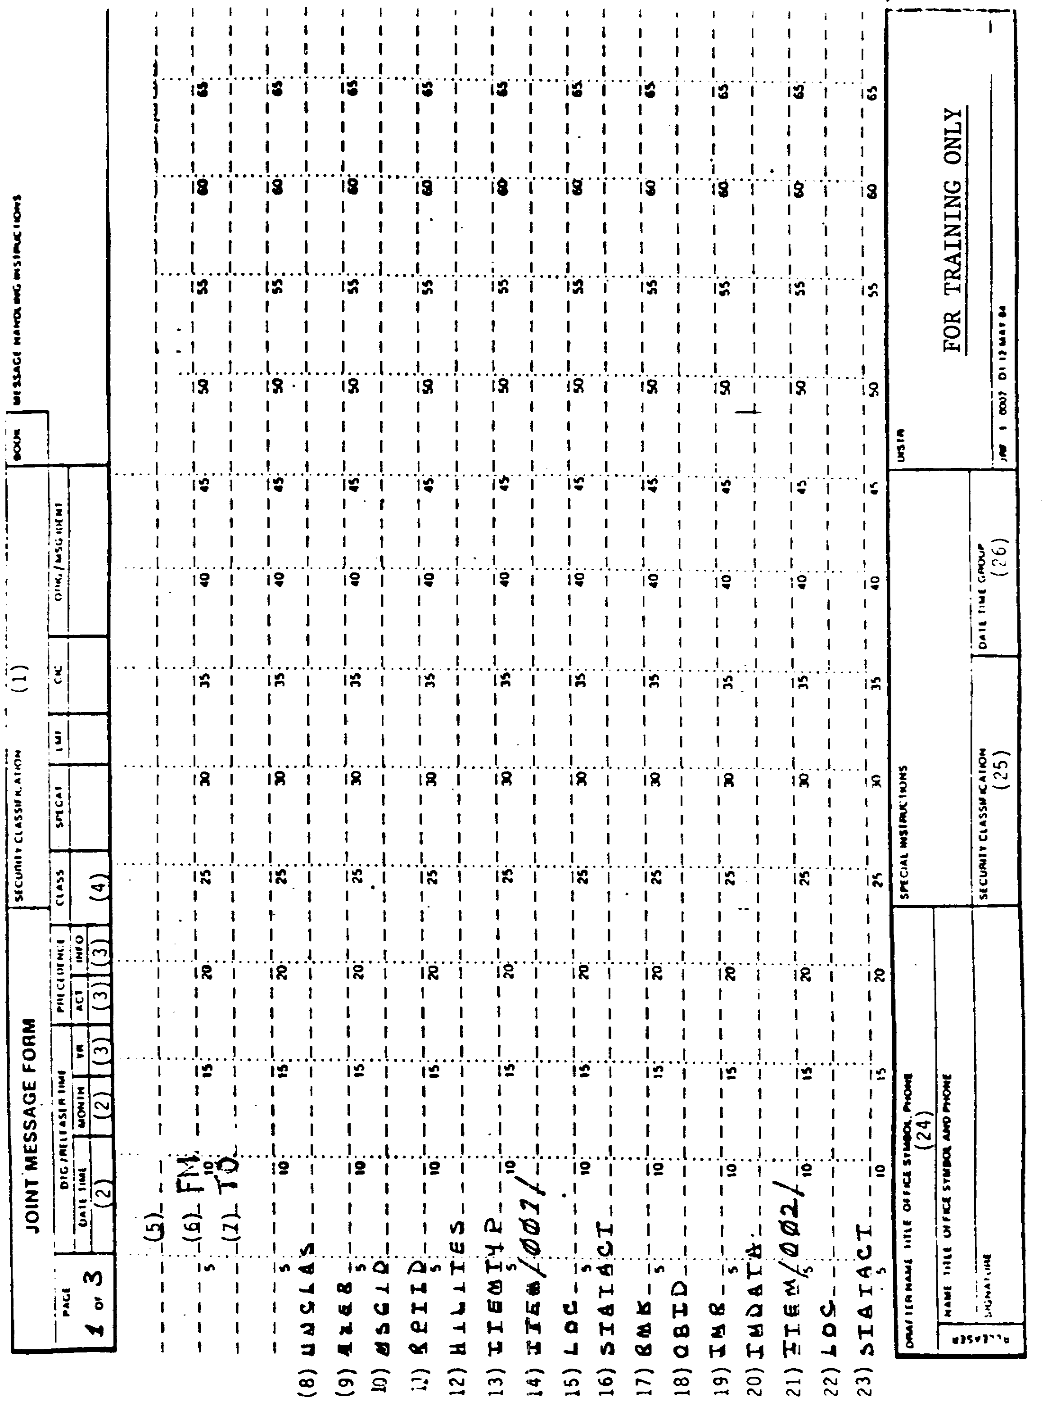

Figure 4-3. Message Map.

IT0667 60

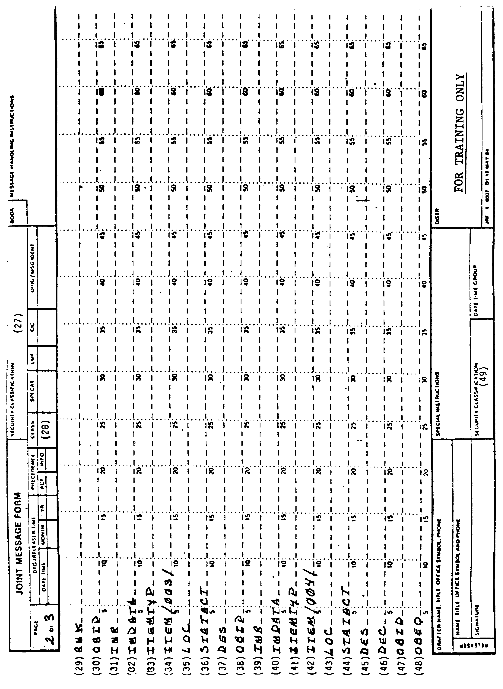

Figure 4-3. Continued.

61 IT0667
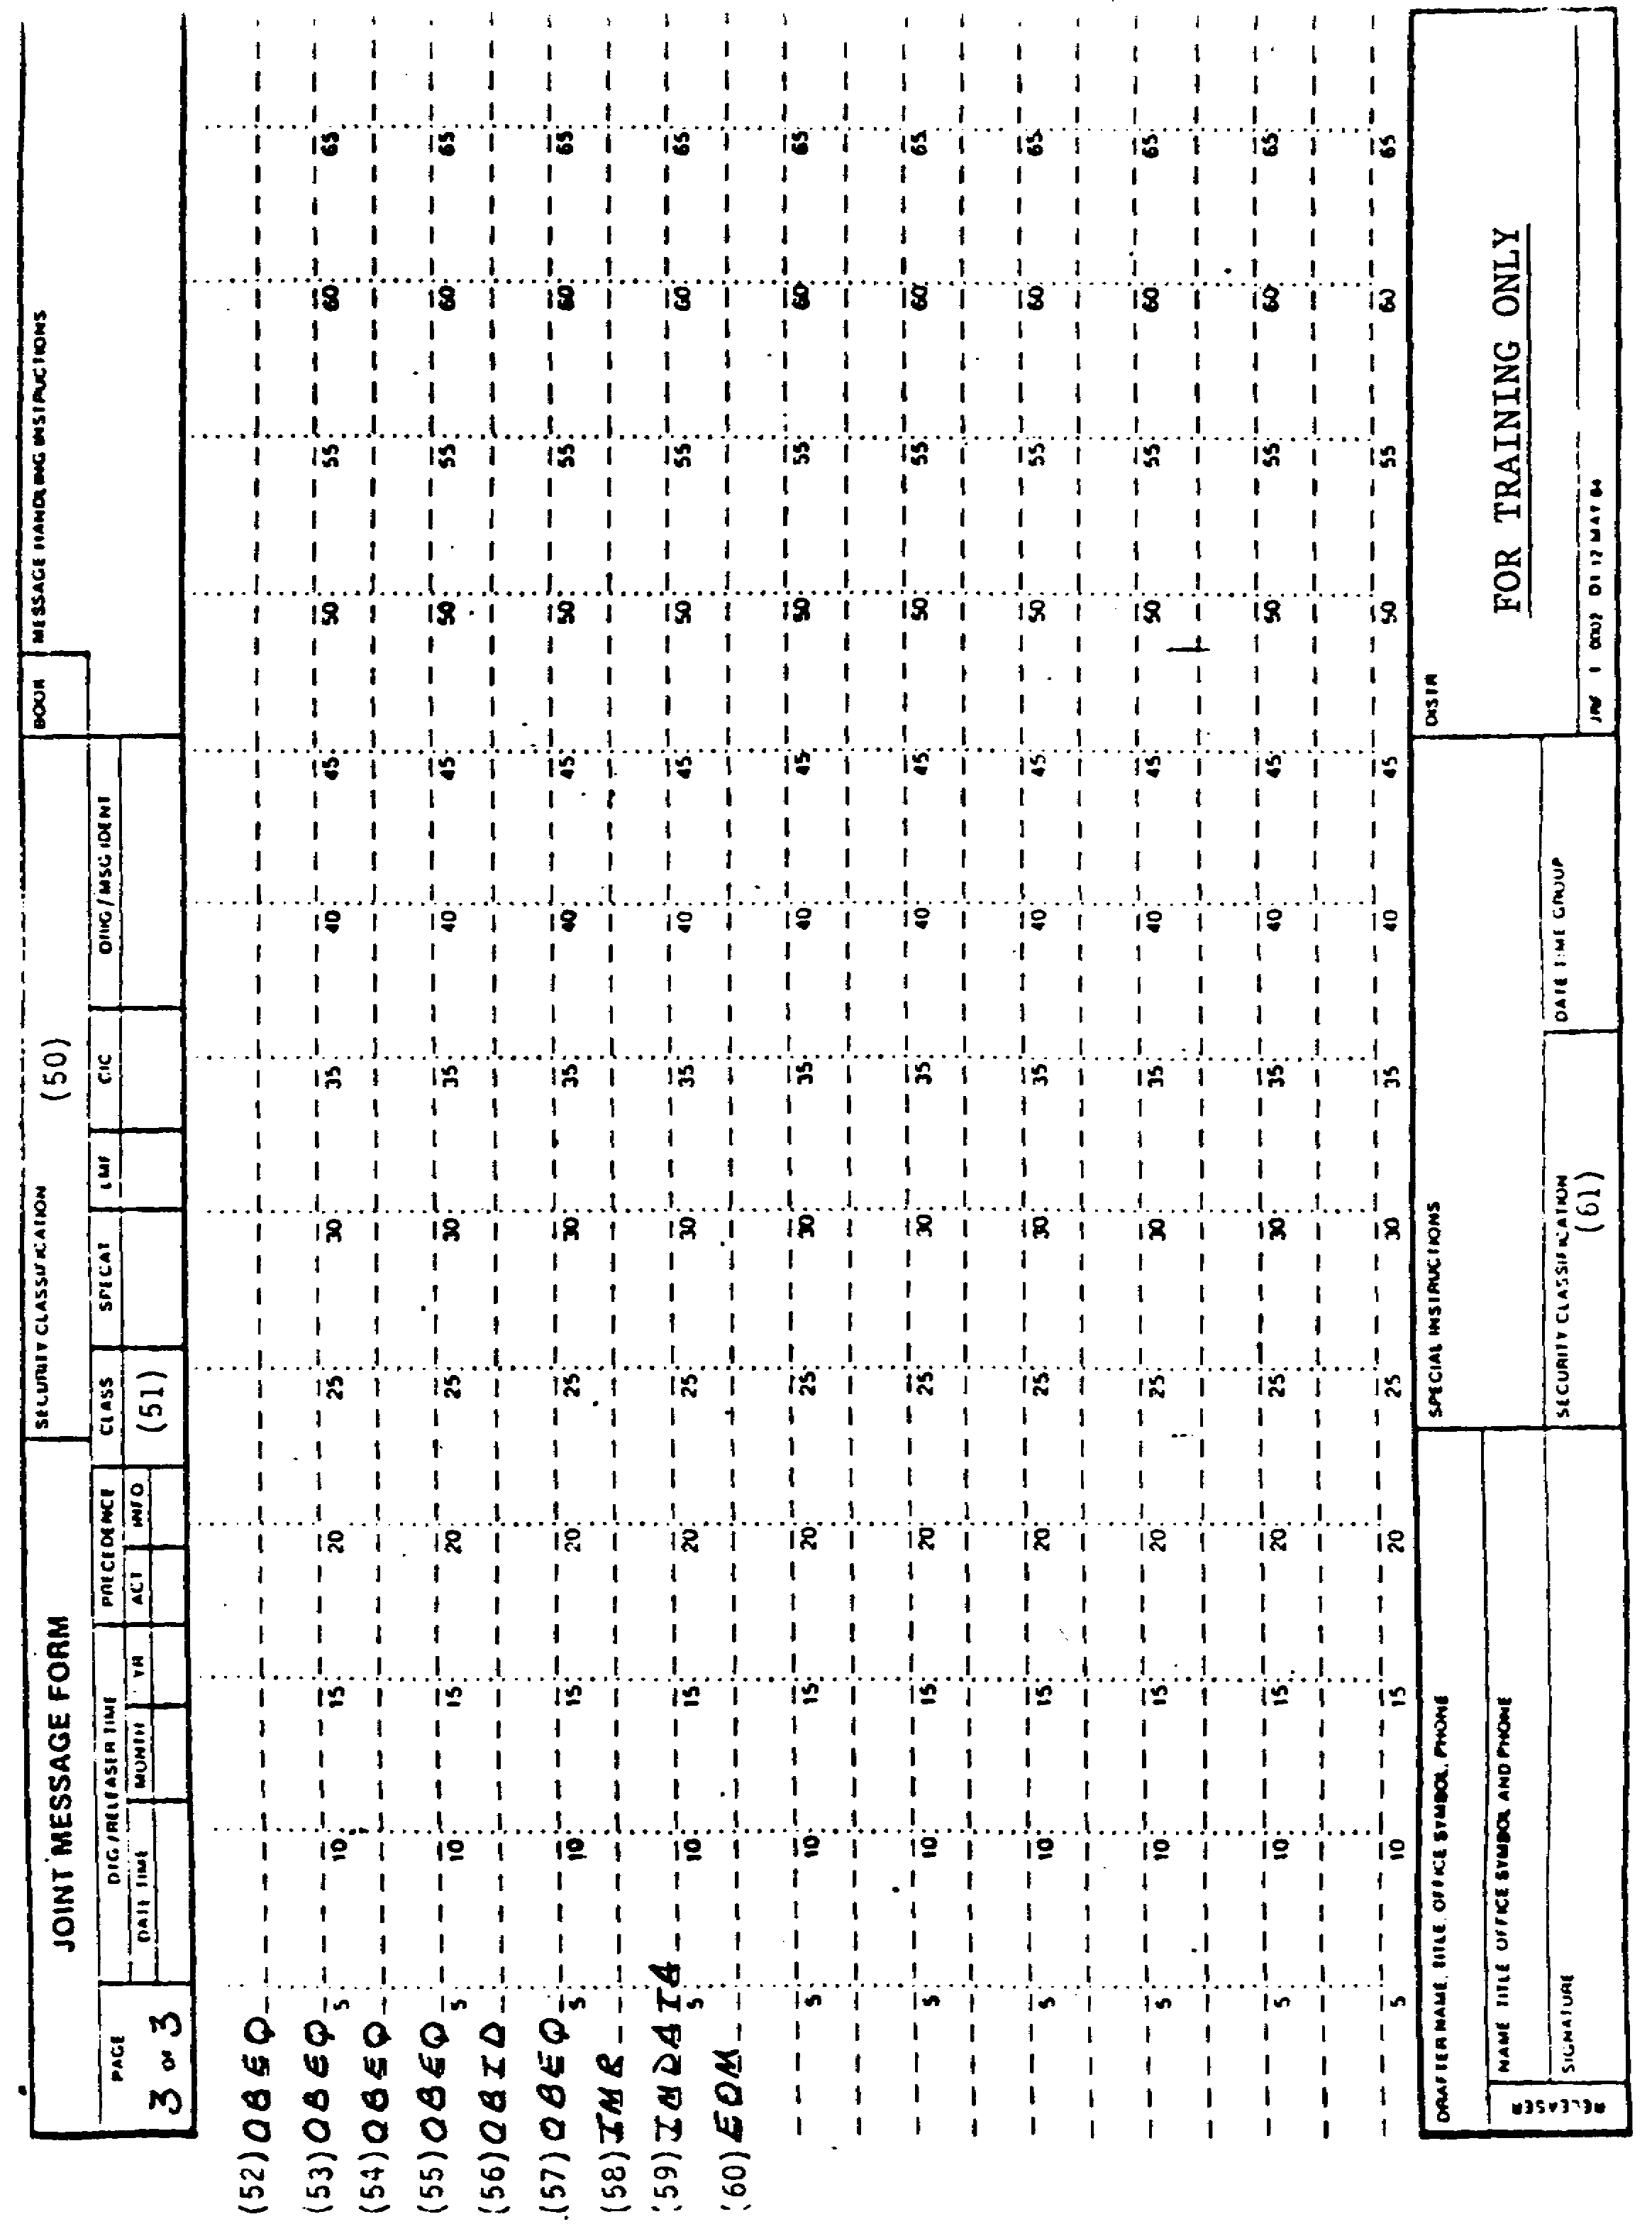

Figure 4-3. Continued.

IT0667 62

Compare your corrected IIR with the IIR in (Figure 4-4).

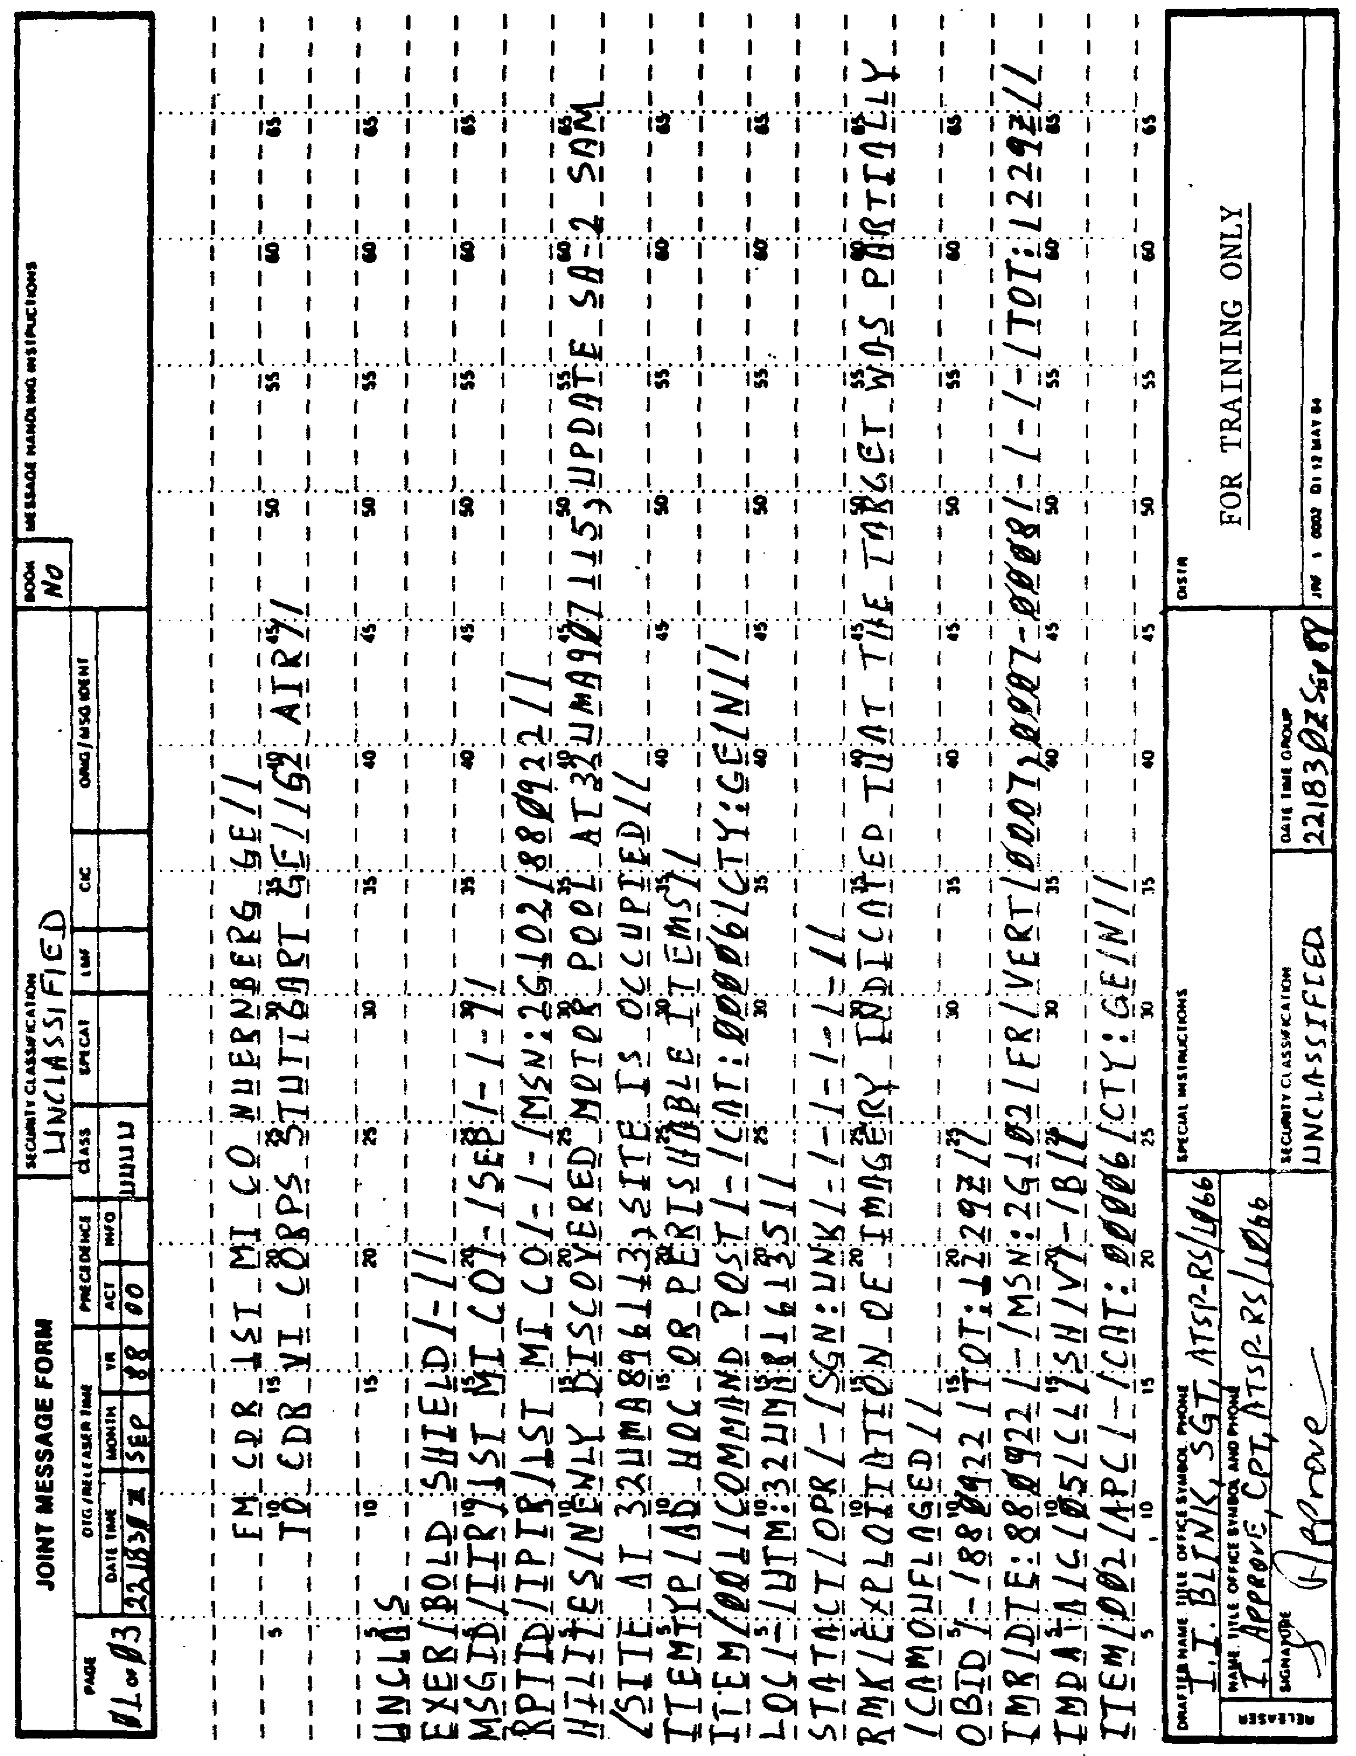

Figure 4-4. Correct IIR.

63 IT0667

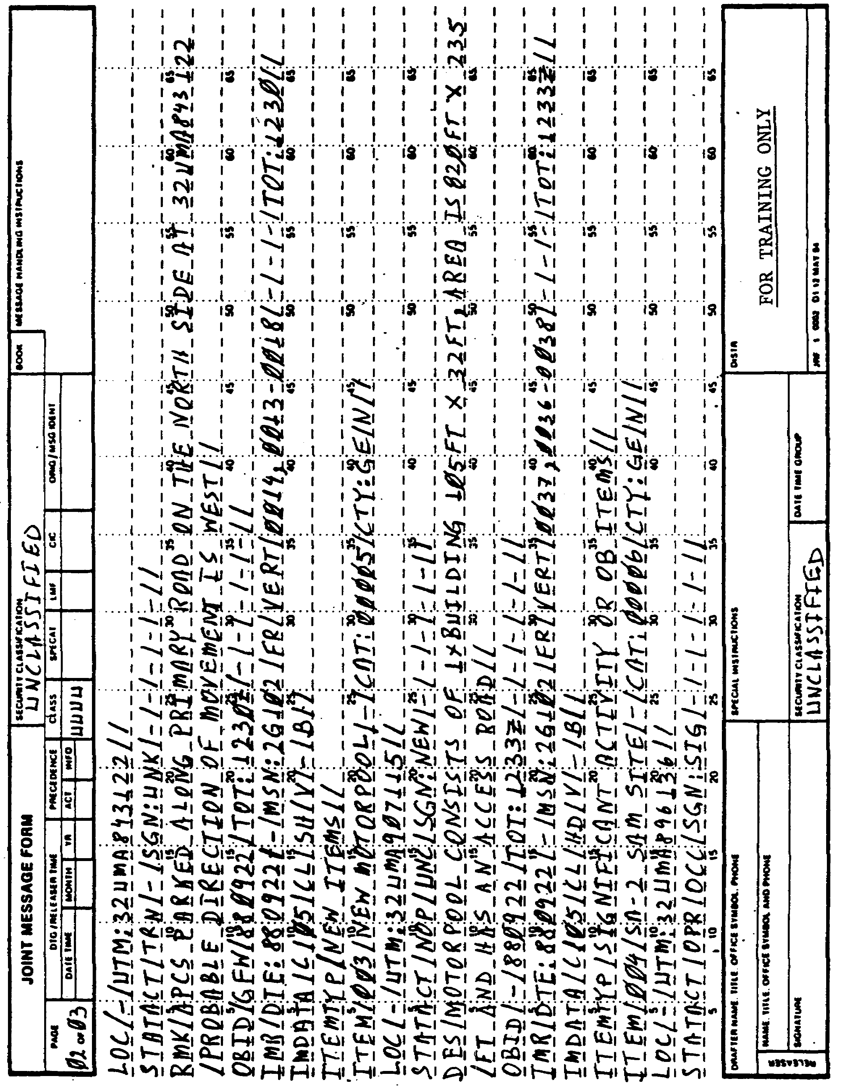

Figure 4-4. Continued.

IT0667 64

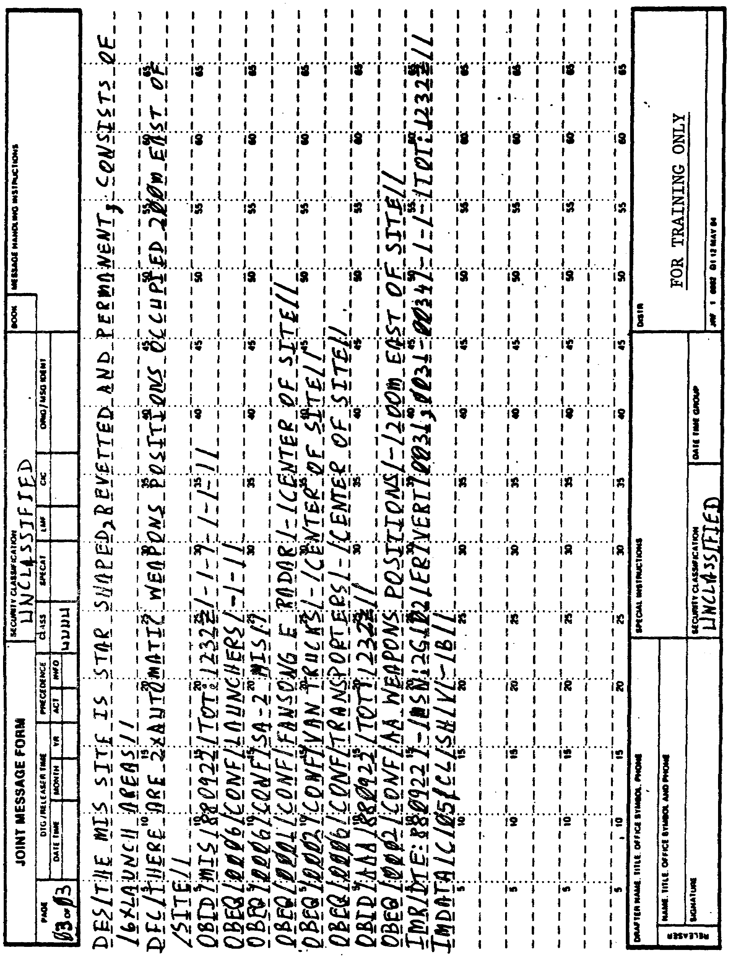

Figure 4-4. Continued.

65 IT0667

LESSON 4

PRACTICE EXERCISE

ANSWER KEY AND FEEDBACK

Item (2). 221330Z is ESD. The correct date/time should read 221830Z after adding 5 hrs to ESD (4 hours) and TOT (approximately 1 hour). After ESD you have 4 hrs in which to complete the IPIR (page 38, note).

Item (5). This line should be blank. The "FM" address should be started on the second line. All other lines should be slipped by one line (page 6, remember).

Item (7). "G-2 AIR" was omitted from this line. G-2 AIR is the section within the VII CORPS to which the report is to be sent (page 6, para (13)).

Item (9). Exercise name was omitted. Exercise name "BOLD SHIELD" must be entered (page 23, para 2a(1)(a)).

Item (12). Set name "HILITES" was left out completely (after RPTID set). In this set you briefly mention NEW TARGETS and SIGNIFICANT ACTIVITY or OB ITEMS. Do NOT mention PERISHABLE ITEMS (page 39, para 3).

Item (14). "ITEM" set. The field target category is CAT: 00006 (page 40, para 5d).

Item (18). "OBID" set. The field time on target is TOT: 1229Z (page 45, para 12c).

Item (19). "IMR" set. The field mission number is MSN: 2G102 (page 47, para 16c); best frame number (0007) must be entered (page 48, para 16f).

Item (23). "STATACT" set. The field operations status is TRN (page 42, para 9a).

Item (31). "IMR" set. The field image numbers are 0014, 0013-0018 (page 48, para 16f). TOT entry should be TOT: 1230Z (page 48, para j).

Item (33). "ITEMTYP" set. The field item type is omitted (page 39, para 4).

Item (34). "ITEM" set. The field target name is NEW MOTORPOOL (page 39, para 5b).

Item (36). "STATACT" set. The field operational status is NOP (not operational (page 42, para 9a, and appendix C, entry list 983, page 291).

The field secondary status is UNC (under construction)(page 301, appendix C, entry list 983).

IT0667 66

Item (38). Set name "OBID" omitted from report completely (page 44, para 12).

Item (40). "IMDATA" set. The field angle of coverage is V (page 50, table 4-8).

Item (42). "ITEM" set. The field item number is 004 (page 39, para 5a).

Item (44). "STATACT" set. The field SGN: amount of change is SGN: SIG (page 42, para 9c and table 4-1).

Item (52). Set "OBEQ/0006/CONF/SA-2 MIS//" was omitted from report completely (page 46, para 13).

Item (54). "OBEQ" set. The field validity description is CONF (confirmed)(page 46, para 13b).

Item (56). "OBID" set omitted from report completely (page 47, para 14).

Item (57). "OBEQ" set. The field equipment comments 200 M EAST OF SITE (page 47, para 13e).

67 IT0667

LESSON 5

JTACSURVREQ PREPARATION

OVERVIEW

Task Description:

In this lesson you will learn how to prepare a JTACSURVREQ in USMTF format.

LEARNING OBJECTIVES:

ACTIONS: Describe the information and procedures on how to prepare a JTACSURVREQ in USMTF format.

CONDITIONS: You will be given extracts from DA Pam 25-7, NATO STANAG 3377, NATO STANAG 3596, STP 34-96D1-SM, and STP 34-96D24-SM-TG.

STANDARDS: You will prepare a JTACSURVREQ IAW to DA Pam 25-7, NATO STANAG 3377, NATO STANAG 3596, STP 34-96D1-SM, and STP 34-96D24-SM-TG.

REFERENCES: The material contained within this lesson was derived from the following publications:

DA Pam 25-7.
NATO STANAG 3377.
NATO STANAG 3596.
STP 34-96D1-SM.
STP 34-96D24-SM-TG.

INTRODUCTION

The JTACSURVREQ is a Reconnaissance and Surveillance (R&S) request prepared by the G2 Air/TSO and IAs. It is used to identify specific information requirements (SIRs) which would normally be short term or of a one-time nature, with a specified time frame.

IT0667 68

PART A: JTACSURVREQ DESCRIPTION

Collection managers use the JTACSURVREQ to identify SIRs. The collection manager ways the SIRs to identify the reports desired by the requester to include time sensitive and summary-type information. If the information you want is available by other means, that information may be given to you by another message (IIR, INTREP, and so on).

PART B: JTACSURVREQ PREPARATION IN USMTF FORMAT

1. Heading and ending descriptions of a JTACSURVREQ message are omitted since these have been sufficiently discussed in the previous lessons. Refer to Appendix B and Figure 5-1 while following the instructions below on how to complete a JTACSURVREQ.

2. The first set of this message is the "EXER" set. This set is conditional and starts the text of the message.

a. The first field entry after the set identification EXER is the "exer name." This will reflect the name of the exercise.

b. The second field entry is the "add id." This is an additional exercise identifier. This will be used if one is available. For example:

EXER/GOLDEN BUSH/SILVER BUSH//

3. The second set is the "OPER" set. This set is conditional and is used if there was an operation in play or an exercise name was not used.

NOTE: Either the "EXER" or the "OPER" set is used. If there was not an exercise or an operation, then neither of the two will be used.

a. The first field entry after "OPER" set is the "oper name." This entry reflects the name of the operation. If there is no operation name this field will be replaced with a hyphen (-).

b. The second field entry is the "plan orig & number." This field contains the headquarters originating the plan and the plan number.

c. The third field entry is the "option name." This field contains an option name, if applicable, within the operation.

d. The fourth field entry is the "2d option." This field reflects the second option name, if applicable, within the operation.

e. Following is an example of the OPER set:

OPER/CANDLESTICK 87/HQ, 3D MI BN/PIE RACK/SNOW QUEEN//

4. The third set is the mandatory "MSGID" set. This is the same as the initial sets. The first field is the only difference. "JTACSURVREQ" will

69 IT0667

be the first field entry. All the other field entries are the same as discussed in previous lessons.

5. The fourth set, the "REF," is optional. It is written exactly as shown in the "initial sets."

6. The fifth set is the "REQDATA." This set is used to describe the request. This is a mandatory set, which can be repeated.

a. The first field entry after "REQDATA" is the "request nr." This field entry reflects the request number. For example:

323

b. The second field entry is the "PRY." This field indicates the request priority. 1 is the highest priority, 2, 3, 4 are lower in that order. For example:

PRY:3

c. The third field entry is the "DATEDES." This is the date the information is desired by the requester. This information will be reflected by two digits for the year, month, and date. For example:

DATEDES:870503

d. The fourth field entry is the "LTIOV." This field contains the latest time the information is of value. It is expressed by two digits for the year, month, day, hour, minute, followed by one letter for the time zone. Following is an example of this field:

LTIOV:8705231430Z

e. The fifth field entry is the "mission type." Table 5-1 lists the allowable mission type codes.

Table 5-1. Mission Type Codes.

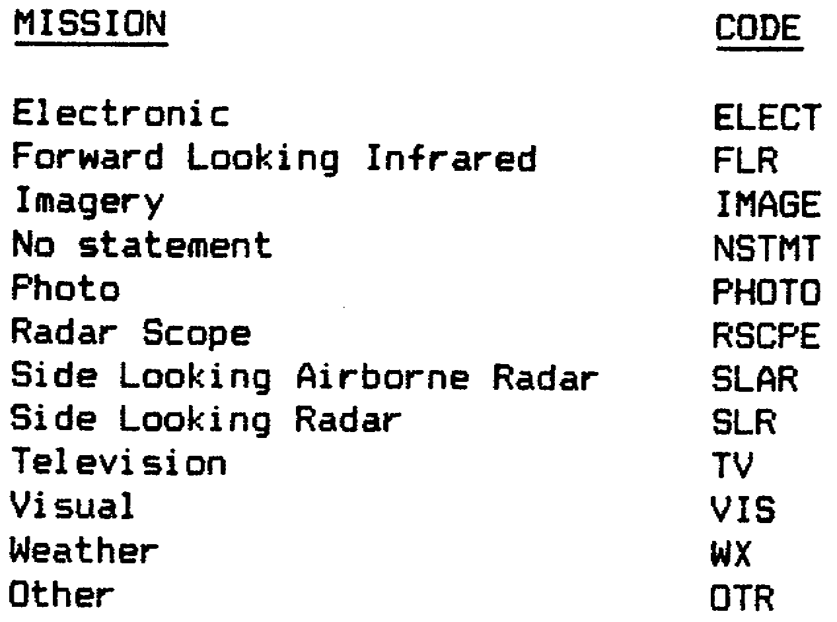

IT0667 70

NOTE: If "OTR" is used, it must be explained in a free text set.

f. The sixth field entry is the "coverage type." Table 5-2 lists the acceptable coverage type codes:

Table 5-2. Coverage Type Codes.

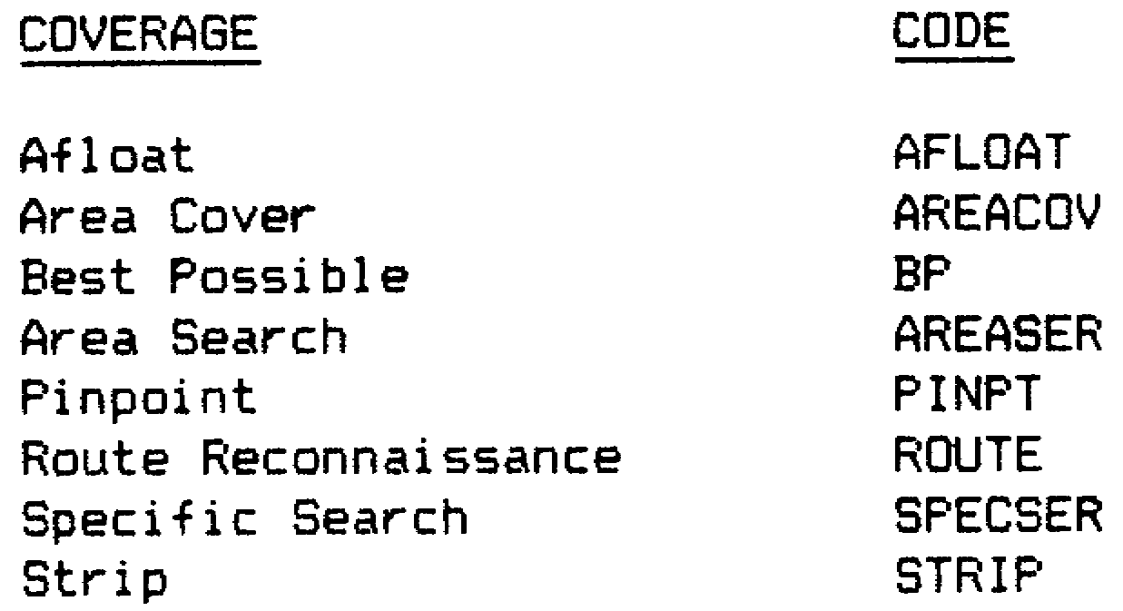

g. The seventh field entry is the "TOT." Enter the time over target, expressed with two digits for the hour, minute, and one letter for the time zone, mission start time. For example:

TOT:1700Z

h. The eighth field entry is the "DPRIOROK." This field states if you will accept prior coverage(s). After the field name, the number of days that prior coverage is acceptable. For example:

DPRIOROK:5 (This would indicate five day old prints are acceptable.)

i. The ninth field entry is the "image type." The imagery type code will be entered here. One of the following codes in Table 5-3 will apply:

Table 5-3. Image Type Codes.

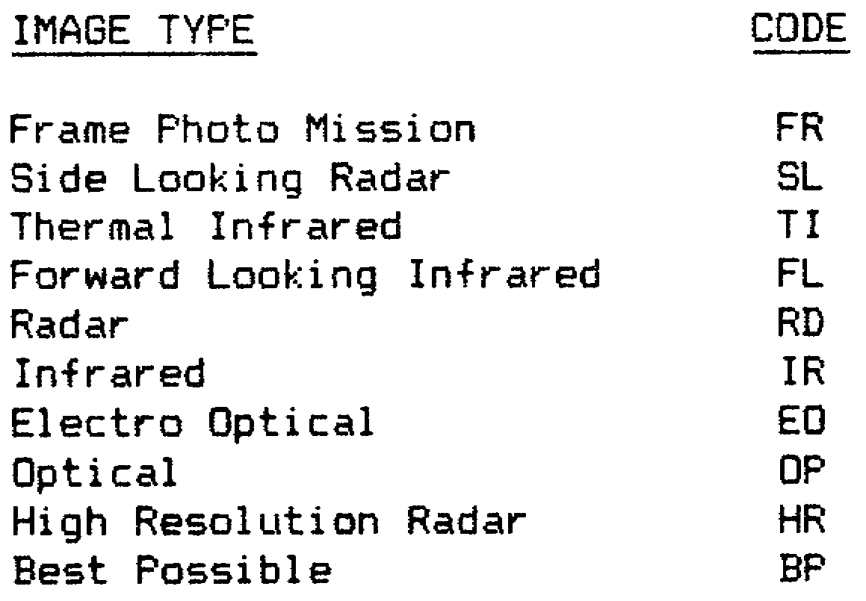

71 IT0667

j. The 10th field entry is the "IMQ." The image qualifier from Table 5-4 will be used:

Table 5-4. Image Qualifier Codes.

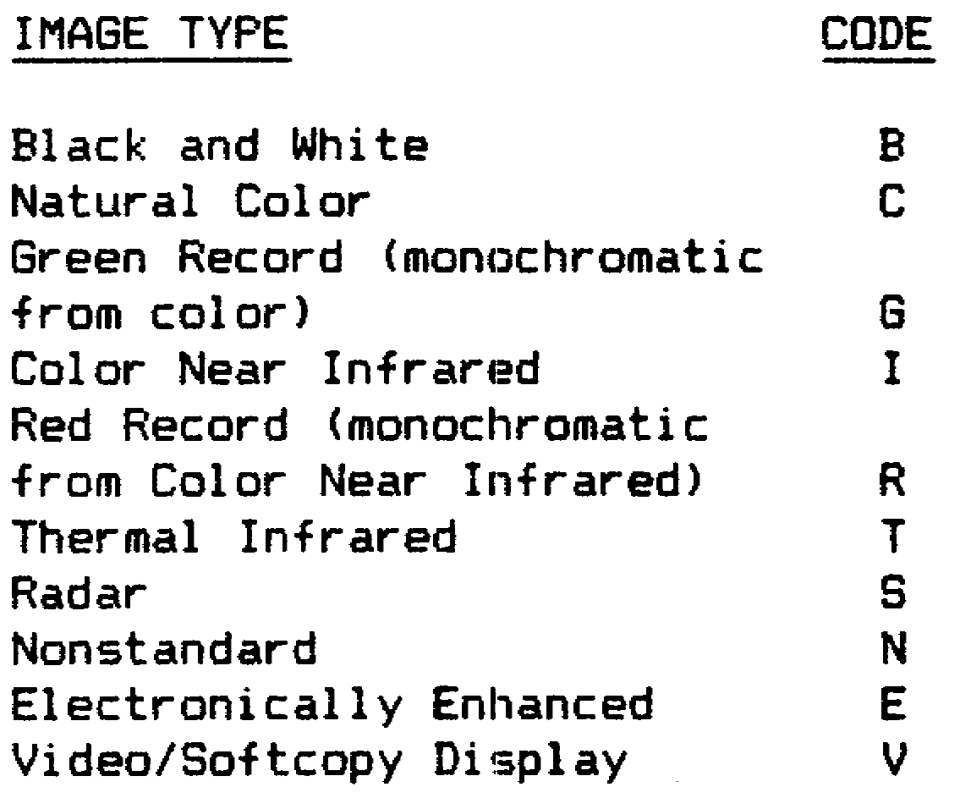

k. The 11th field entry is the "CM." This field indicates the coverage mode/extent. One of the following codes from Table 5-5 will be used.

Table 5-5. Coverage/Mode Codes.

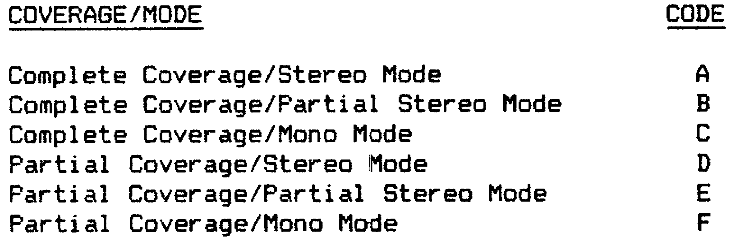

1. The 12th field entry is the "sensor pos." This field indicates the sensor position. This field will be used if the sensor tasked has a variable orientation capability. See Appendix C, entry list 564, for authorized codes.

IT0667 72

m. The 13th field entry is the "map reference." This field is used to record the map reference, which is used to plot the area of interest. Record the information in the following sequence:

(1) Map Series Designator, such as: M201

(2) Sheet Name or Number, such as: Hillsburg or 5678

(3) Edition Number, such as: 02

(4) Year, such as: 84

(5) Following is an example of this field:

M201HILLSBURG4284

n. The 14th field entry is the "print scale." Enter the scale of prints required (0 through 1000000). For example:

50000

o. The 15th and last field entry for this set is the "requesting agency." This field shows the requesting agency's name to include the delivery address for an airdrop of imagery. For example:

3RD ARMORED CORPS

p. Following is an example of a complete REQDATA set:

REQDATA/'323/PRY:3/DATADES:870503/LTIOV 8705231430Z/PHOTO/ROUTE
/TOT: 1700Z/DPRIOROK:5/FR/IMQ:B/CM:A/VERT/M201HILLSBURG4284/50000/3D
ARMORED CORPS//

7. The sixth set is the "TRCPLOT." This set is mandatory and shows the area or point of interest.

a. The first field entry after "TRCPLOT" is "initial point." This contains the map coordinates of the initial point. The following instructions apply:

(1) For a circle or ellipse, enter the center.

(2) For a rectangle enter one end of the center line.

(3) For an irregular area enter the first point on the outline.

(4) Longitude/Latitude (GEO) coordinates or UTM (10M or 100M) will be used. For example:

453215N231556W

73 IT0667

b. The second field entry is the "area." This field entry describes the area as RAD (Radius), WDTH (Width), or ELP (Elliptical. The following conditions apply for whichever of these three options are used:

(1) "RAD." The field will start with "RAD." RAD is used for a circular area. The radius will follow RAD; after the radius, one of the following codes will apply (Table 5-6). If necessary, use a "K" to show thousands. For example:

RAD:45FT

Table 5-6. Radii Codes.

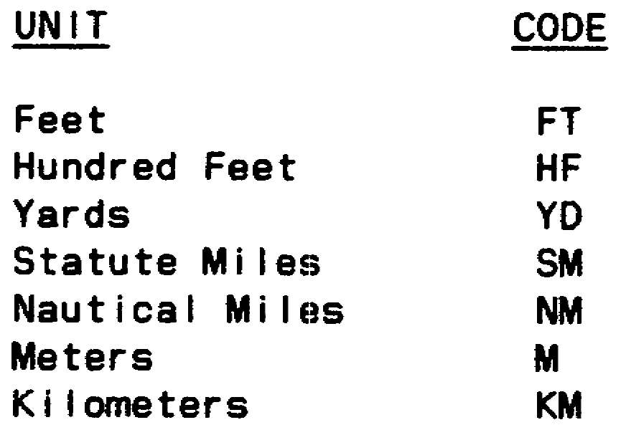

(2) "WDTH." The field will start with "WDTH." This is used for a rectangular area. The only entry will be the width of the rectangle in the same manner as the previous field, utilizing the same codes. For example:

WDTH:25KFT

(3) "ELP." The field will start with "ELP." This field is used for an elliptical area.

(4) The length of the semi-major axis will be entered first the same way as for the radius. After the length, follows a hyphen (-). For the length of the semi-minor axis length, a hyphen (-) is entered.

(5) The last entry for this field is the direction of the major axis points. Enter the number and degrees true to the nearest .1 degree. For example:

ELP:10KFT-5KFT-15DEG

c. The third field entry within the "TRCPLOT" is the "trace." For a rectangular area enter map coordinates of the other end of the center line. For an irregular area enter the map coordinates that outline the area. The last coordinate must be the same as the one you entered in the field "initial point." For example:

453215N231777W

d. Following is an example of a complete "TRCPLOT" set:

TRCPLOT/453215N231556W/WDTH:25KFT/453215N231777W//

IT0667 74

8. The seventh set is the "TGTCOD." This set is conditional and used to give the "recce target code(s) " of interest. The set identifier TGTCOD is the first entry.

a. The only field entry is "target code." This is the RECCE Target Category (Appendix C, entry list 1218), followed by the code for the Target Item Category (Appendix C, entry list 1220). For example:

2ABCD

b. Following is an example of a complete "TGTCOD" set:

TGTCOD/2ABCD//

9. The eighth set is the "Heading/Reports." This set is conditional and used to request the reports that are desired. This set is not mandatory, but is conditional. This set carries two other sets that go along with it. For example:

HEADING/REPORTS//

10. The ninth and 10th sets.

The first of the two sets that go along with the "HEADING/REPORTS" is the "9RECONRQ" set. This set is conditional; however, it must be used if the previous set (Heading/Reports) was used.

a. The first entry after 9RECONRQ of this set is the set identifier "9RECONRQ." On the next line, the column headers will be listed. Three column headers will be used as follows:

(1) RPTREQ, starting on space number 1, using a slant character.

(2) RECPD, starting on space number 22, using a slant character.

(3) QTY, starting on space number 28, using a slant character.

b. The "RPTREQ" column contains the USMTF short title of the desired report. The "RECPD" column contains the code for the required product. Table 5-7 lists the required codes:

Table 5-7. RECPD Codes.

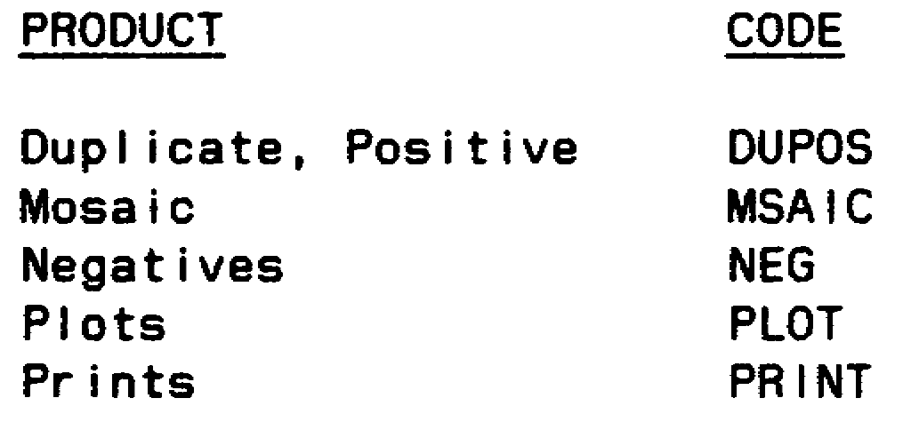

75 IT0667

c. The "QTY" set contains the number of products that are desired.

d. Following is an example of this set:

9RECONRQ
/RPTREQ /RECPD/QTY
/RECCEXREP /NEG /15
/RADAREXREP /PLOT /23//

NOTE: Double slant after the last entry, of the last line, under column "QTY," to indicate end of set.

11. The 11th set is the "9INFLTRF." This set is conditional and used only if you request an INFLIGHTREP.

a. The only entry on the line is the set identifier "9INFLTRF."

b. On the next line, the column headers will be listed. Four column headers will be used as follows:

(1) "CALLSIGN," which has the callsign of the unit receiving the INFLIGHTREP.

(2) "R-FREQ," which has the radio frequency of the ground unit that wants the INFLIGHTREP as follows:

Enter the number and use the decimal point if needed. Then enter one of the following: Hertz (HZ), Kilohertz (KHZ), Megahertz (MHZ), or Gigahertz (GHZ).

(3) "EFF-FM," which contains the effective time period for the call sign and frequency. Enter two digits for the date, hour, minute and one letter for the time zone.

(4) "EFF-TO," which contains the end time period for the call sign and frequency. Entries are made the same as the previous field (column header).

c. Following is an example of "9INFLTRF" set:

9INFLTRF
/CALLSIGN /R-FREQ /EFF-FM /EFF-TO
/RED DOG /32.5 MHZ/111400Z/111915Z
/RED WAGON /15.3 KHZ/121916Z/122350Z//

NOTE: Double slant after the last entry in the "EFF-TO," which indicates end of set.

IT0667 76

12. The 12th set is the "HEADING/AIR DROP INFORMATION." This set is conditional and used if you want an aerial delivery of the products/reports. There are no fields for this set, only the heading identifier.

13. The 13th set is the "REQDATC." This set is conditional. It is used if the previous set was used. This set will contain the fields for the delivery address, location and run-in heading.

a. The first field entry after "REQDATC" is the "delivery address." This will contain the name of the unit to receive the drop. For example:

7TH INF DIV.

b. The second field entry is the "location." Use this field if the previous field does not give the exact location of the air drop. Enter the location in GEO coordinates or UTM coordinates (10M). For example:

33XNS512341234

c. The third field entry is the "RNHDG." This field is used if the run-in heading is operational or a safety factor. The first three digits will contain the numerical heading in degrees. The fourth digit will be an alpha character, either a "T" for True North, or an "M" for Magnetic North. For example:

RNHDG:176M.

d. Following is a complete "REQDATC" set.

REQDATC/7TH INF DIV/33XNS12341234/RNHDG:176M//

14. The last set is "DECL." This set is conditional and it contains the message downgrading instructions. This set will only be used if the message is classified. If the message is unclassified the entire set is disregarded.

a. The only field within this set is the "inst." This field contains the downgrading or declassifying instructions as shown in Table 5-8.

Table 5-8. Declassification Instructions

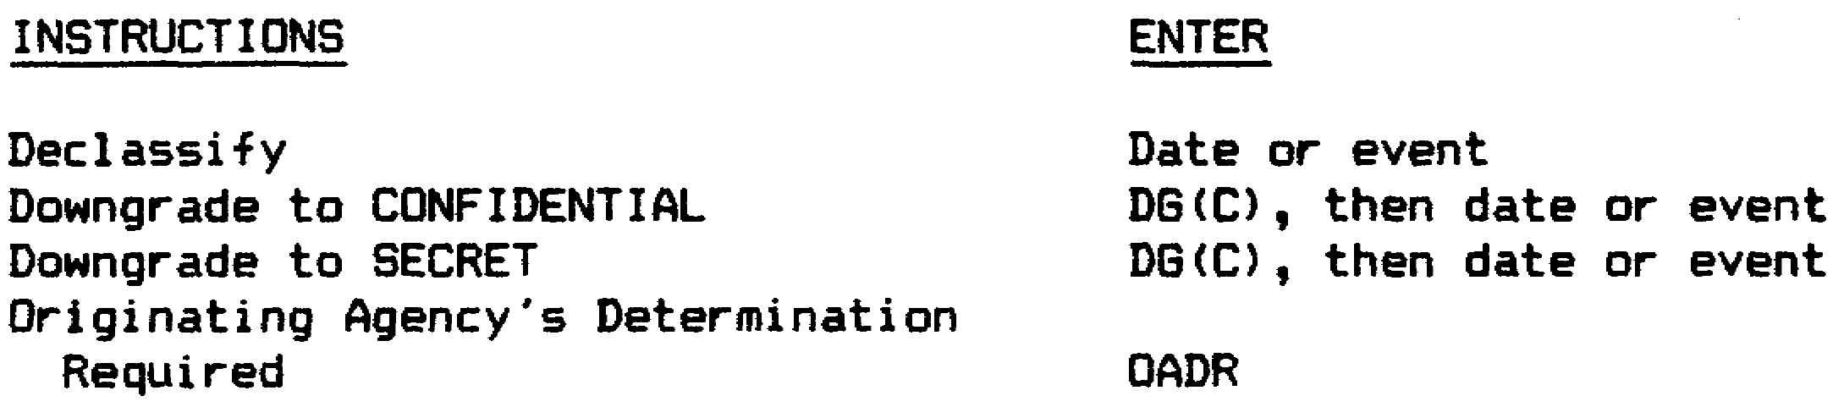

b. For this case, we will use "OADR." For example:

DECL/OADR//

77 IT0667

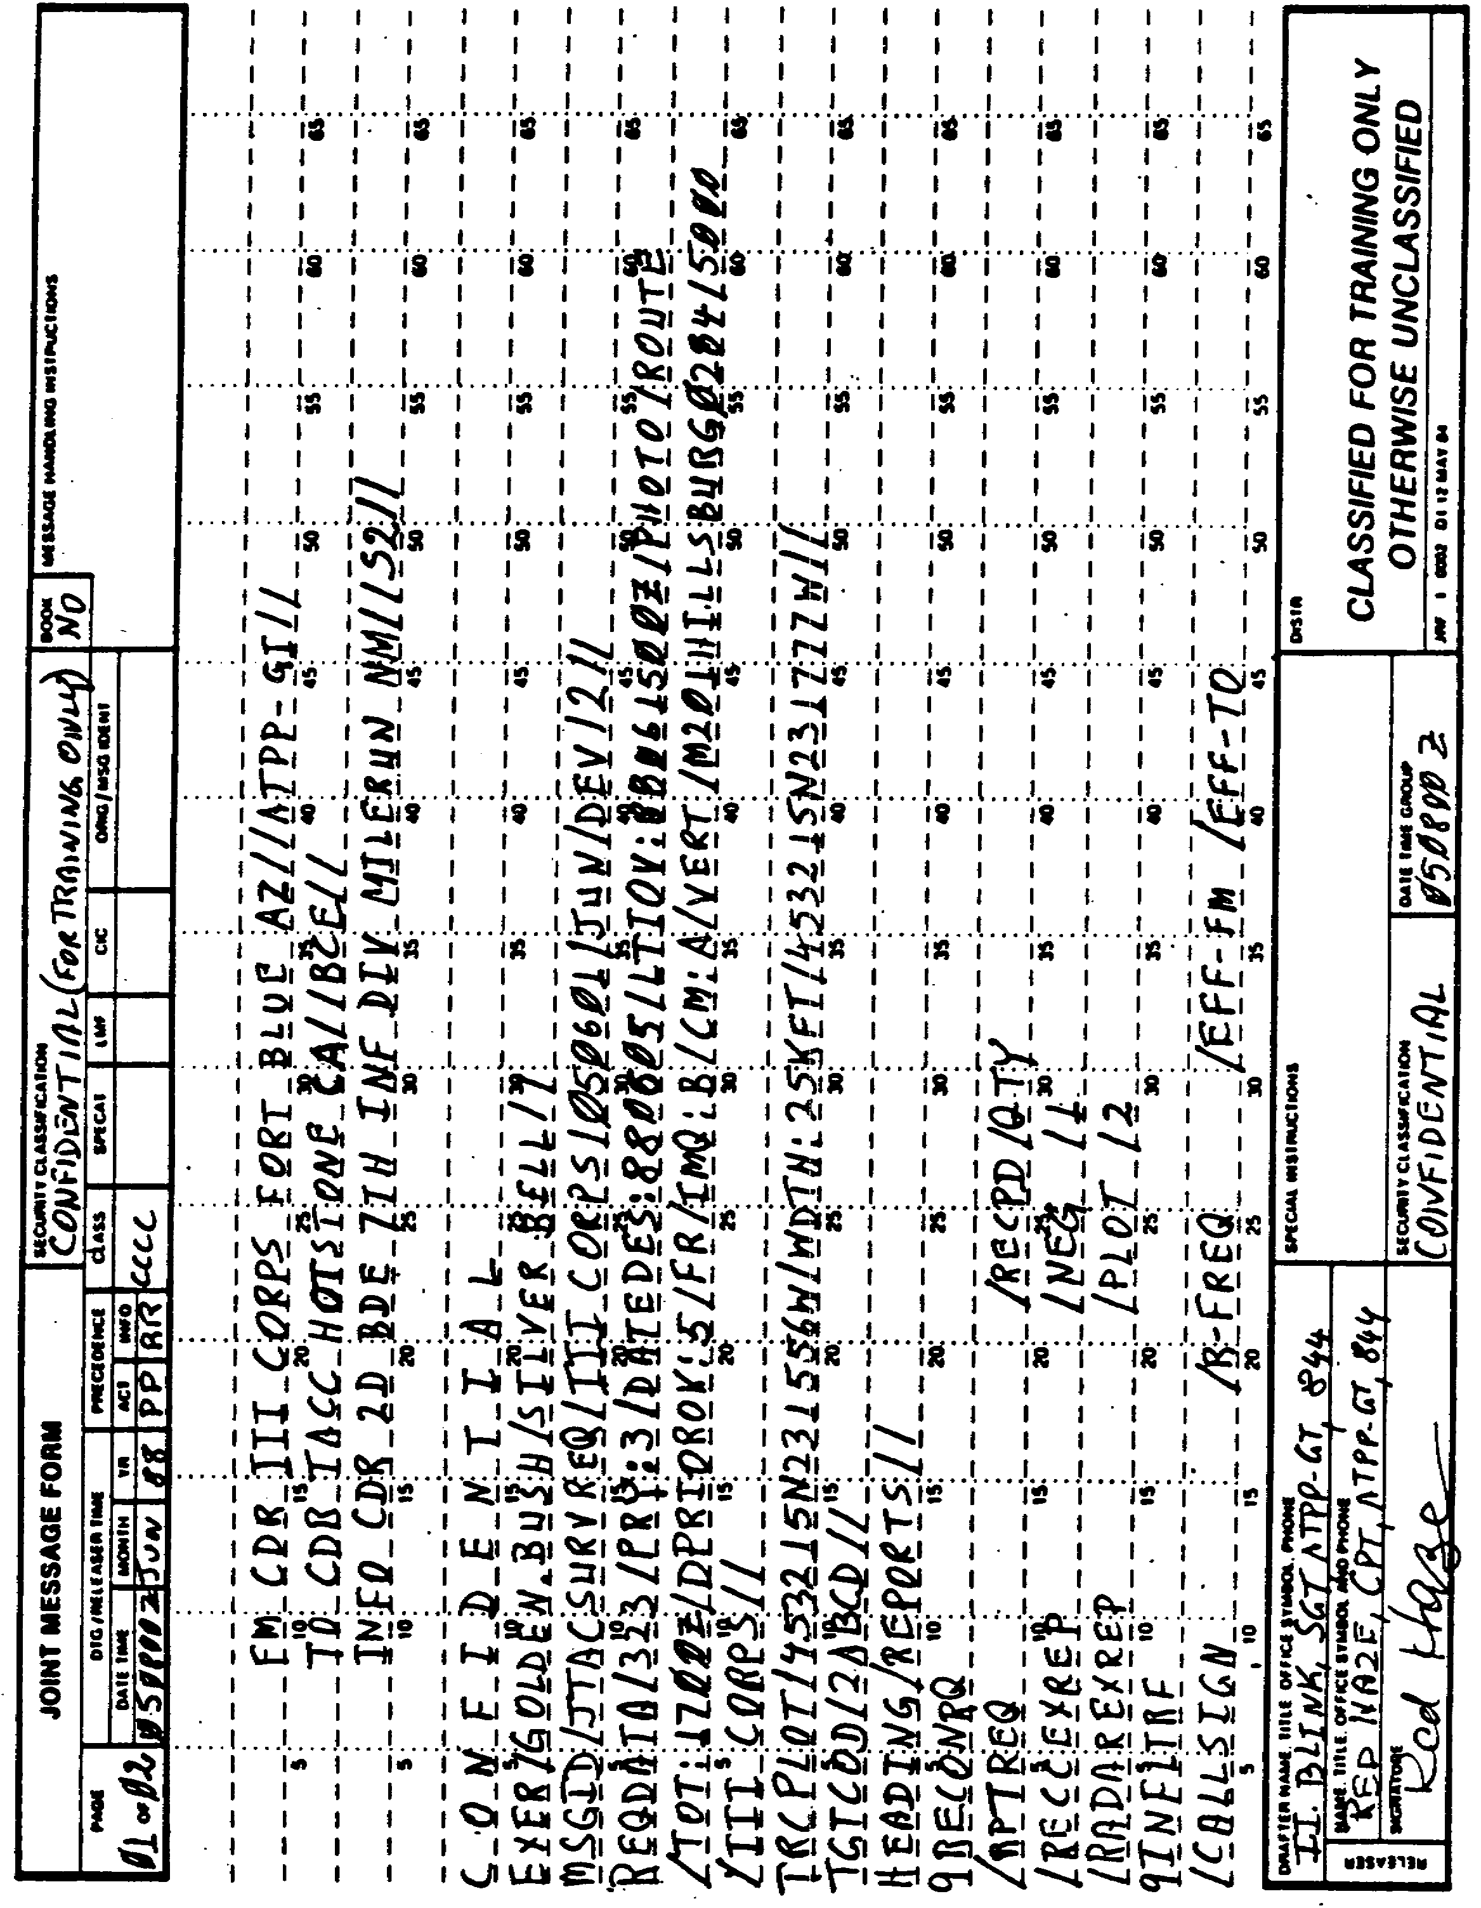

Figure 5-1. Typical JTACSURVREQ.

IT0667 78

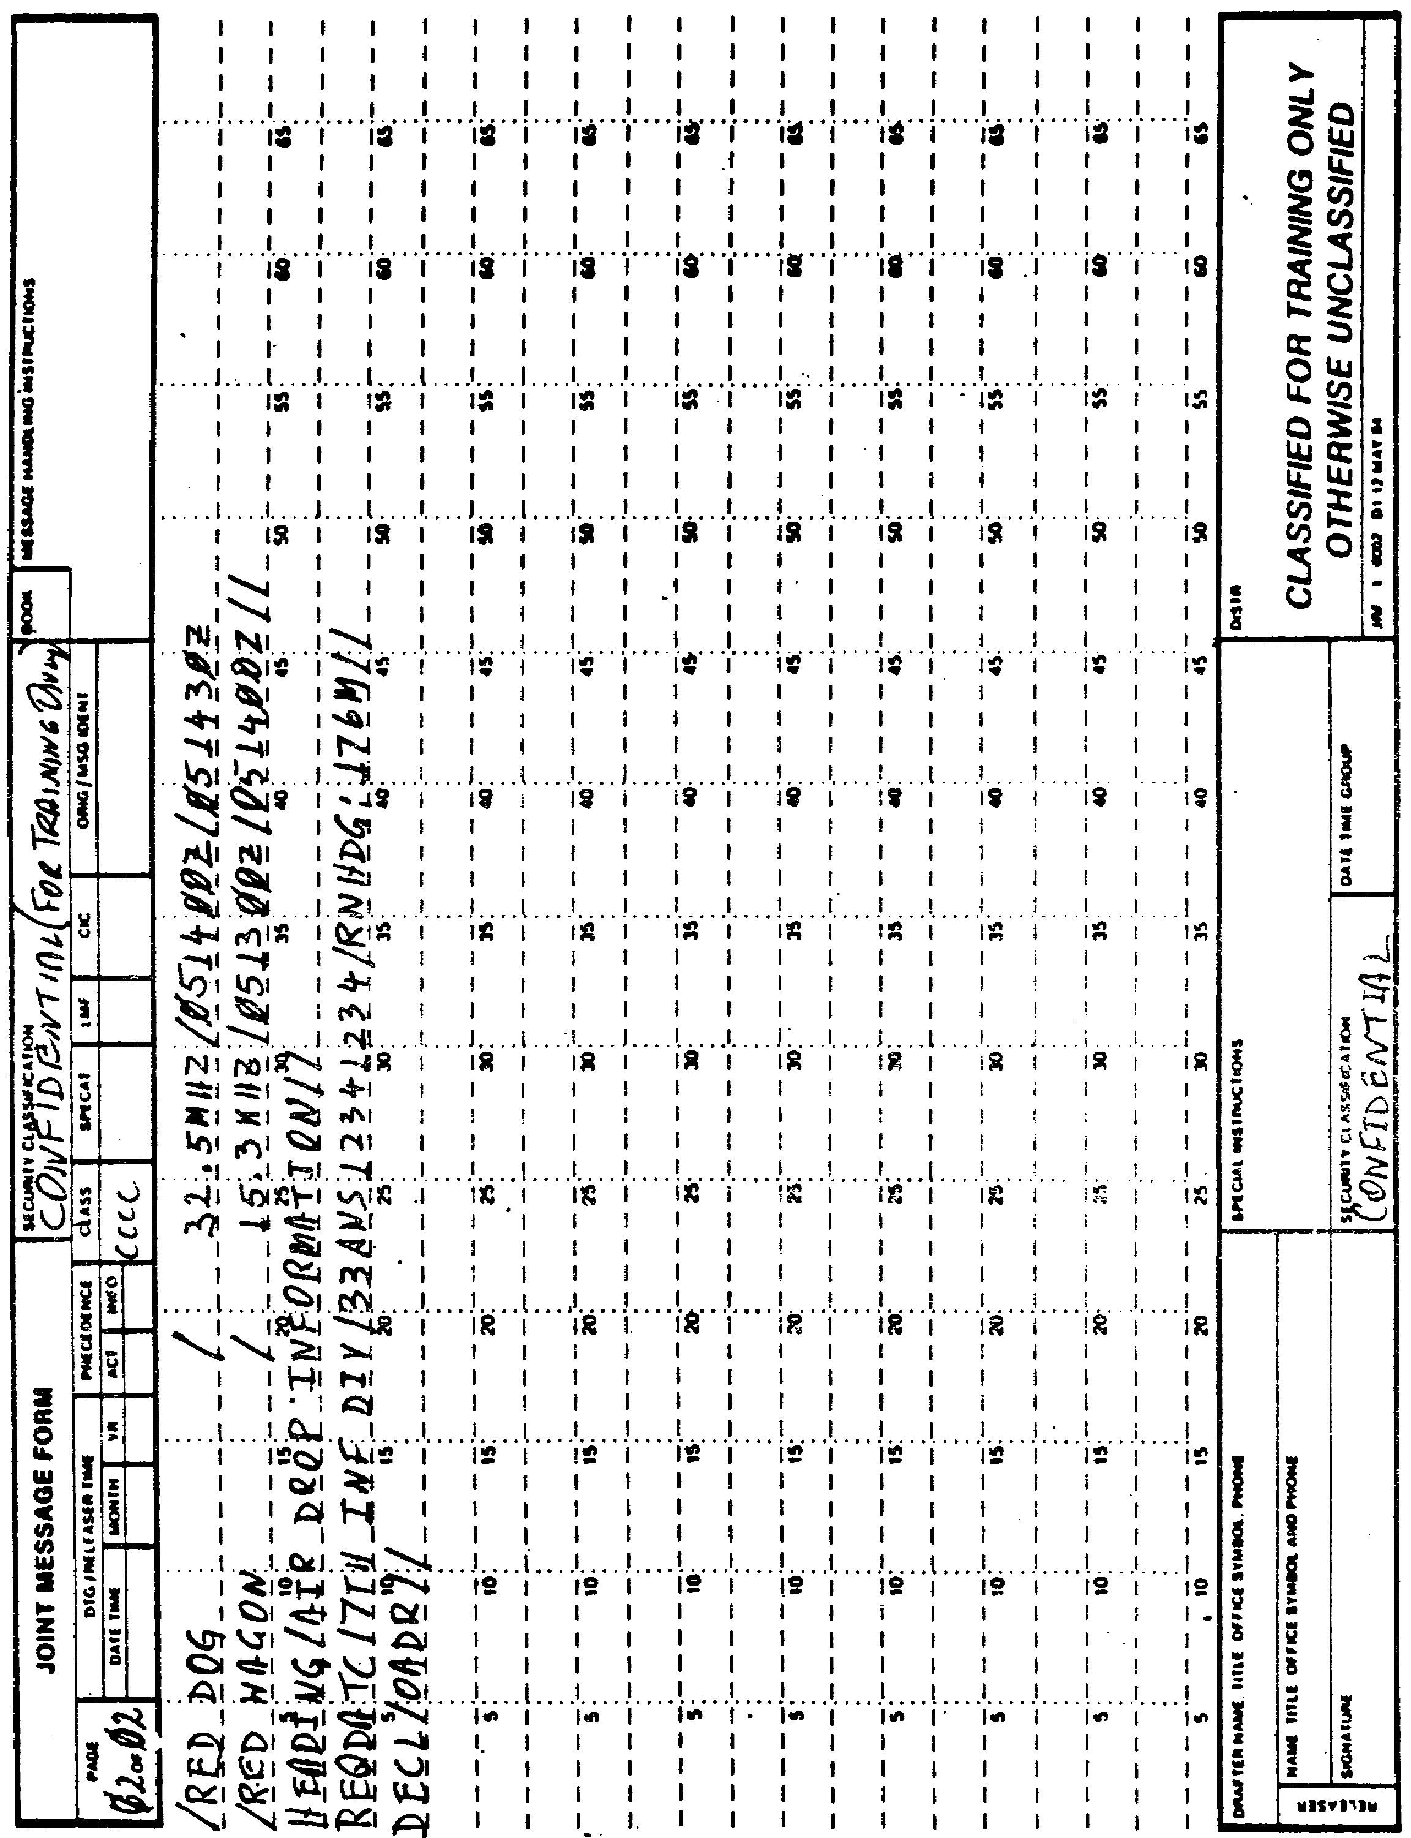

Figure 5-1. Concluded.

79 IT0667

Part C: AIRREQRECON VOICE TEMPLATE PREPARATION

1. The AIRREQRECON Voice Template is used to request preplanned and immediate aerial R&S support missions. This message is transmitted by voice only, using standard radio procedures.

2. The following instructions (Figure 5-2) will assist you in completing the AIRREQRECON Voice Template.

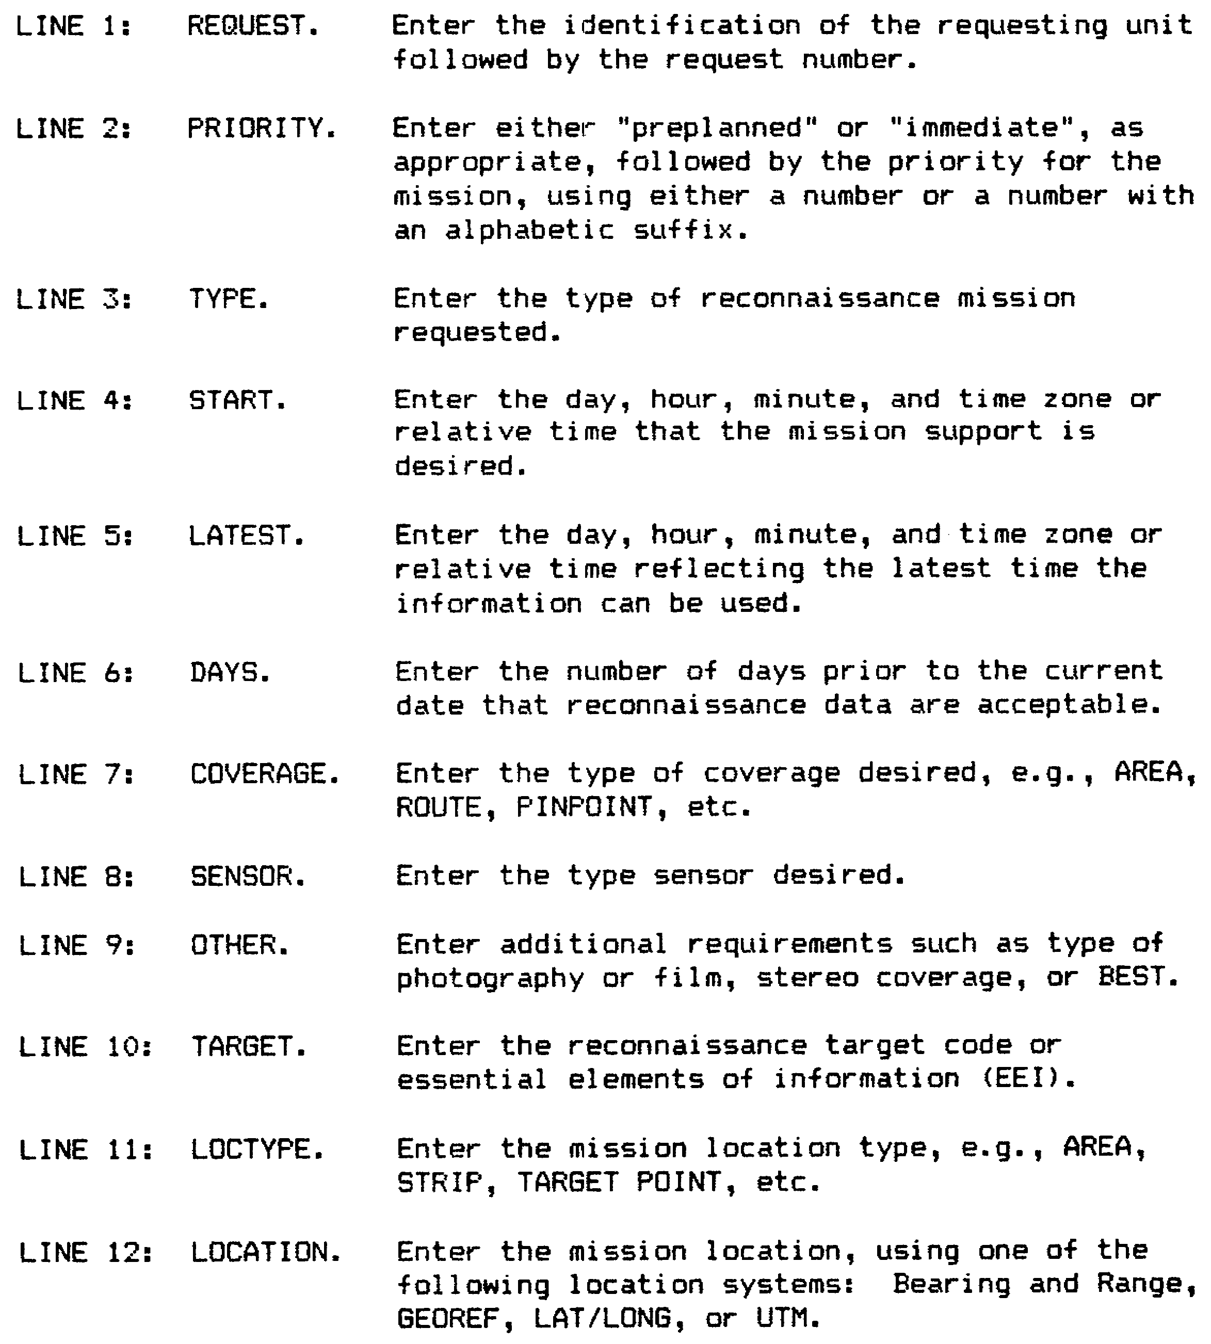

Figure 5-2. AIRREQRECON.

IT0667 80

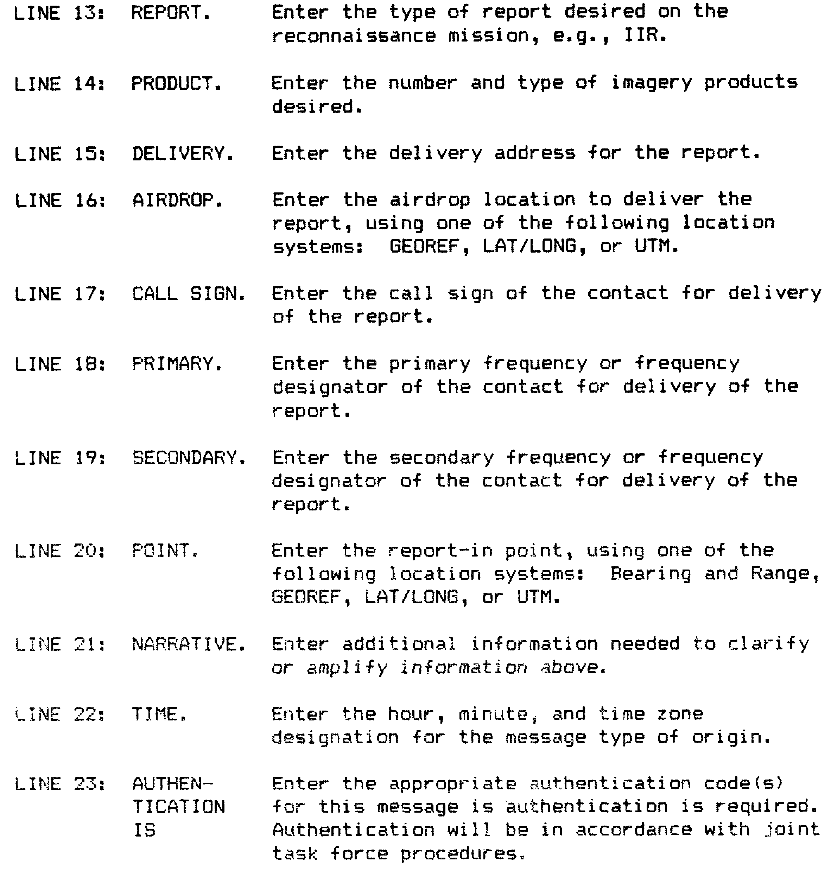

Figure 5-2. AIRREQRECON (concluded).

3. A completed AIRREQRECON Voice Template is shown in Figure 5-3.

NOTE: You must underline the message security classification and precedence.

81 IT0667

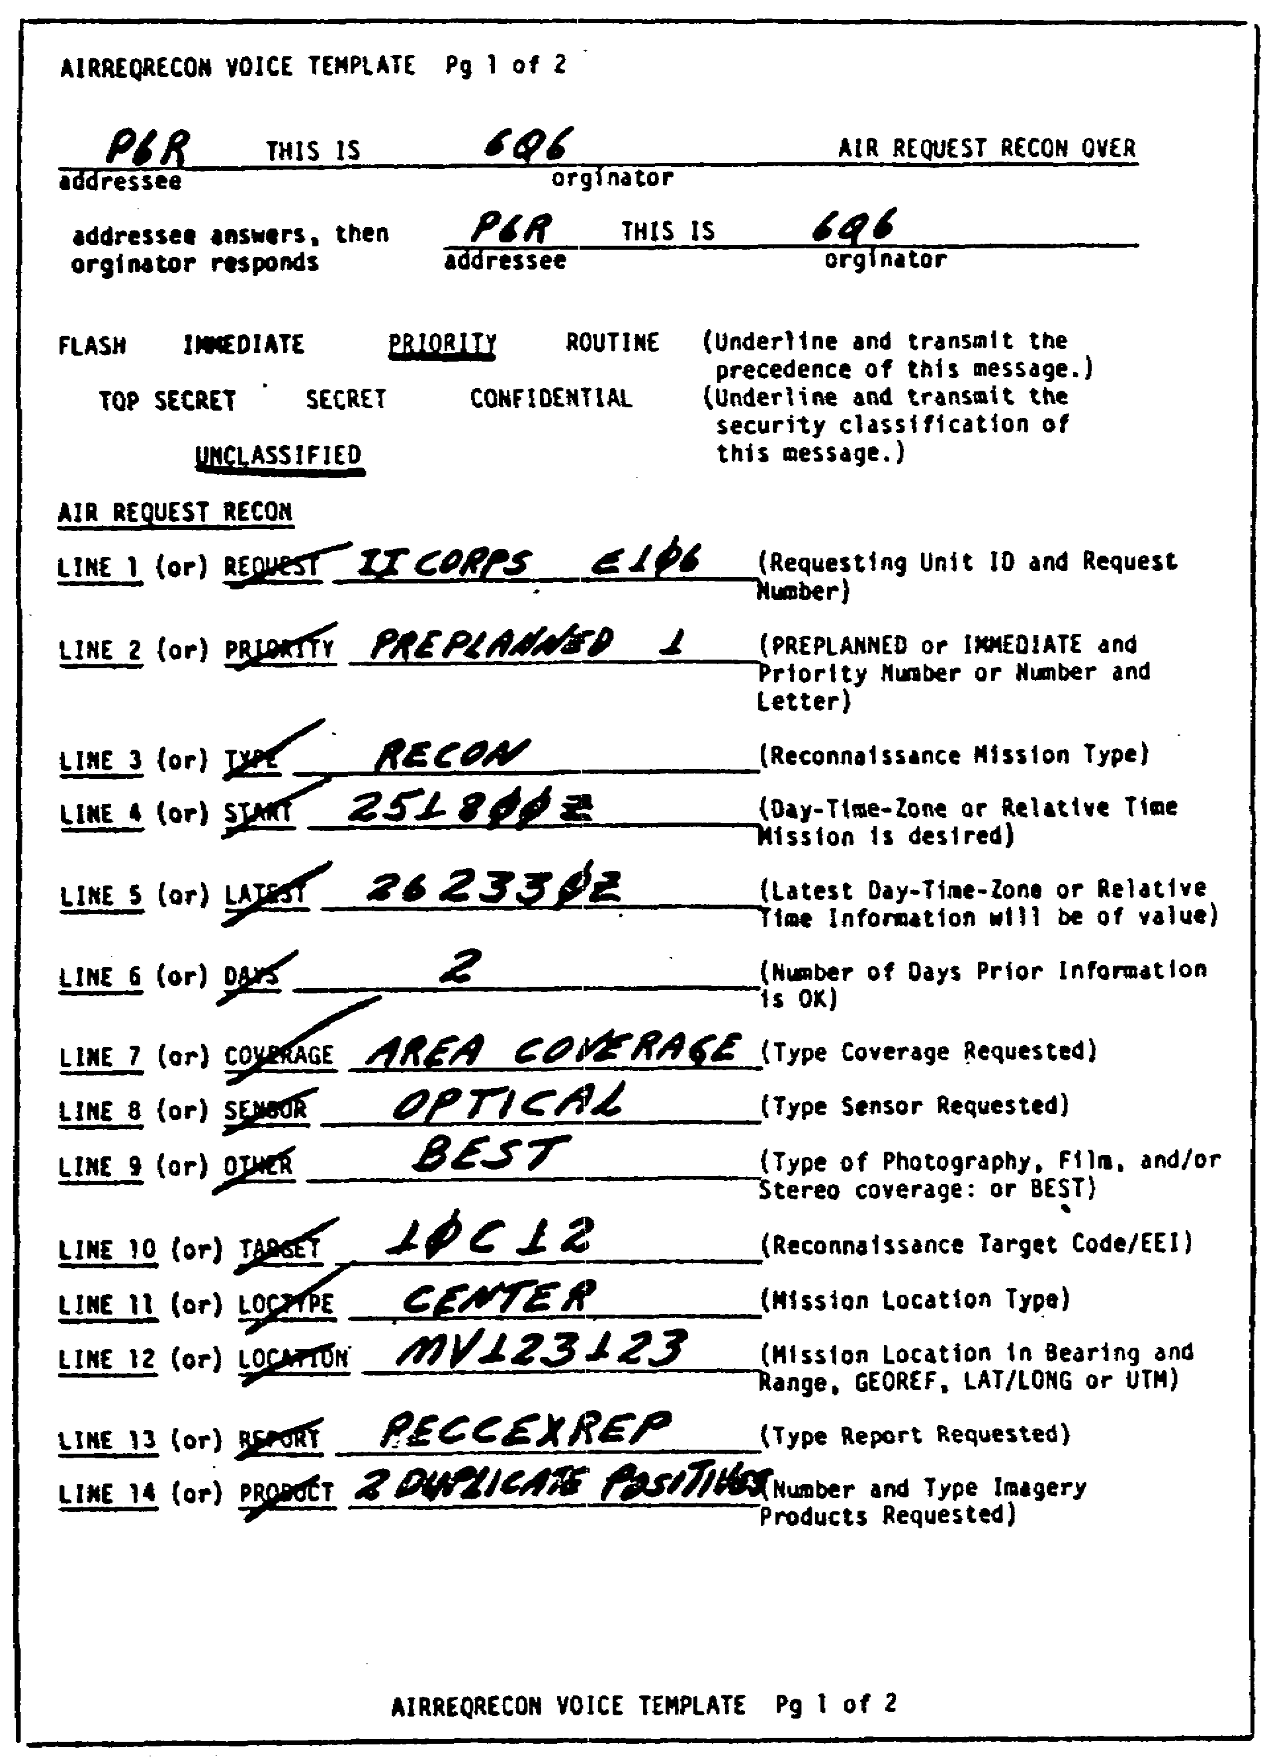

Figure 5-3. Typical AIRREQRECON Voice Template,

IT0667 82

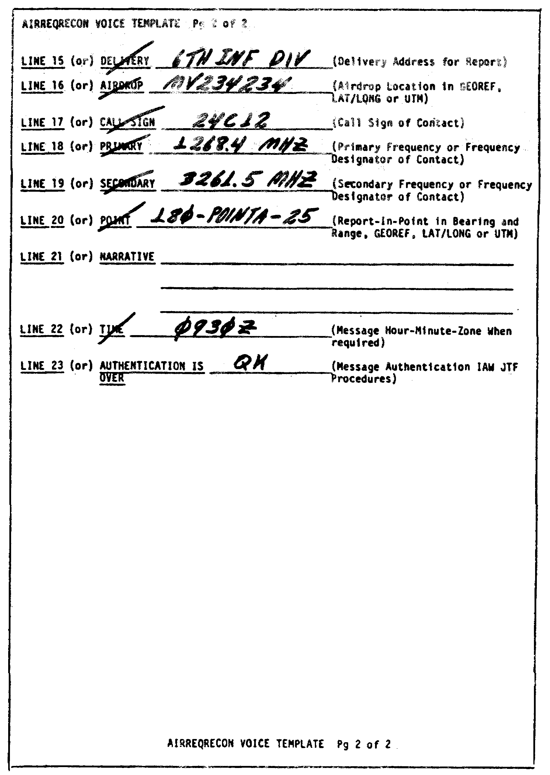

Figure 5-3. Concluded.

83 IT0667

LESSON 5

PRACTICE EXERCISE

The following items will test your grasp of the material covered in this lesson. There is only one correct answer for each item. When you have completed the exercise, check your answers with the answer key that follows. If you answer any item incorrectly, study again that part of the lesson which contains the portion involved.

1. As JTACSURVREQs are prepared, which of the following numbers has the highest priority?

A. 4.

B. 3.

C. 2.

D. 1.

2. What is the purpose of the "REQDATA"' set?

A. Describes the mission.

B. Requests specific information.

C. Requests description.

D. Analyzes mission.

3. Which of the following set(s) in the JTACSURVREQ is (are) NOT repeatable?

A. Exercise and operation.

B. 9RECONRQ.

C. TGTCOD and REF.

D. TRCPLOT.

IT0667 84

use figure 5-4 for questions 4 through 7.

4. Which field entry is incorrect in the "MSGID" set?

A. Title.

B. Originator.

C. Month.

D. Qualifier.

5. Which entry is incorrect in the "REQDATA" set?

A. Request number field.

B. DATADES field.

C. Incorrect entry of LTIOV,

D. Incorrect closure of set.

6. What is the Error in item 10 between "TOT" and "print scale"?

A. No error.

B. Incorrect entry for image qualifier.

C. Incorrect entry for image type.

D. Incorrect entry for map reference.

7. What is the error in the "TRCPLOT" set?

A. No error.

B. Field width missing.

C. Field ELF missing.

D. Correct width measurement code missing.

85 IT0667

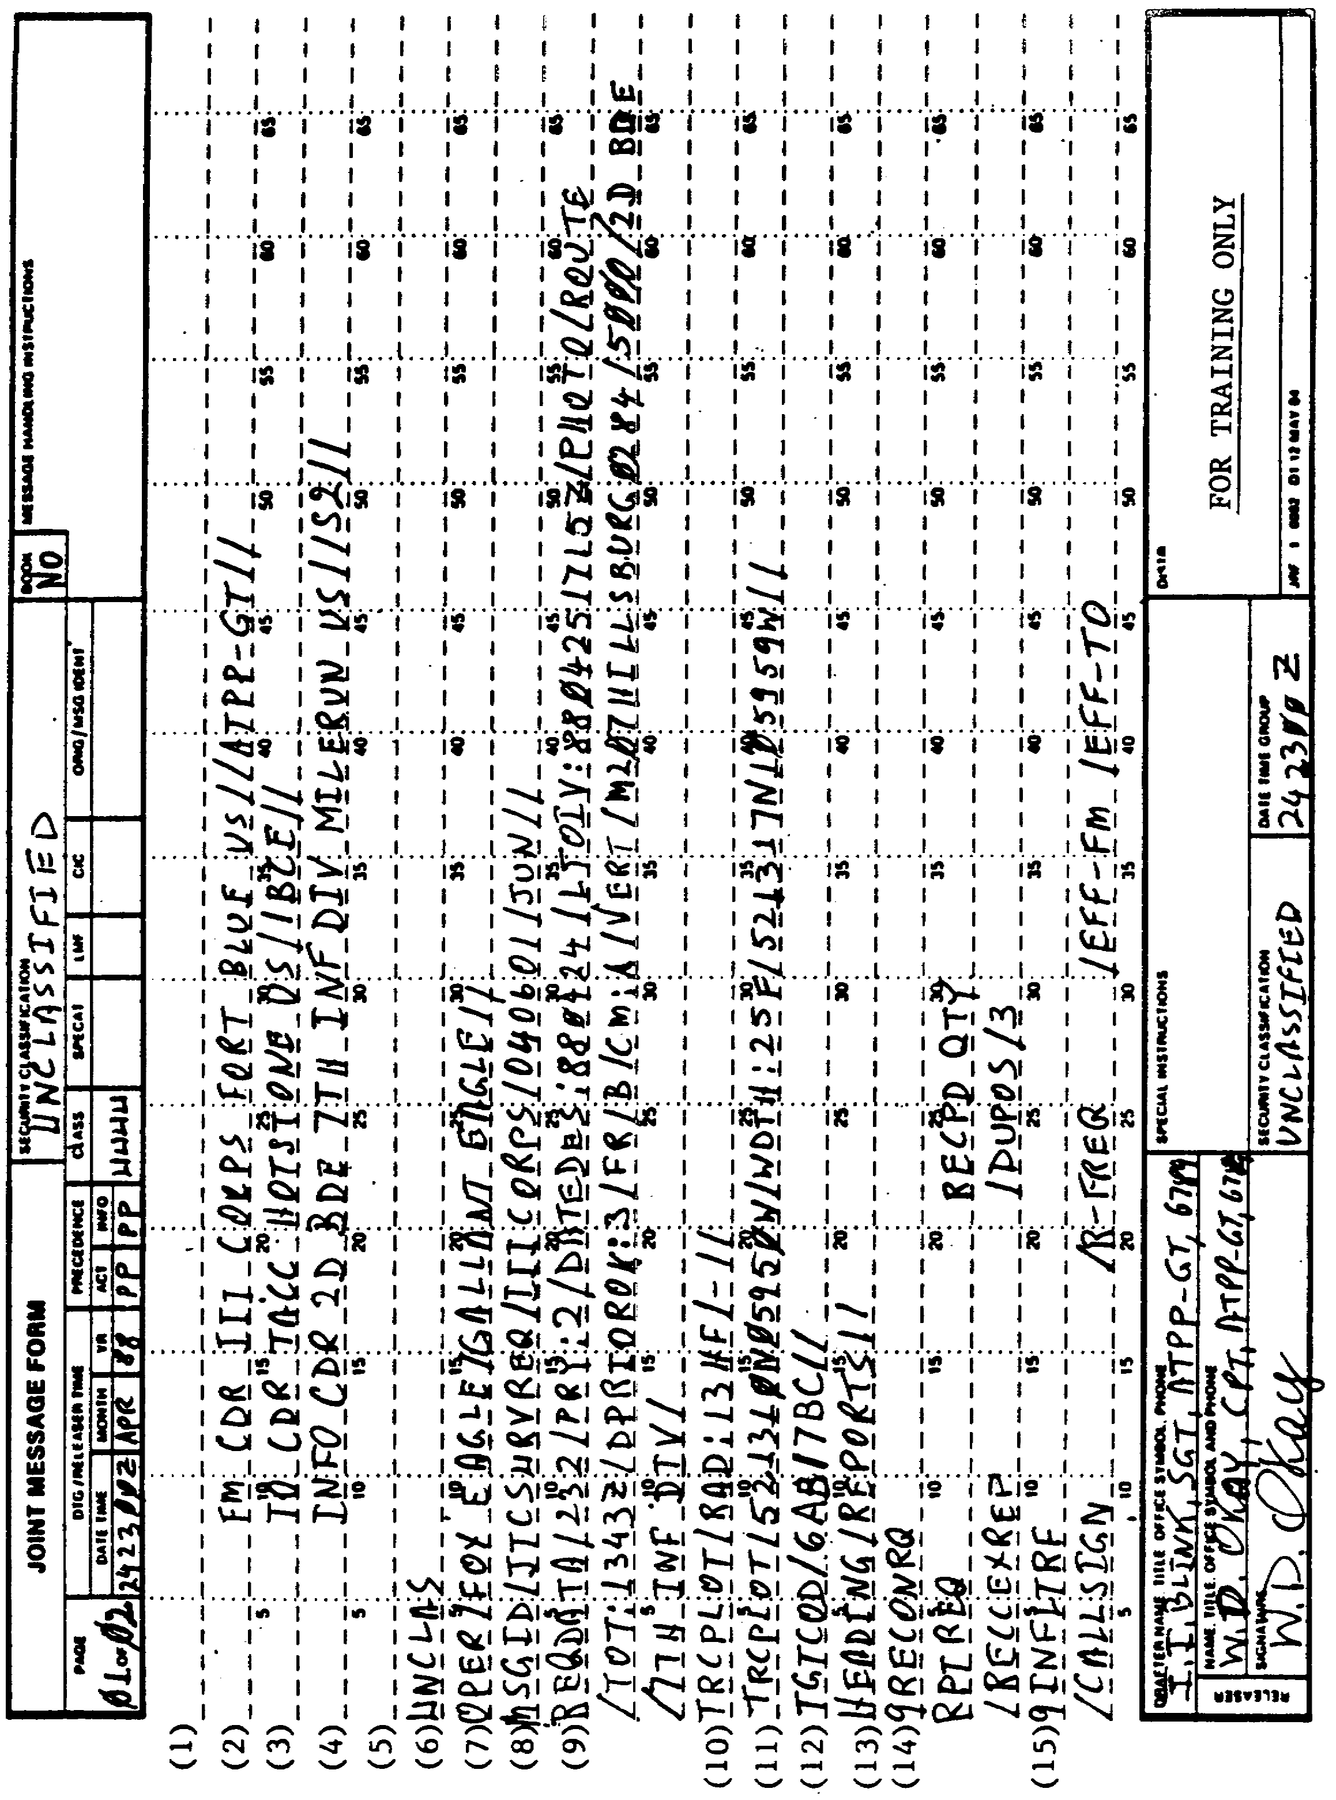

Figure 5-4. JTACSURVREQ with Mistakes.

IT0667 86

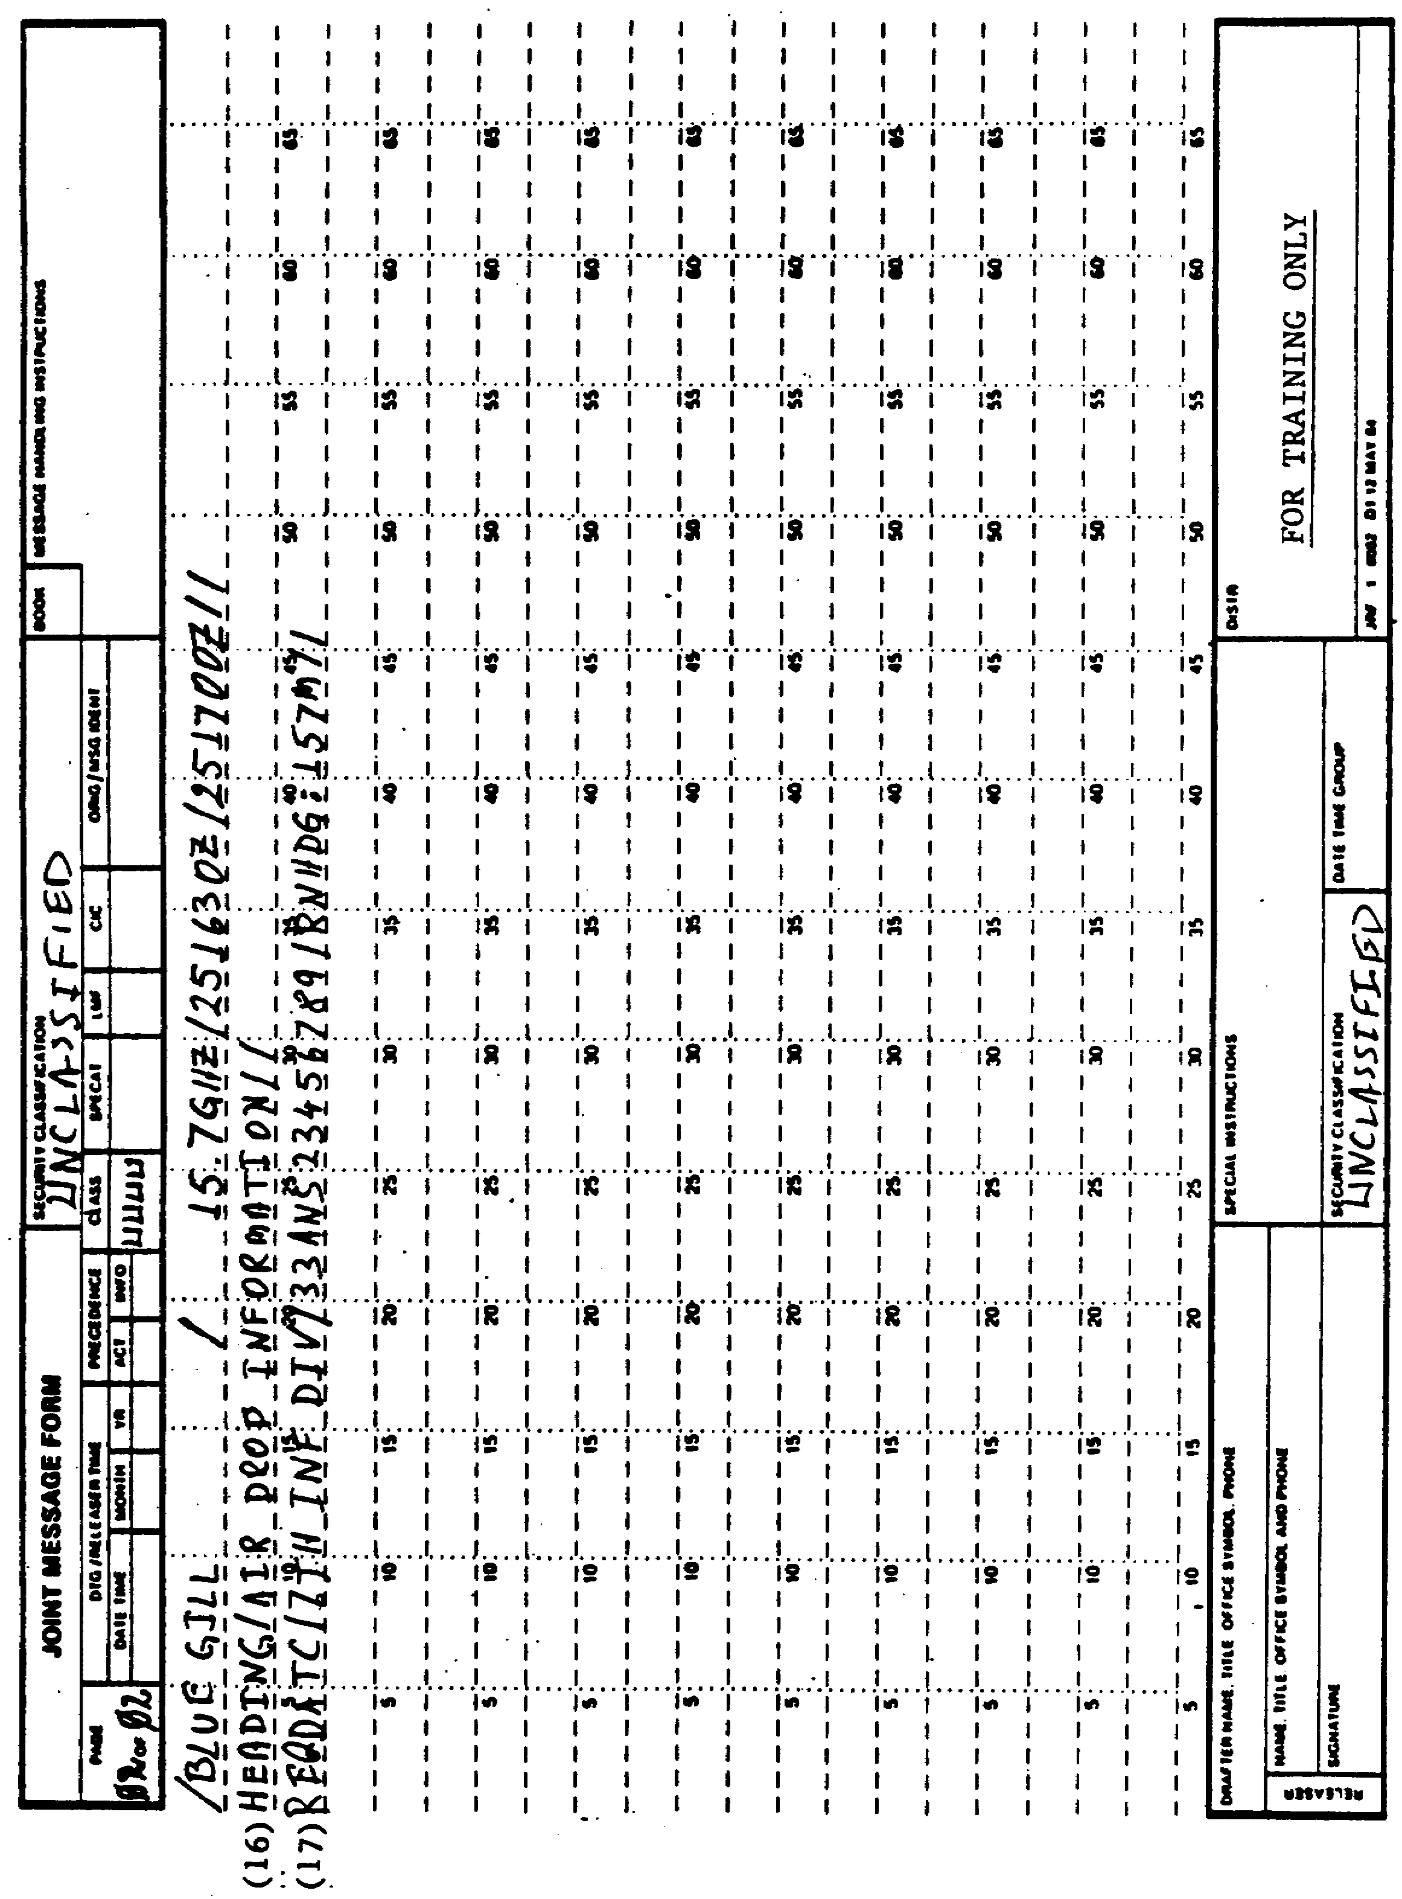
Figure 5-4. Concluded.

87 IT0667

8. Which statement applies to the missing "DECL" set?

A. Classification could be SECRET NOFORN.

B. Message was unclassified.

C. Message was higher than SECRET.

D. Error.

9. Which line of the AIRREQRECON Voice Template indicates the type report desired?

A. 12.

B. 13.

C. 14.

D. 15.

IT0667 88

LESSON FIVE

PRACTICE EXERCISE

ANSWER KEY AND FEEDBACK

ITEM ANSWER KEY AND FEEDBACK

1. D. The number 1 has the highest priority as the JTACSURVREQ is prepared (page 70, para 6b).

2. C. The purpose of the "REQDATA" set is for request description (page 70, para 6).

3. A. On JTACSURVREQ the exercise and operation set are not repeatable (page 106, appendix A).

4. A. The title is incorrect in the MSGID set (page 106, Appendix A).

5. D. In the "REQDATA" set there is an incorrect closure of the set, it should be double slashed (page 10, para 2a).

6. B. There is an incorrect entry between the "TOT" and "print scale" (page 72, table 5-4).

7. D. The correct width measurement code is missing in the "TRCPLOT" set (page 74, table 5-6).

8. B. The message was unclassified if the "DECL" set was missing (page 77, para 14).

9. B. Line 13 of the AIRREQRECON Voice Template indicates the type of report you desire (page 81, line 13).

IT0667 90

